**Adding Navigation with Event Binding and ngIf**

Using ngIf to show any one component on the basis of property change just like router it will work

In App component

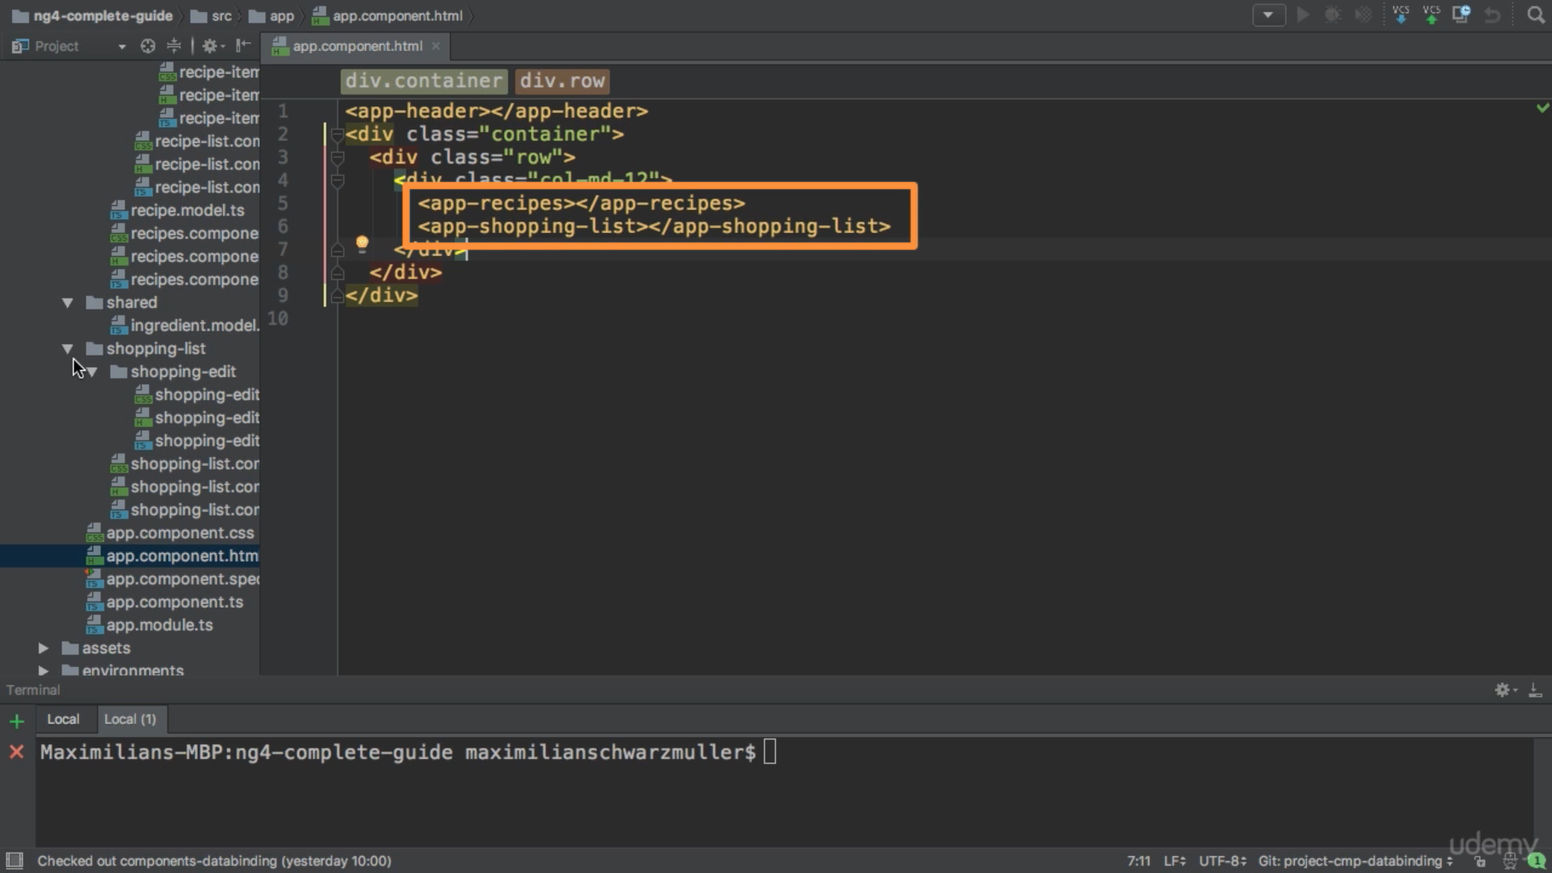

So in header component we have below two links

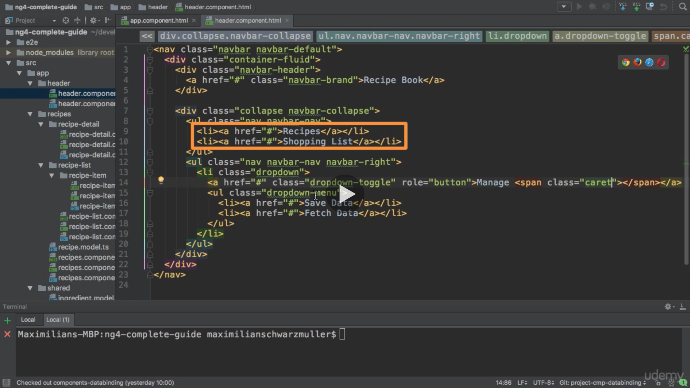

We now create a click event here and pass data to method

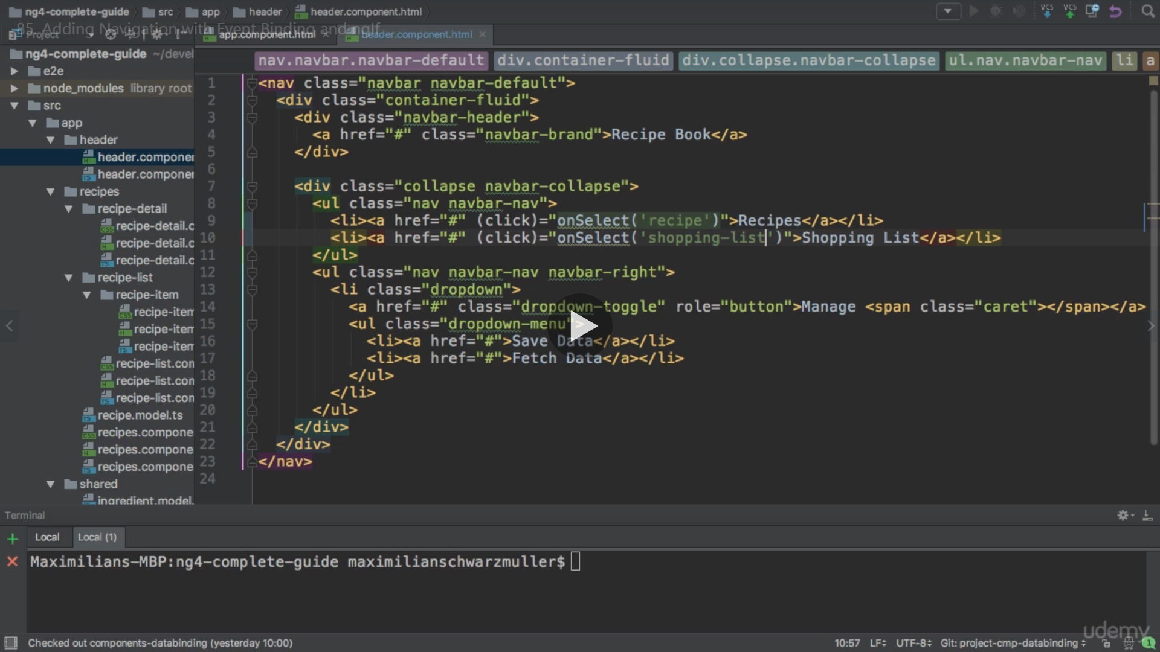

Here we create an eventemitter of type string as we are passing string data

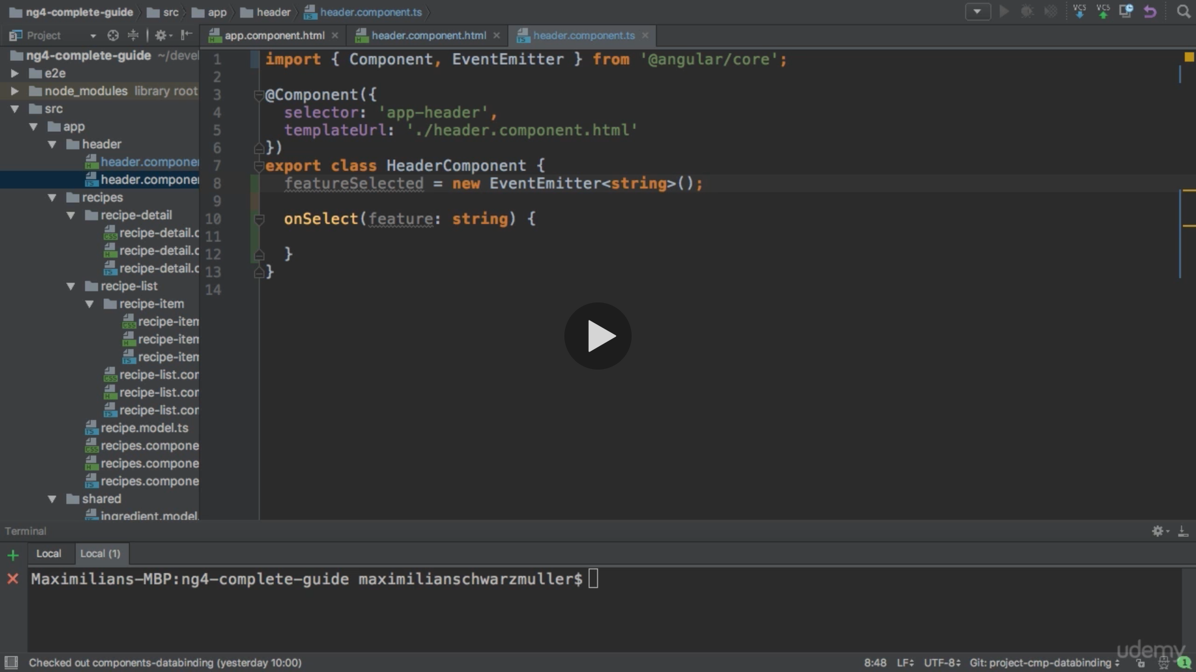

We implement method onSelect which we created in the HTML

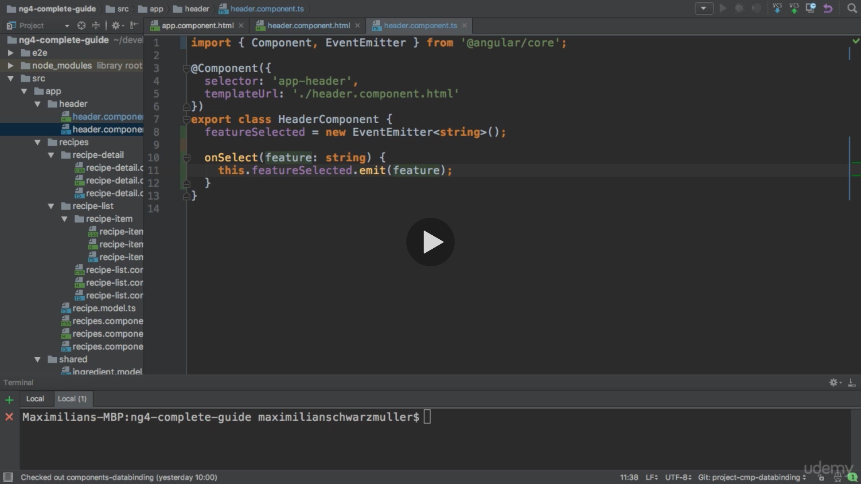

Now we need to make this listenable to listen to it from parent component outside of this component which is (app component here)

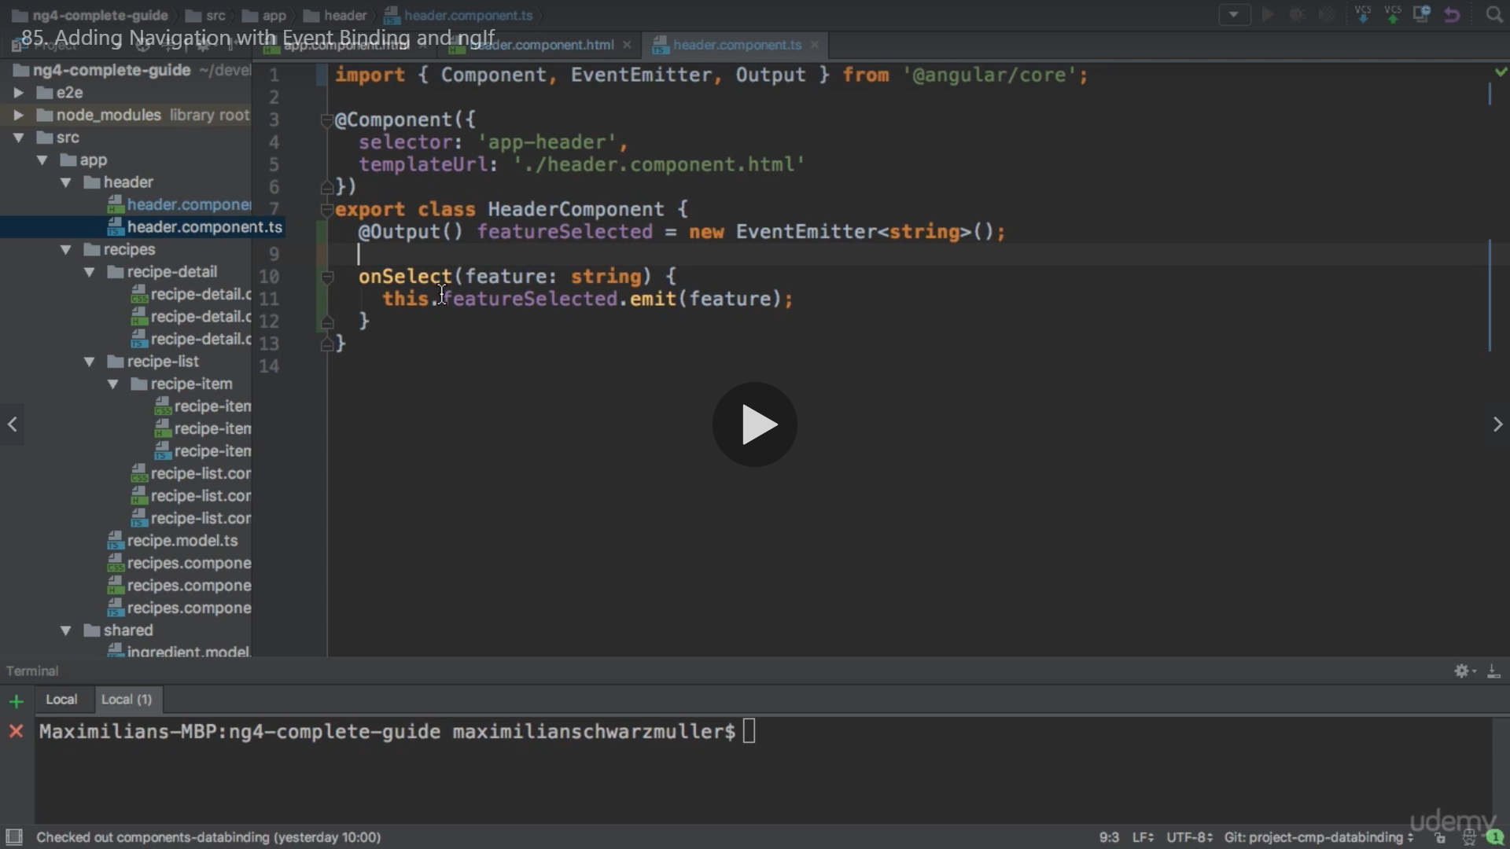

Now in App component

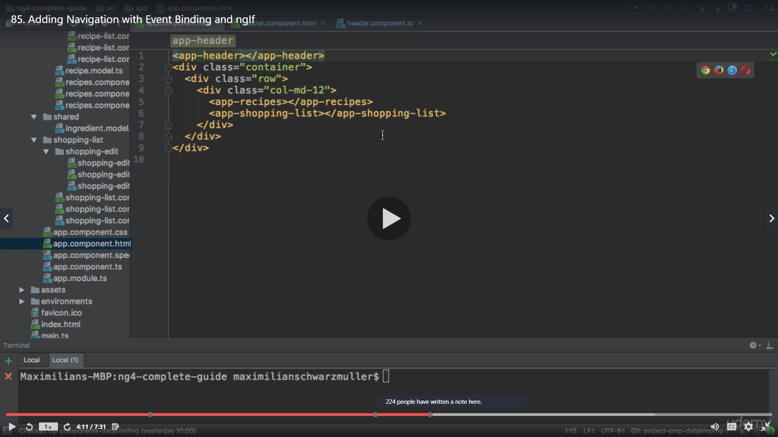

We use our created event

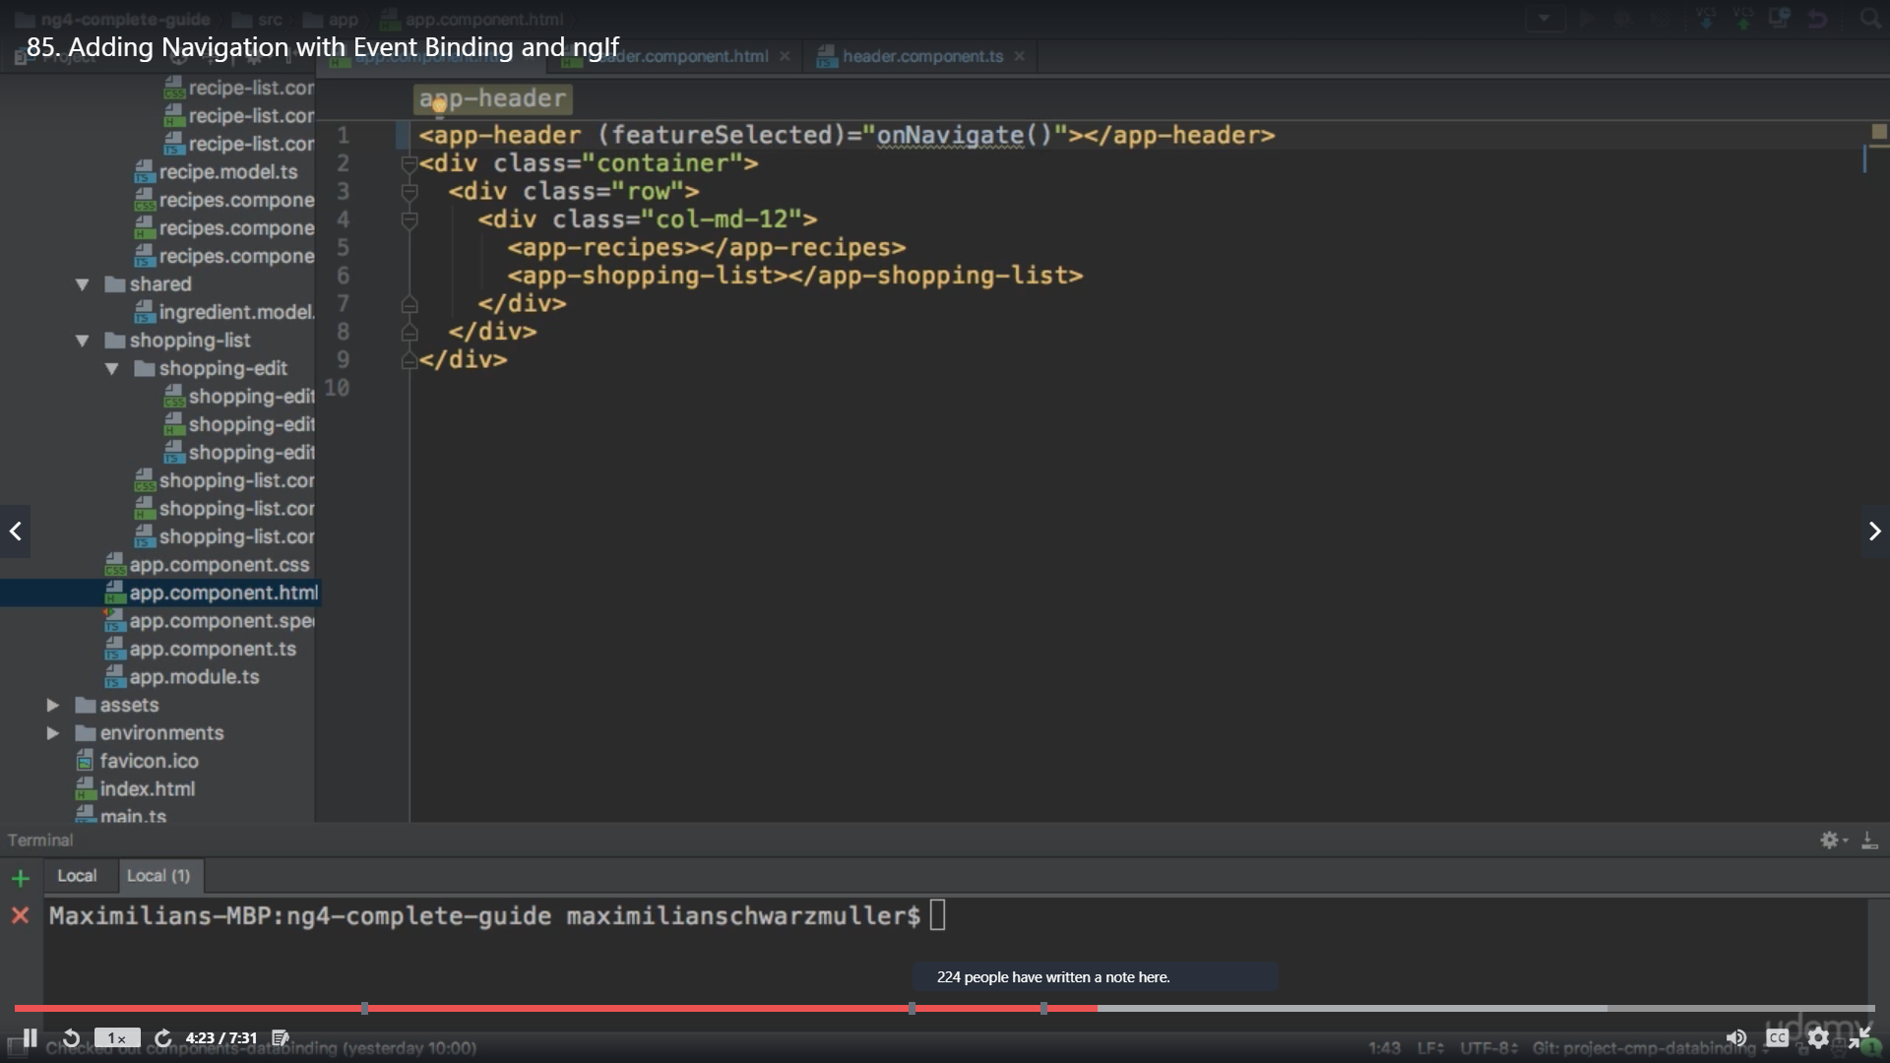

We use $event to get access to any data or event passed

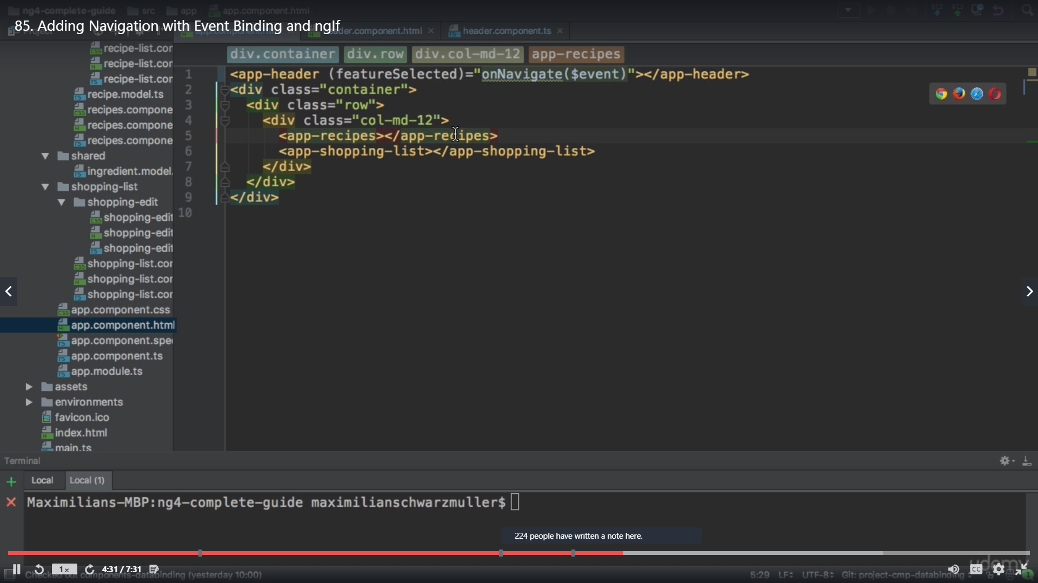

We can use other data as well in place of $event like we have mentioned below recipe we can have 2 arguments as well like below but we keep only ‘recipe’ now

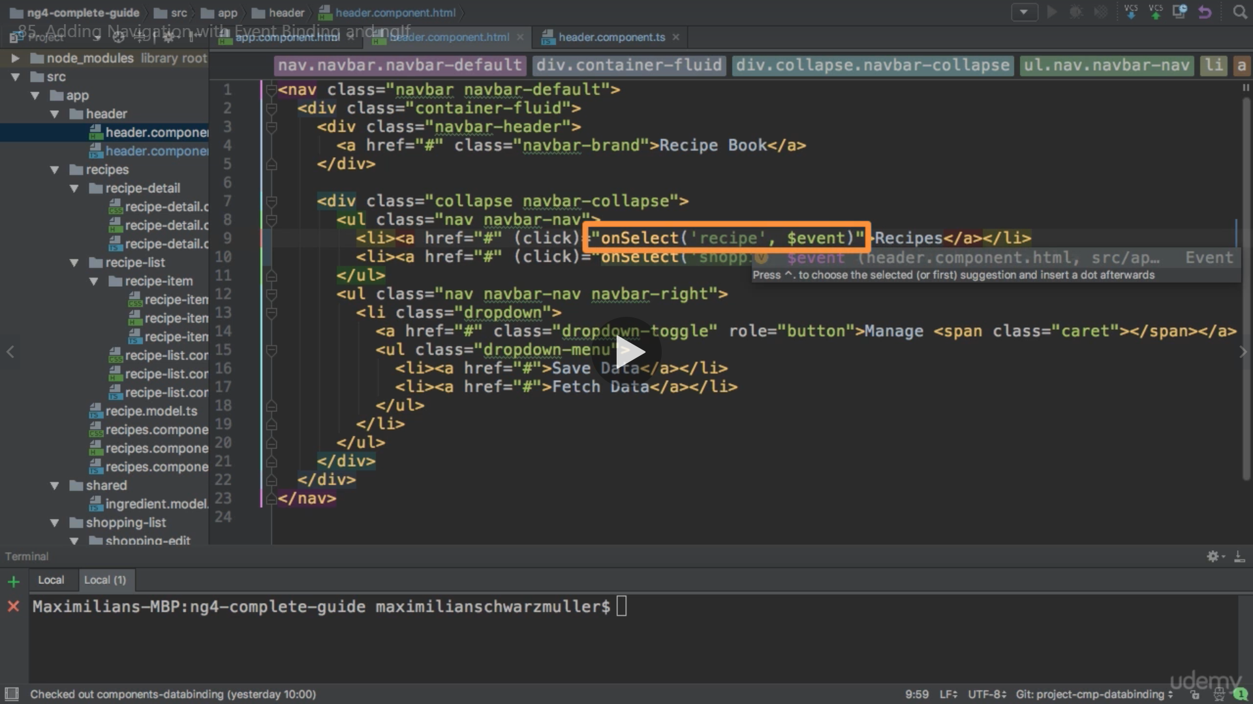

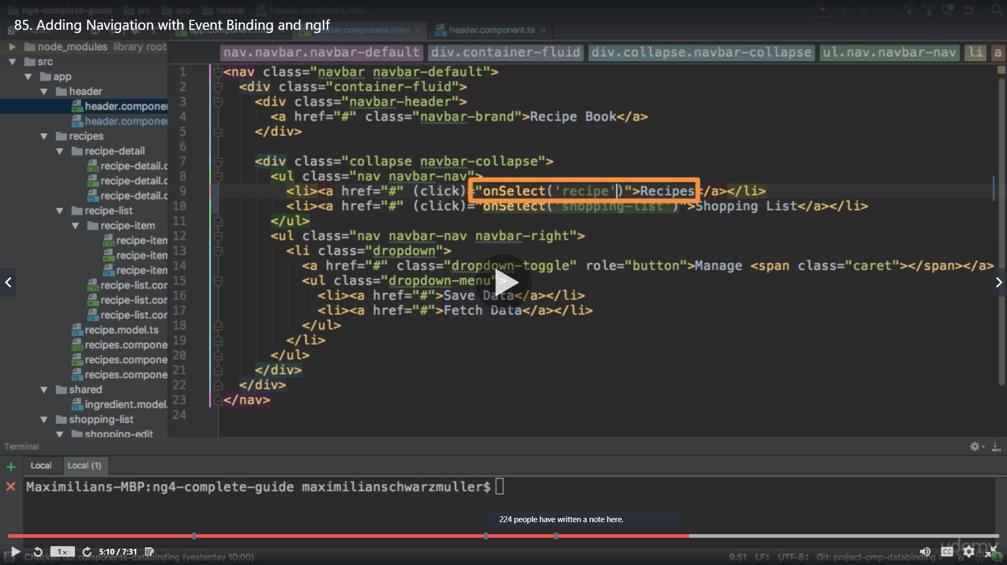

So in APP component we use our event featureSelected which we created in child component and pass argument the method to it like below

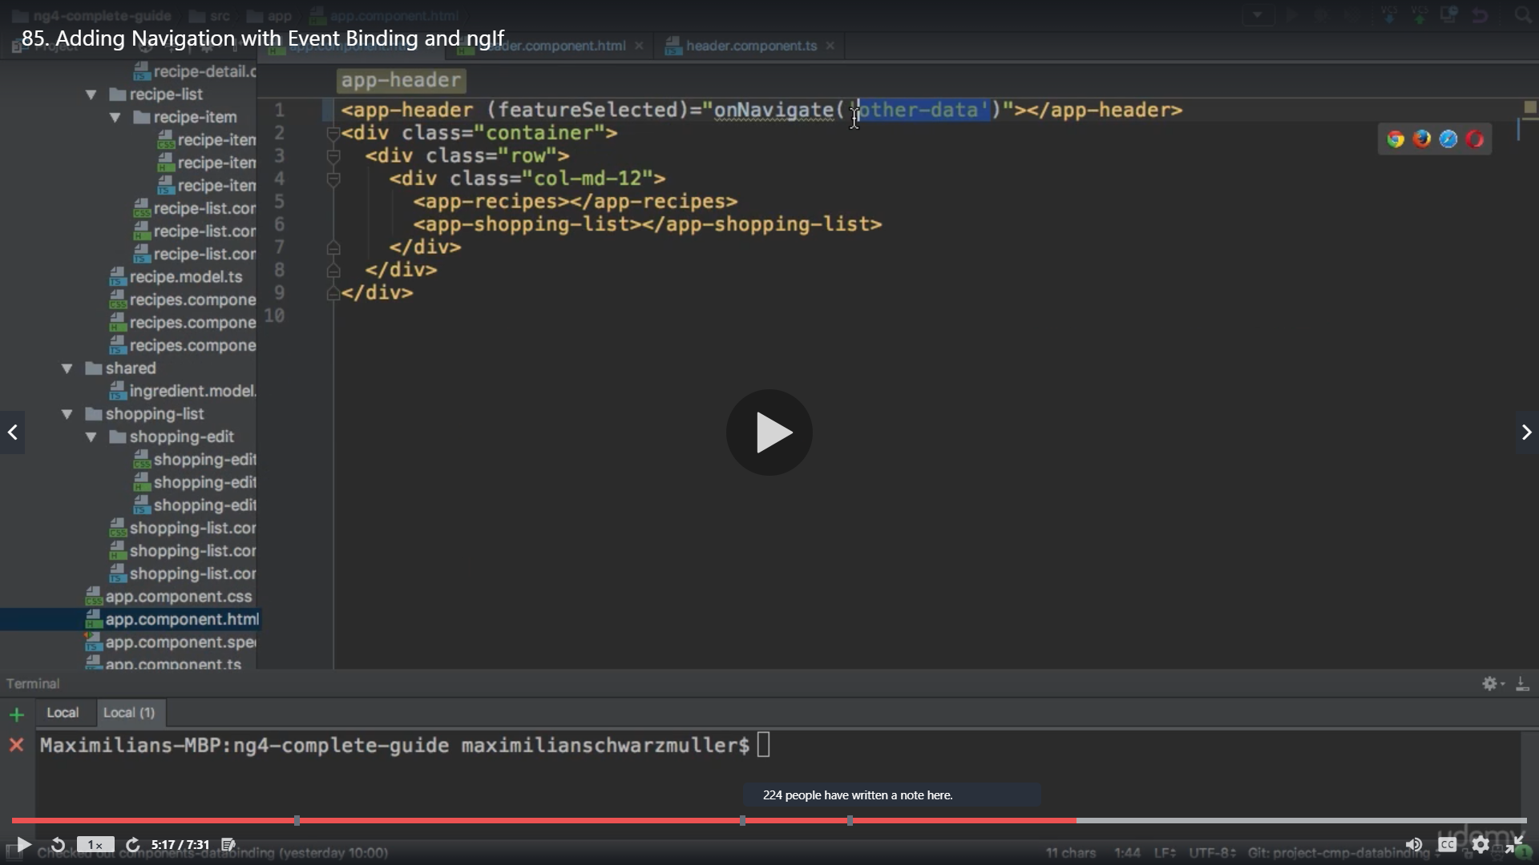

We change it to $event to get the event data

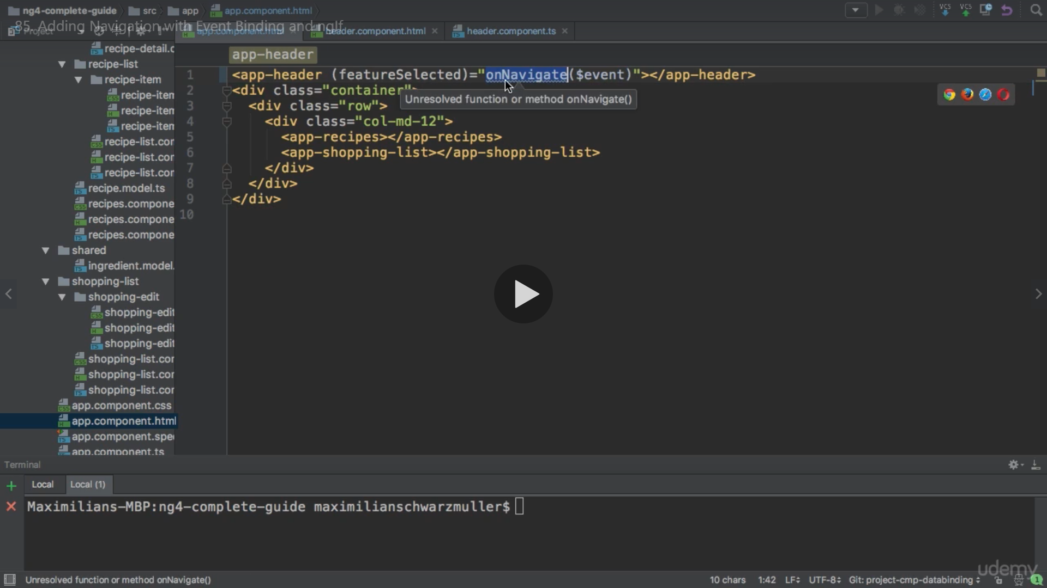

We create a property loadfeature =’recipe’ this is the same as we passed in HTML method on click

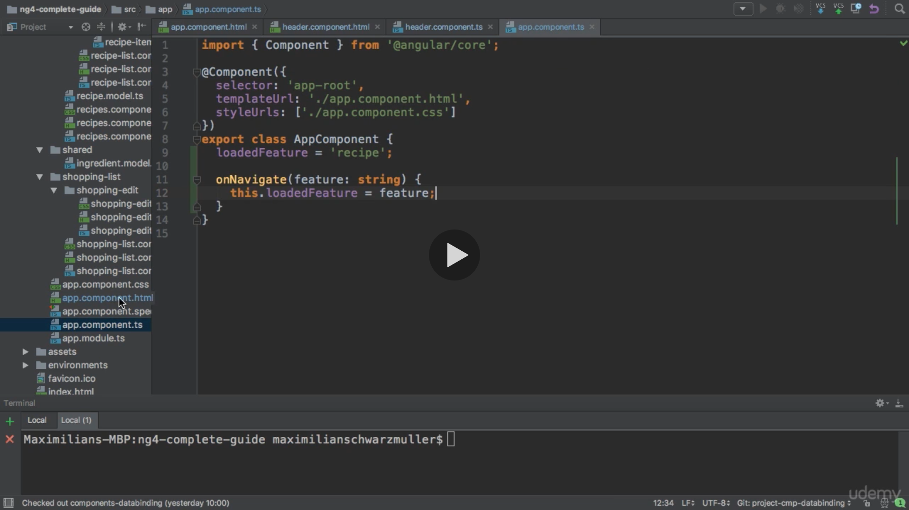

Now we use *ngIf on other component selectors to compare with ‘recipe’ to show a particular component

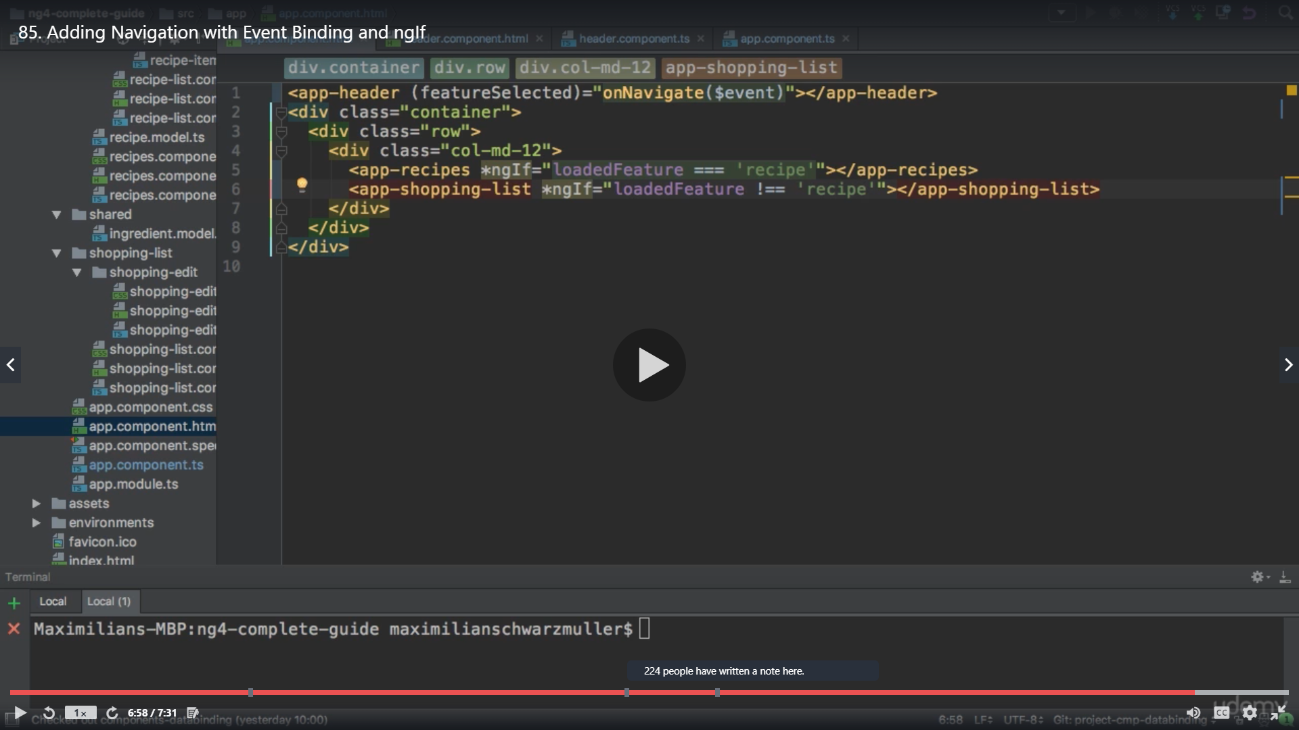

Result

Click recipe

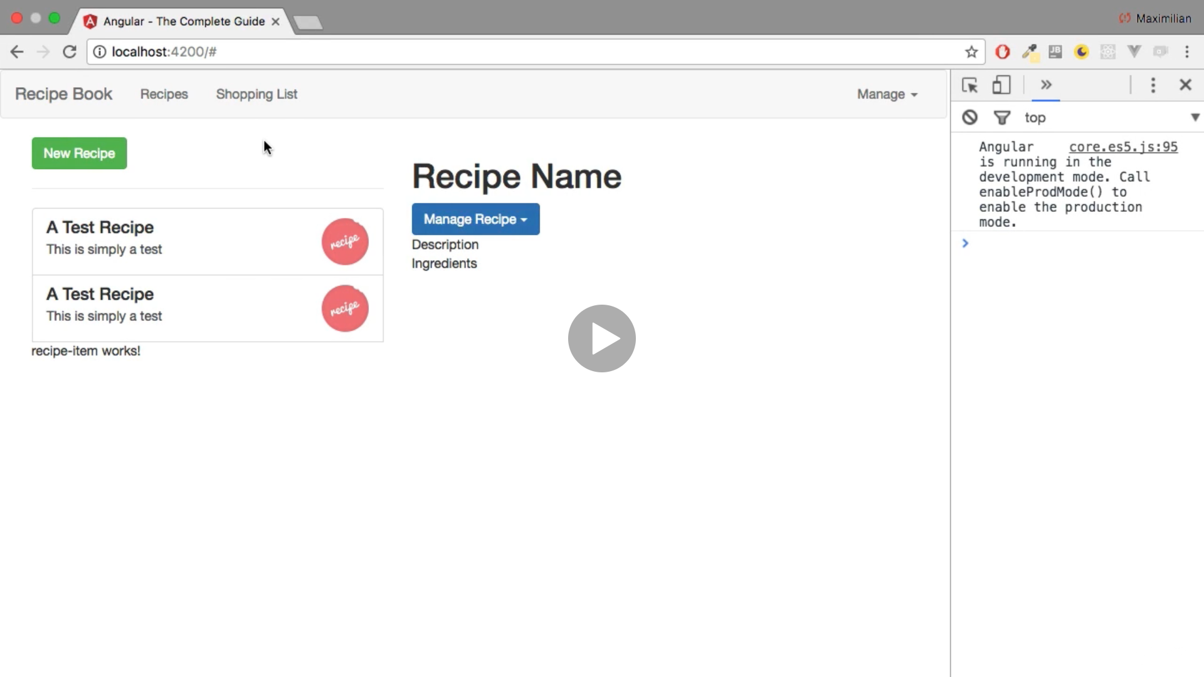

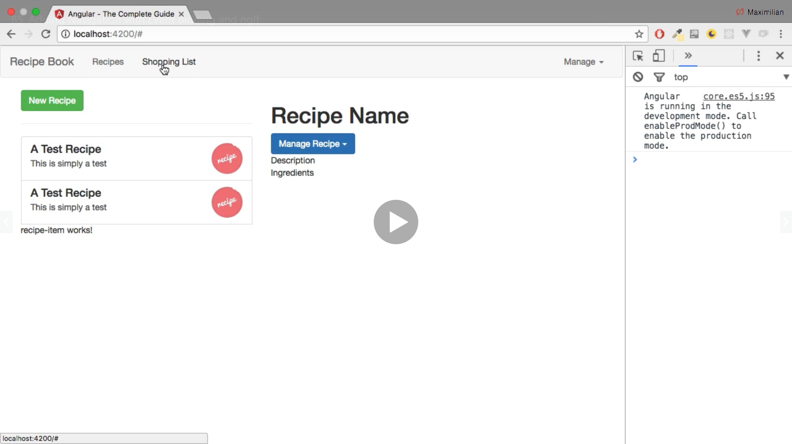

Click shopping list

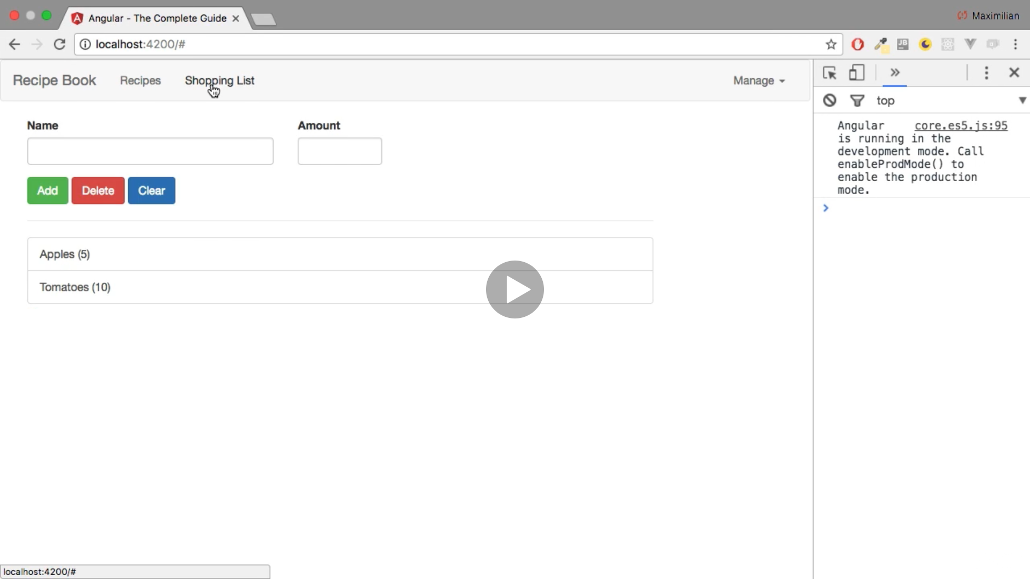

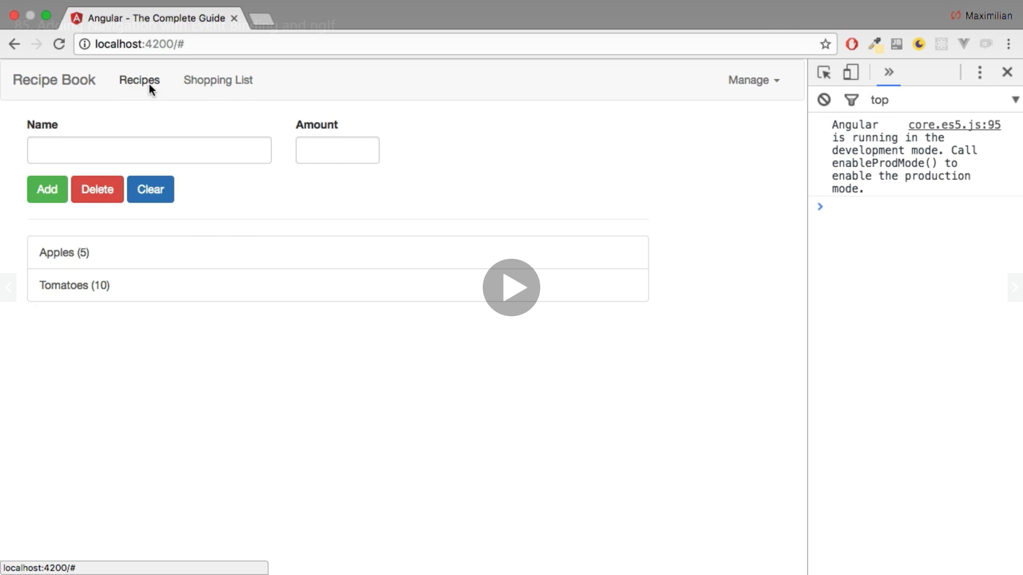

Click recipe

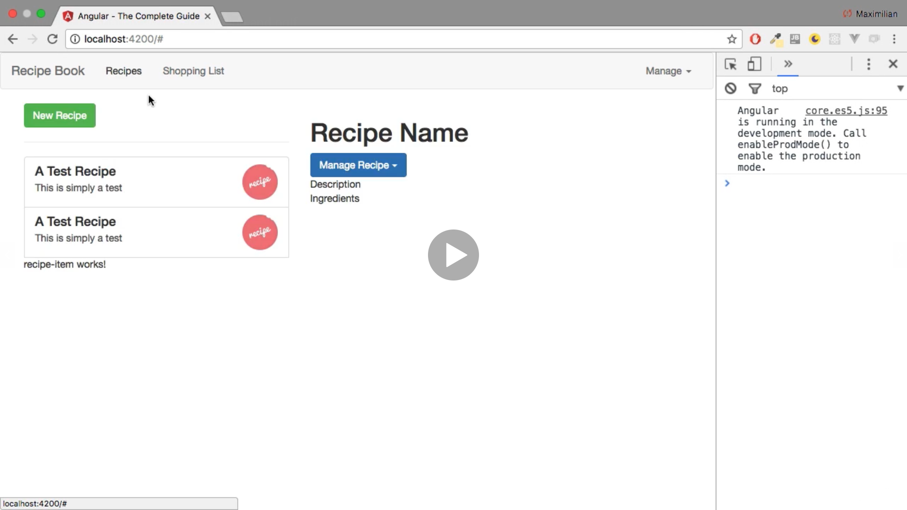

**Passing Recipe Data with Property Binding**

**We separate the recipe code to different component**

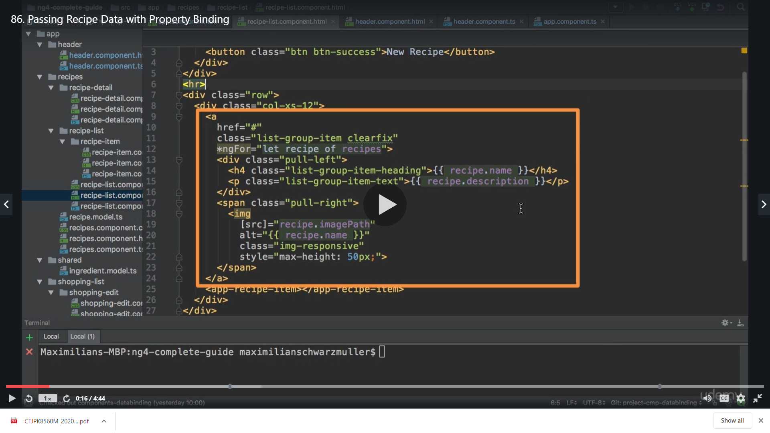

**We cut the above code and put it in recipe-items.component**

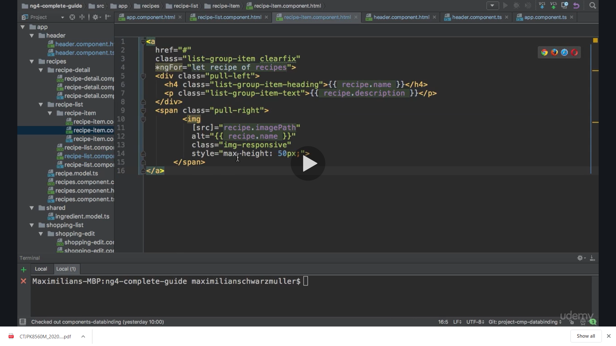

**Now we have to remove the for loop ,so we cut the loop**

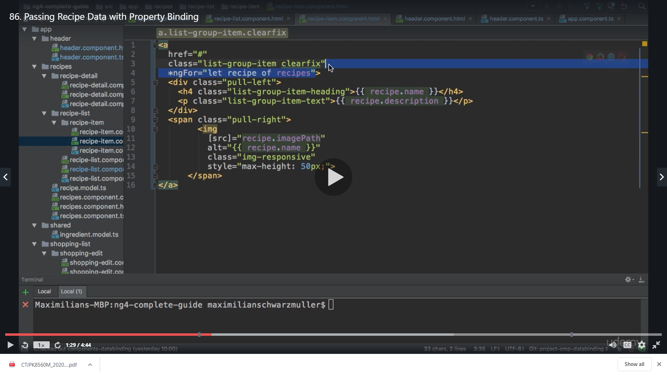

**And add it to the selector of app recipe items selector so that now the whole component is replicated for each recipe**

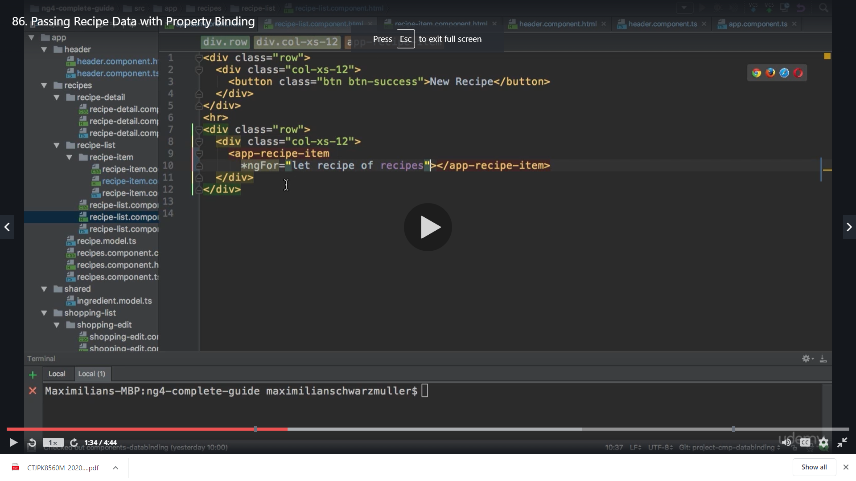

**Now we don’t have the recipe access inside the recipe item component anymore**

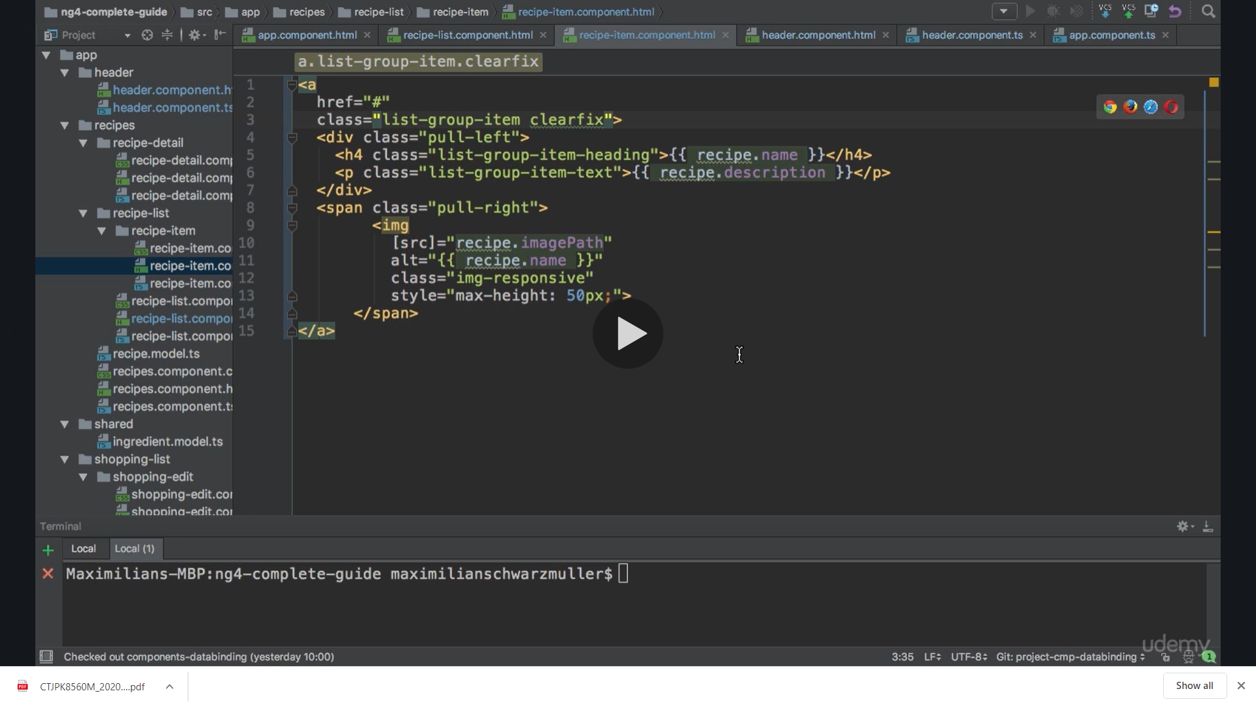

**So we add a recipe model that we had and import it , initially it will not have any value because we want to get the value from outside**

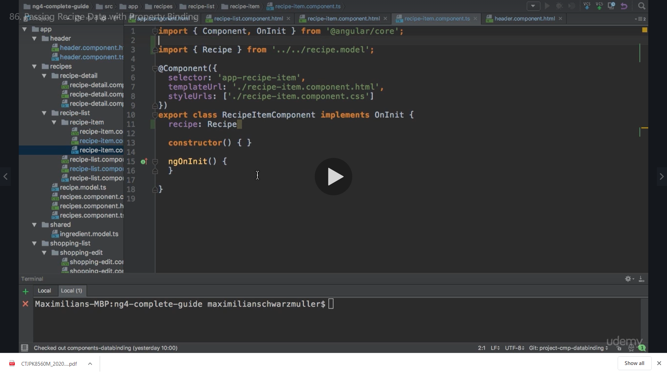

**So we use @Input**

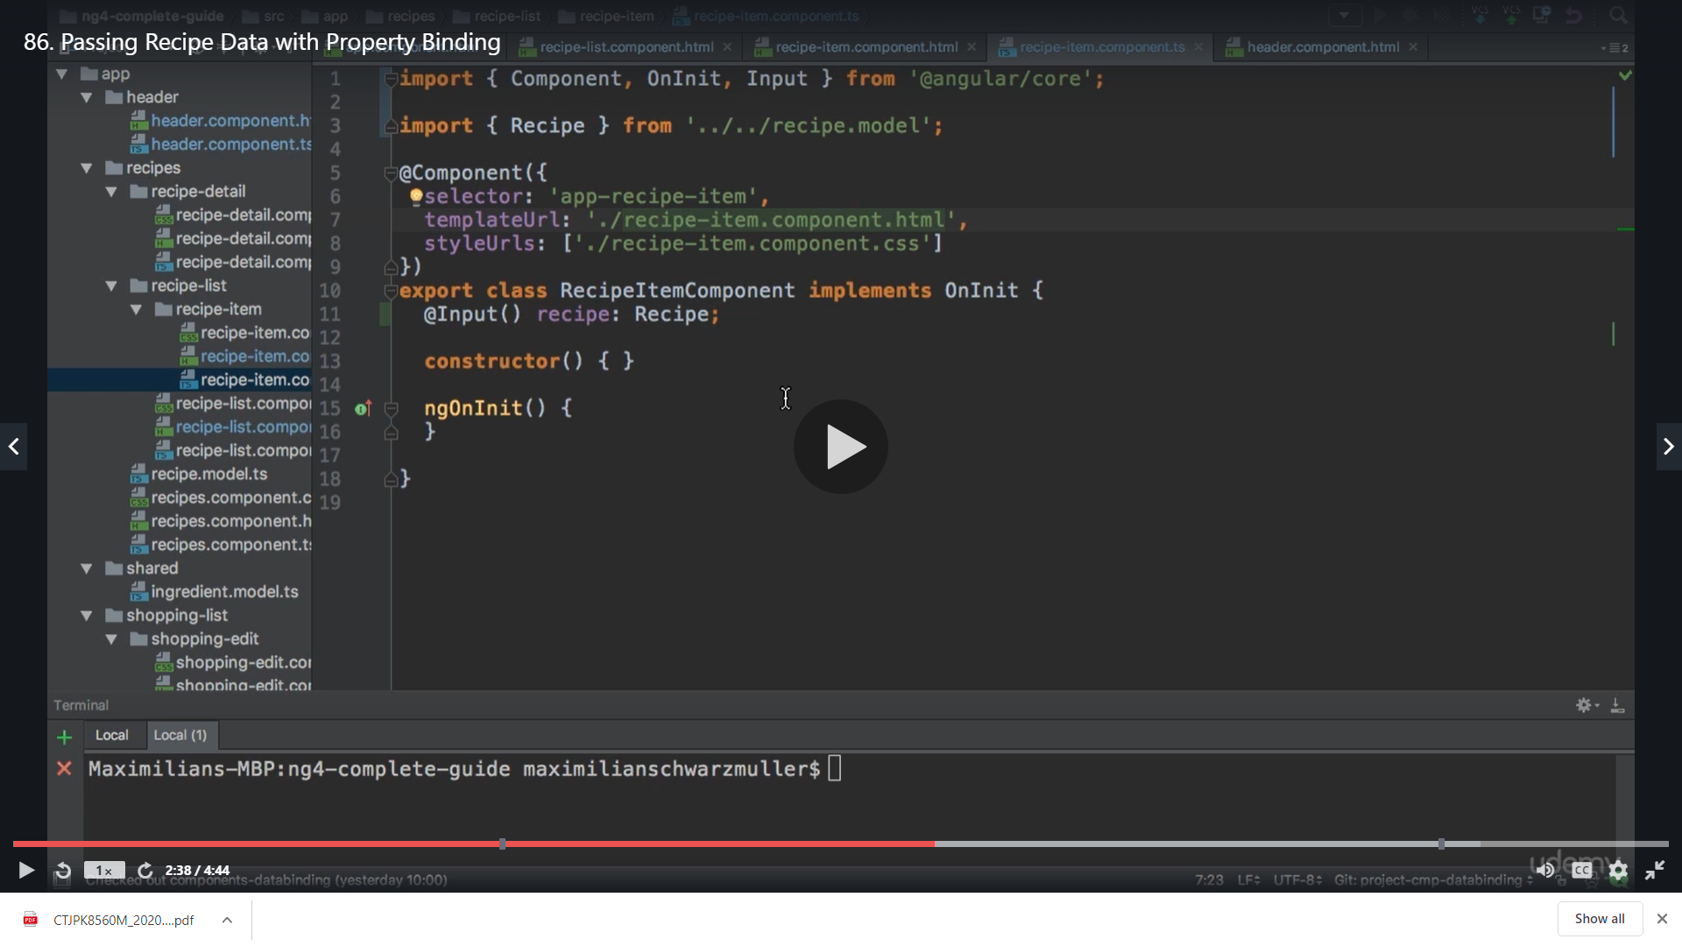

**Now we bind it in recipe list component**

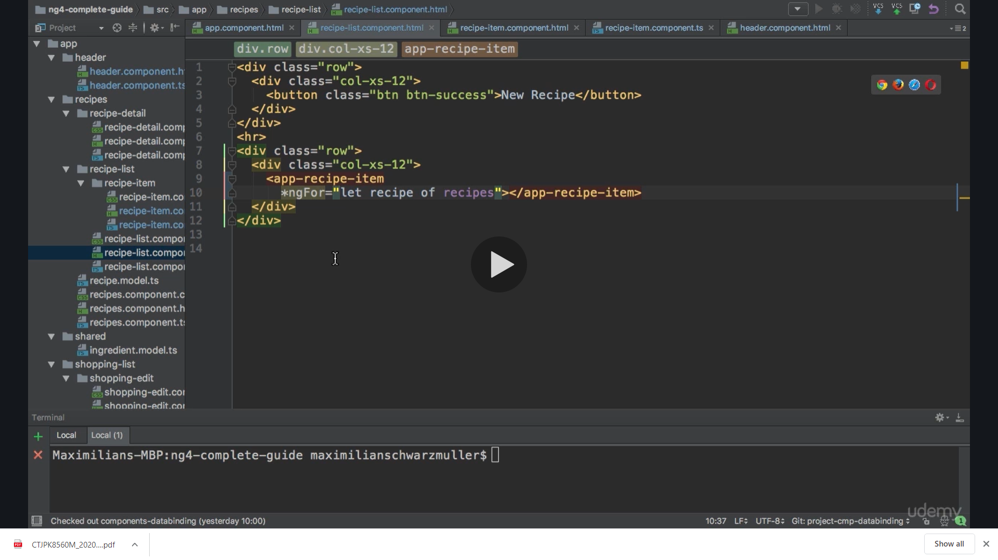

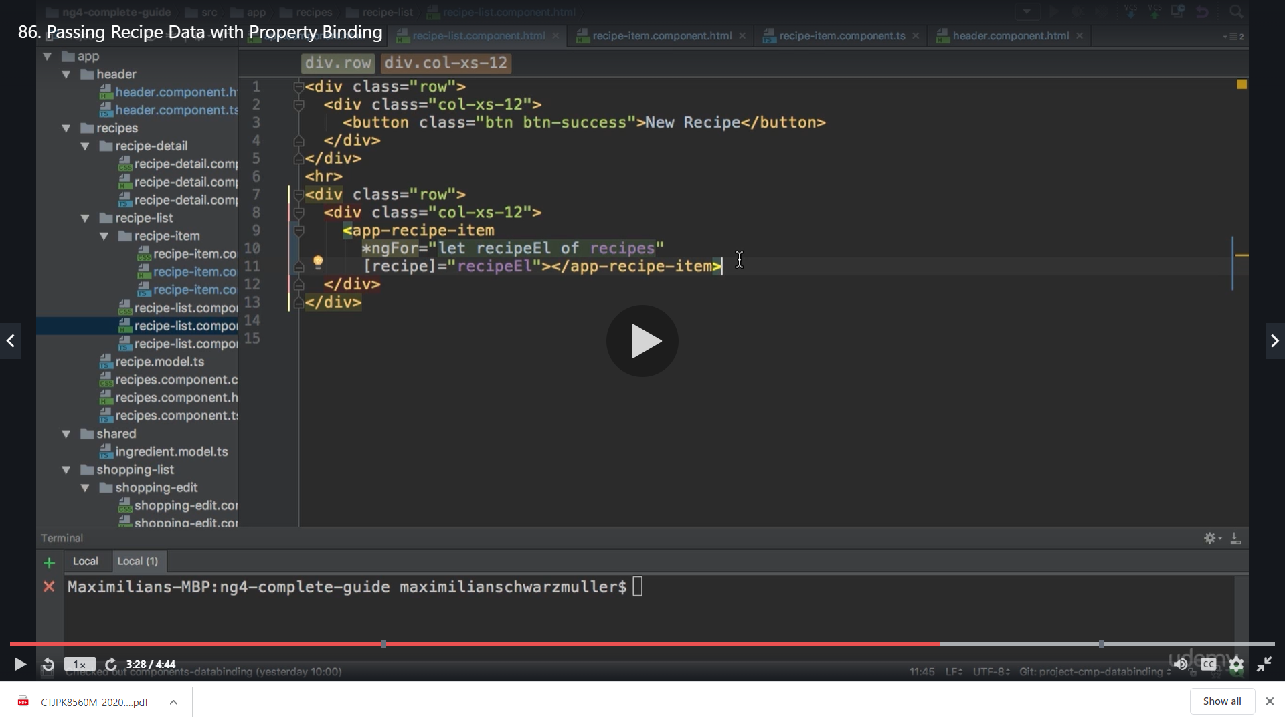

[recipe] is the property in our component

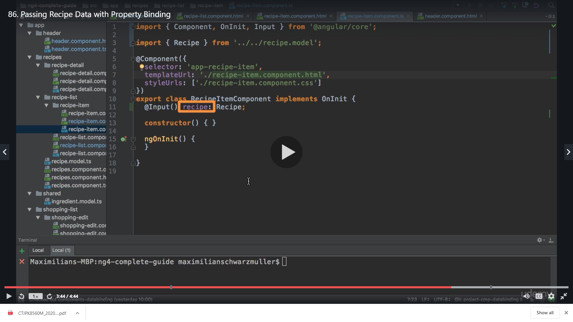

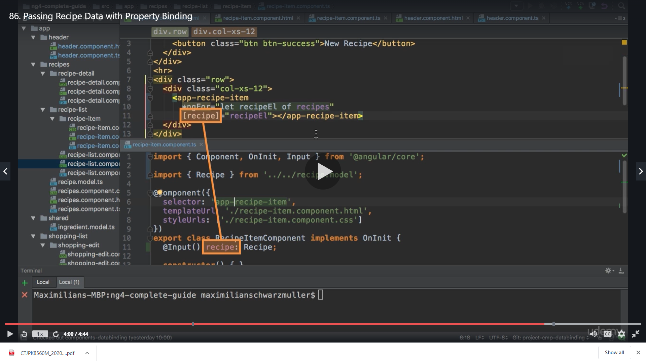

The date we have is from

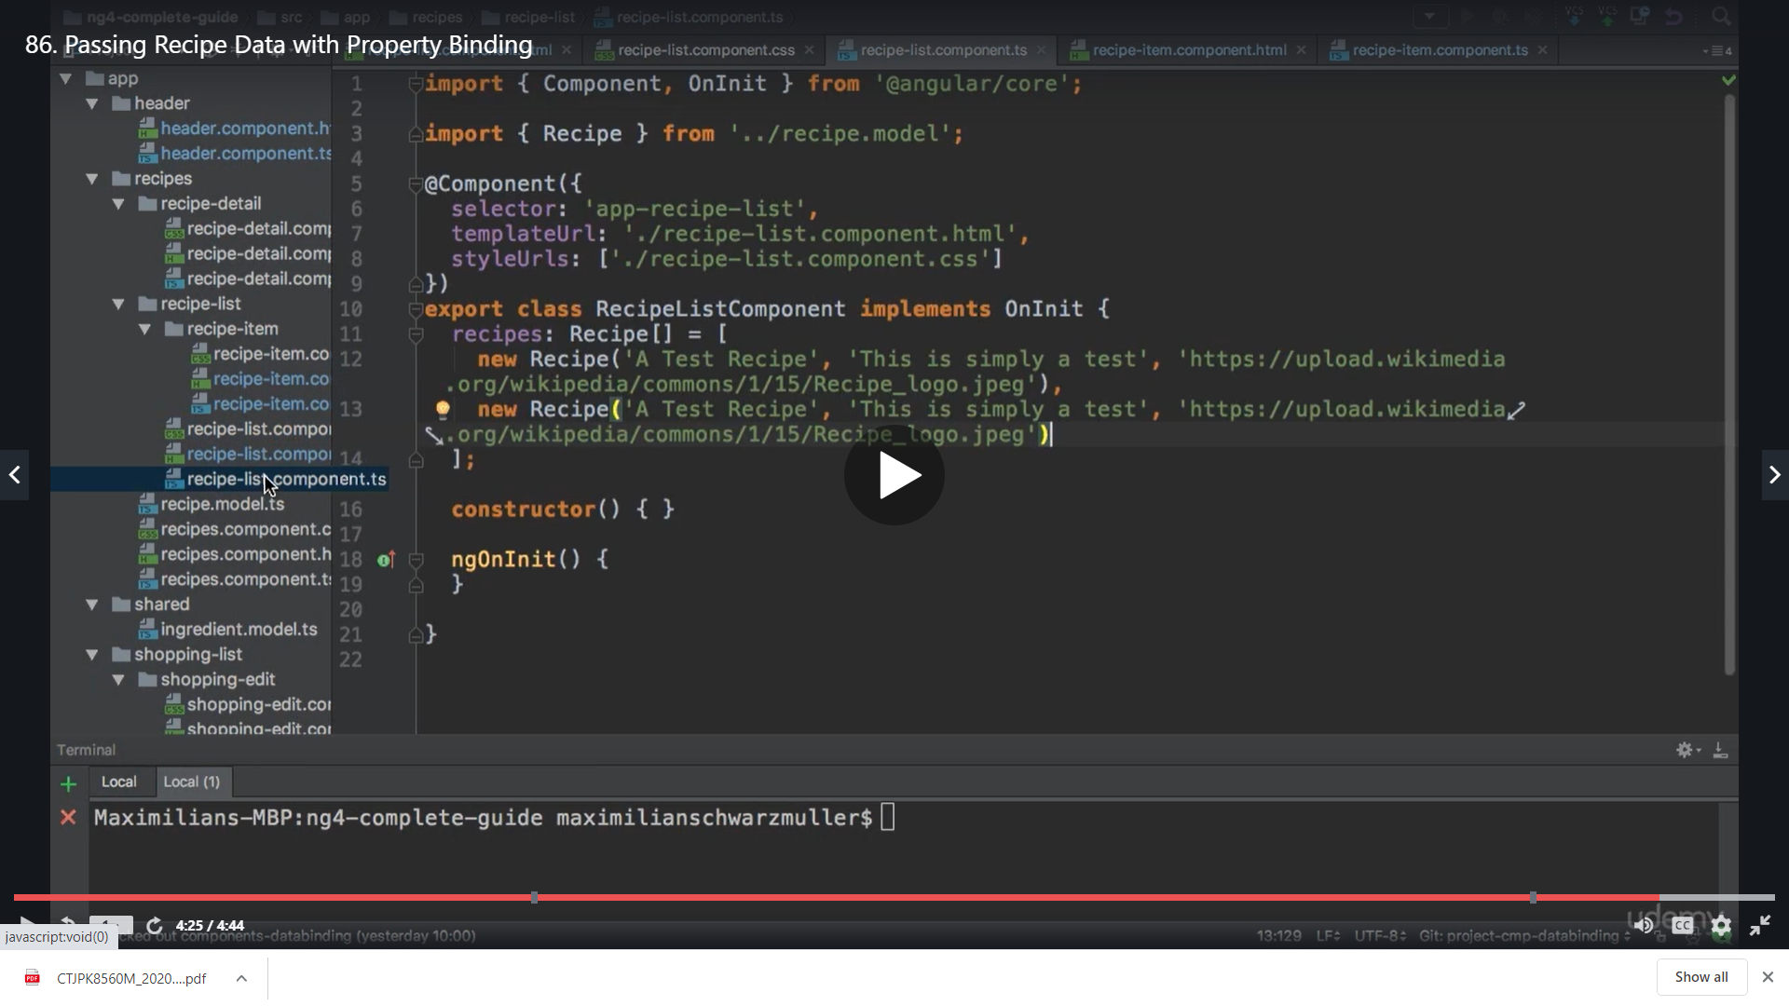

We are passing it to

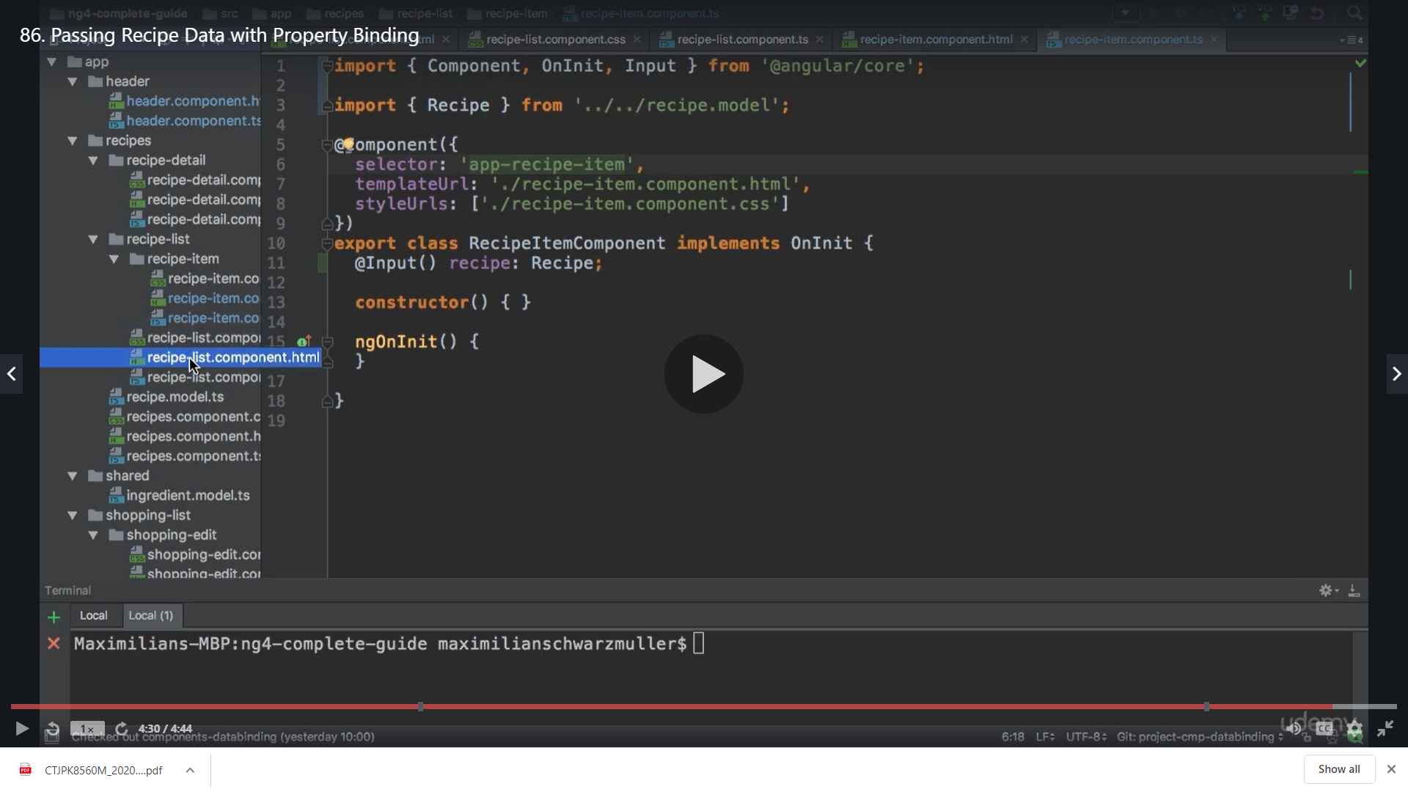

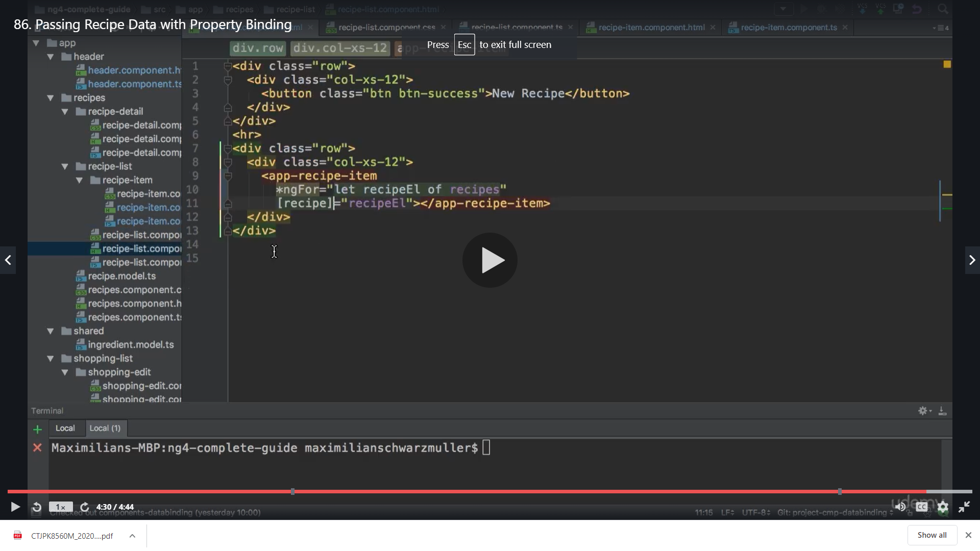

Result

It gives the same result like before but the difference is that we have the recipe splited in other component

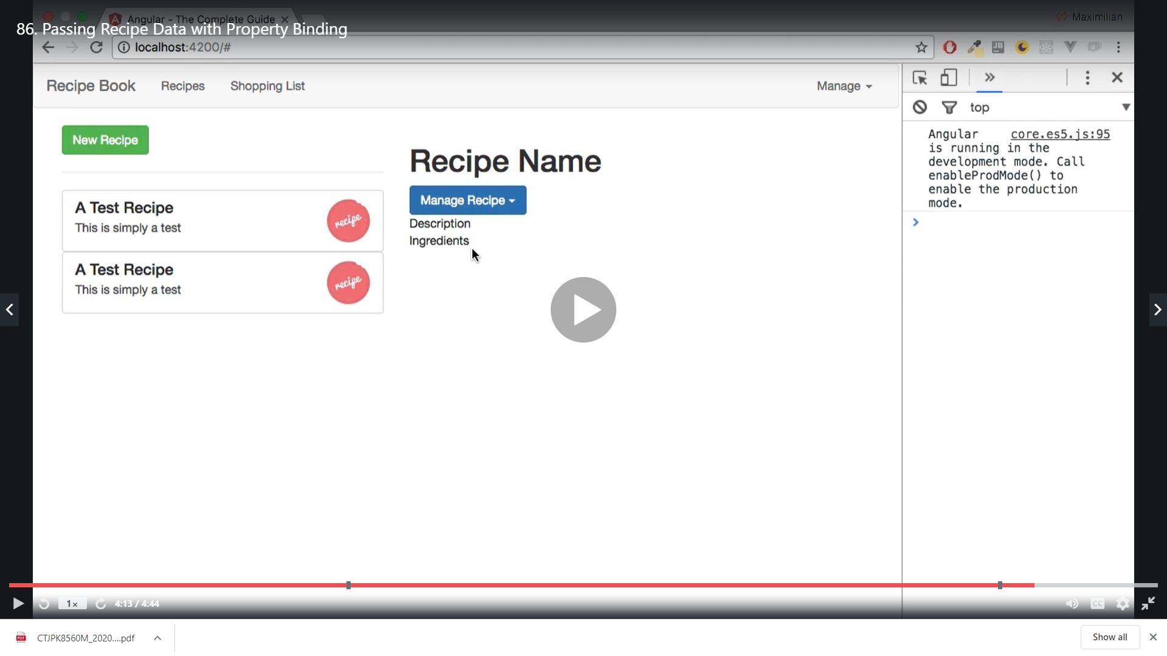

**Passing Data with event and property binding**

**When we click on individual recipe it should display in other component ie recipe details**

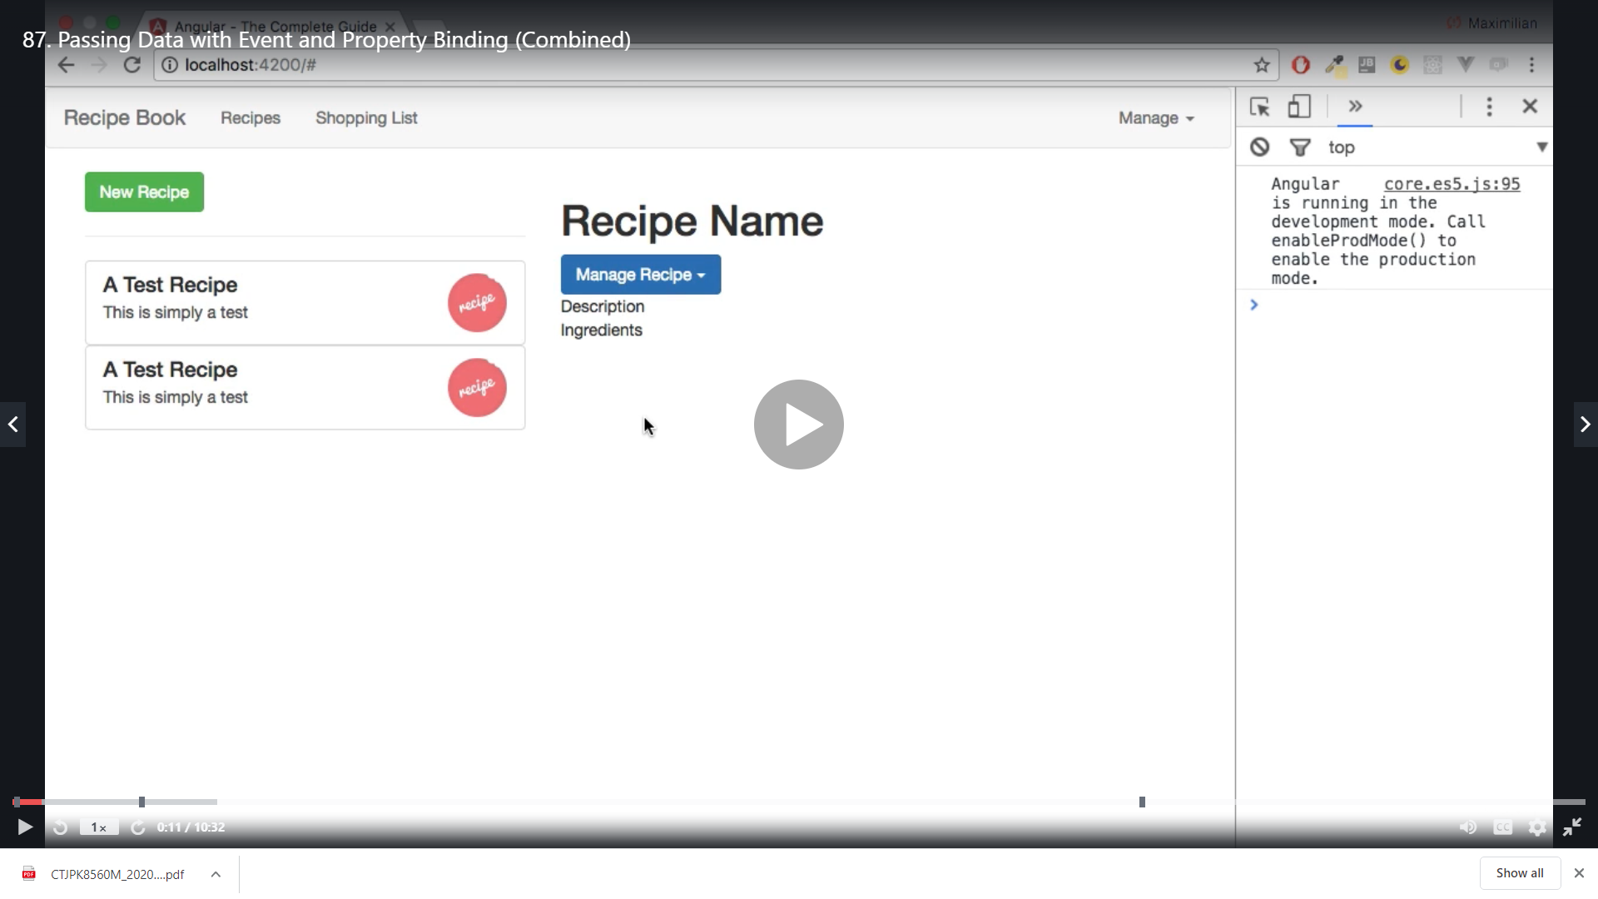

**First we will need to select a recipe and for that we need to create a click listener event on recipe items**

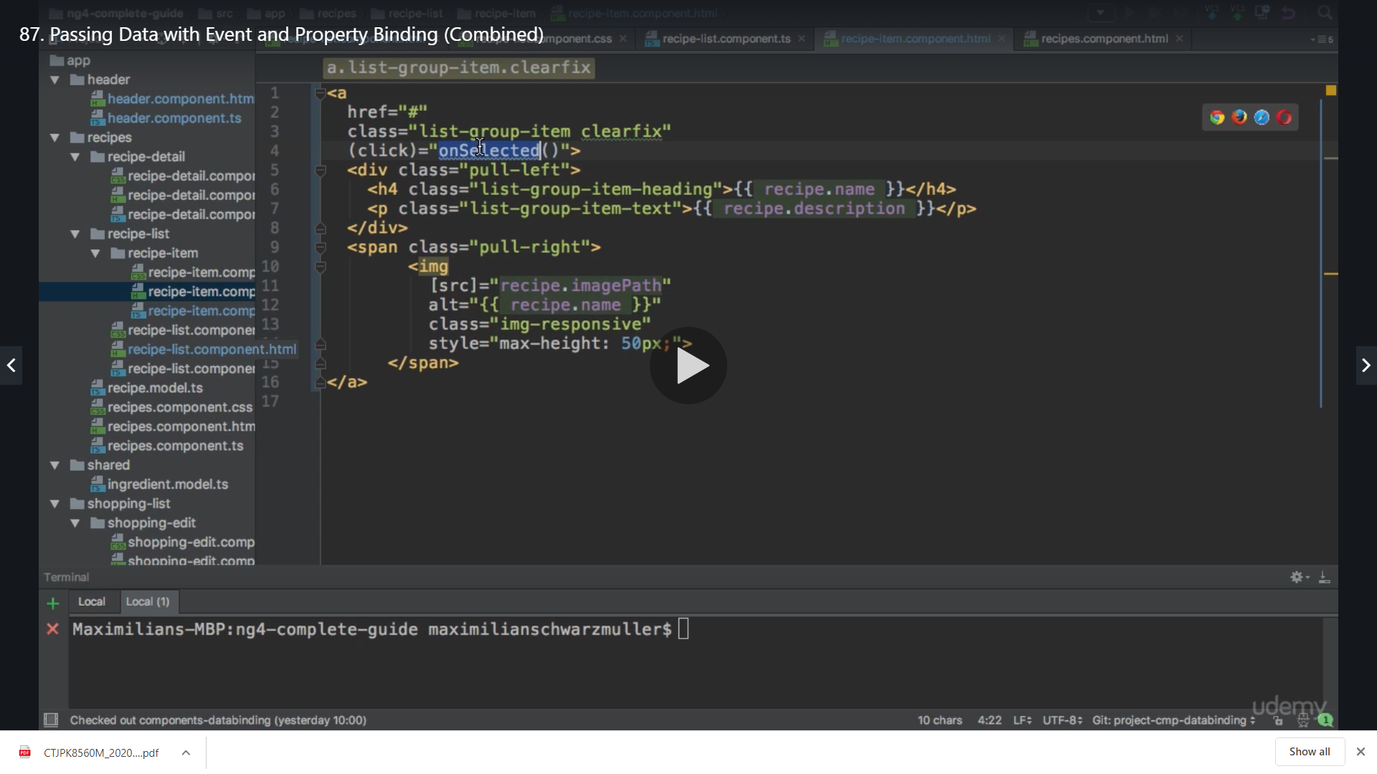

**We implement the method in ts**

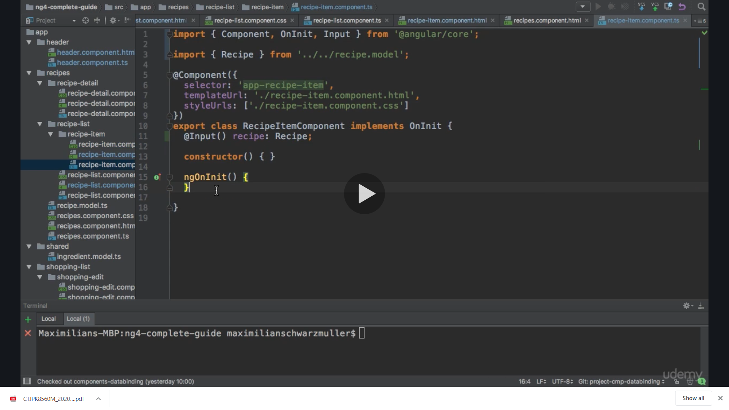

**Now we need to emit our event**

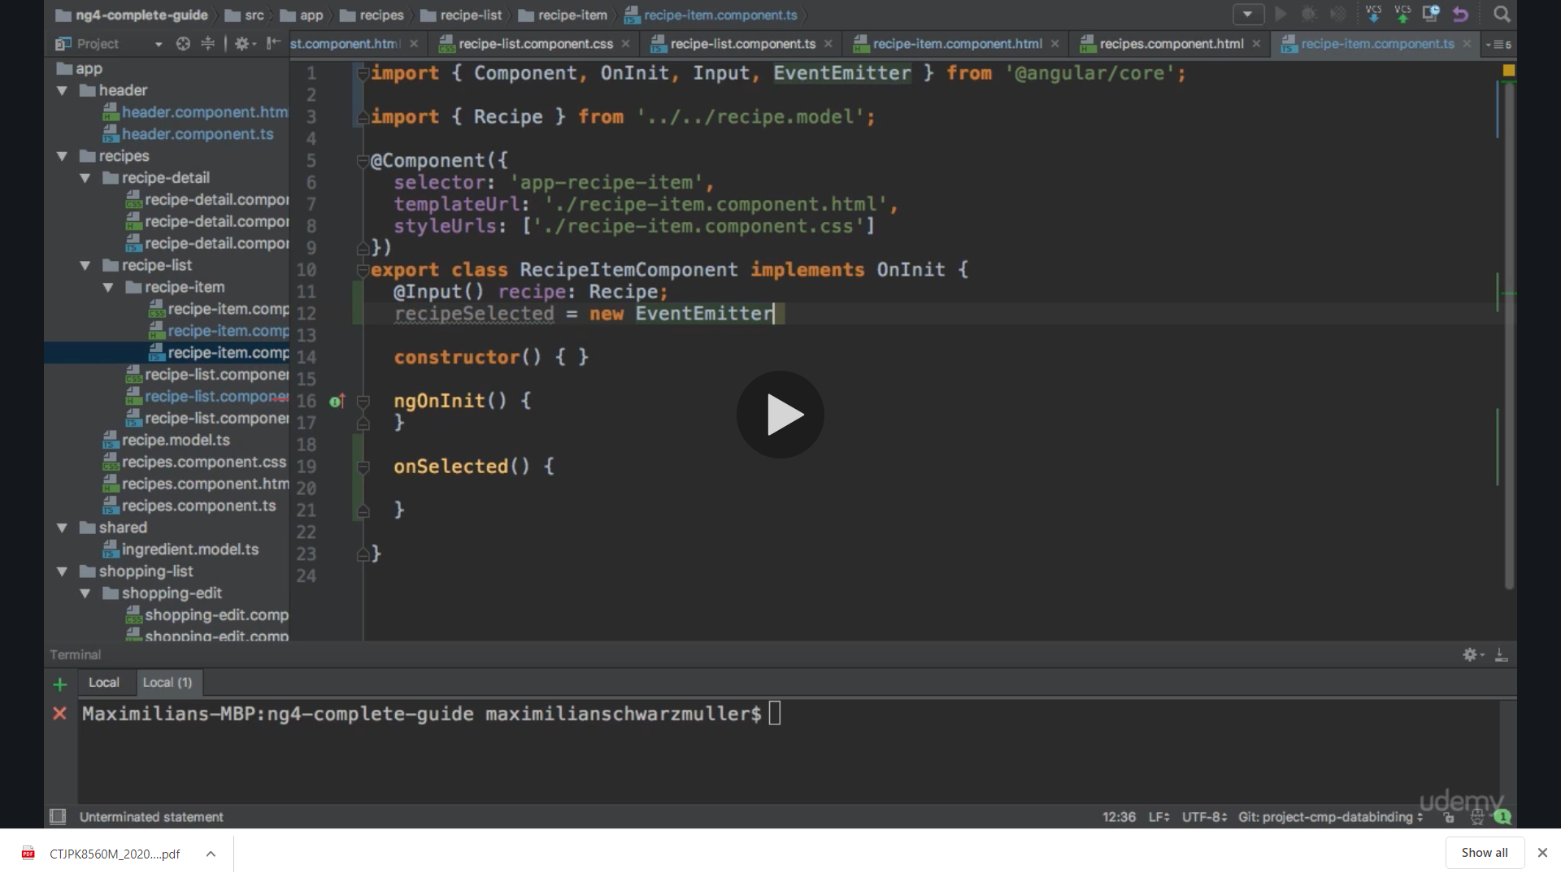

**The event emitter will not pass any information so we set it to void here**

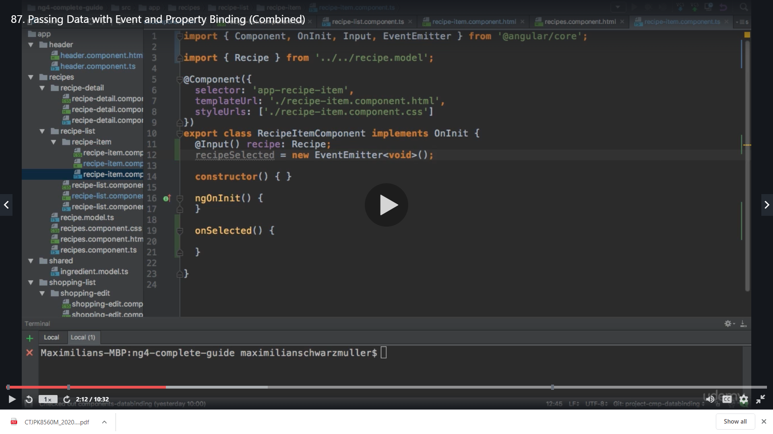

**We add @output() so that we can listen to this event from outside**

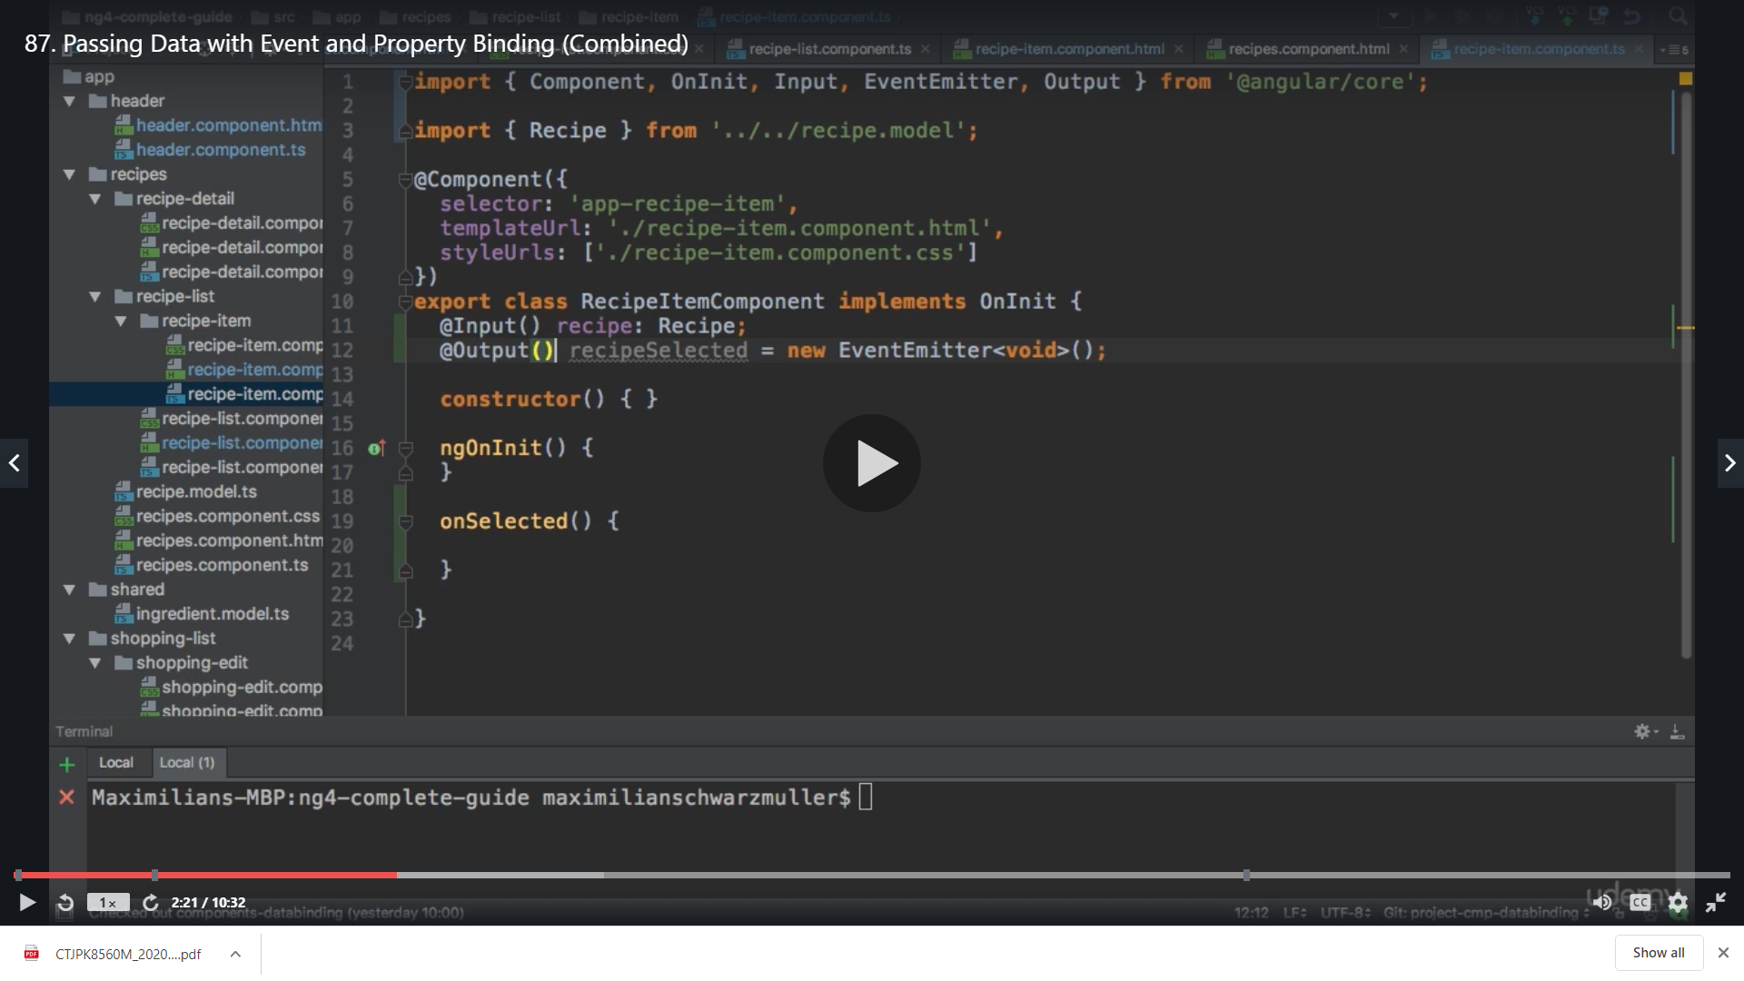

**And we emit in the method**

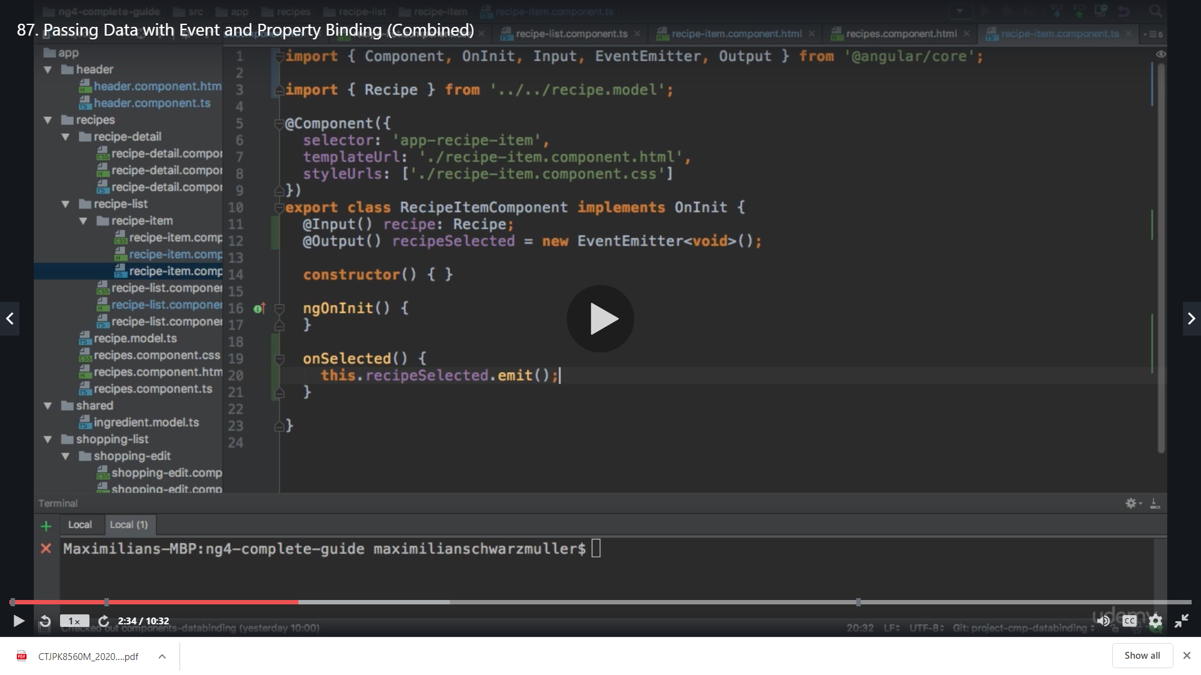

**We do not pass anything because on the recipe selector its already having [recipe]so we use void**

**Now in our recipe list component on recipe-item selector**

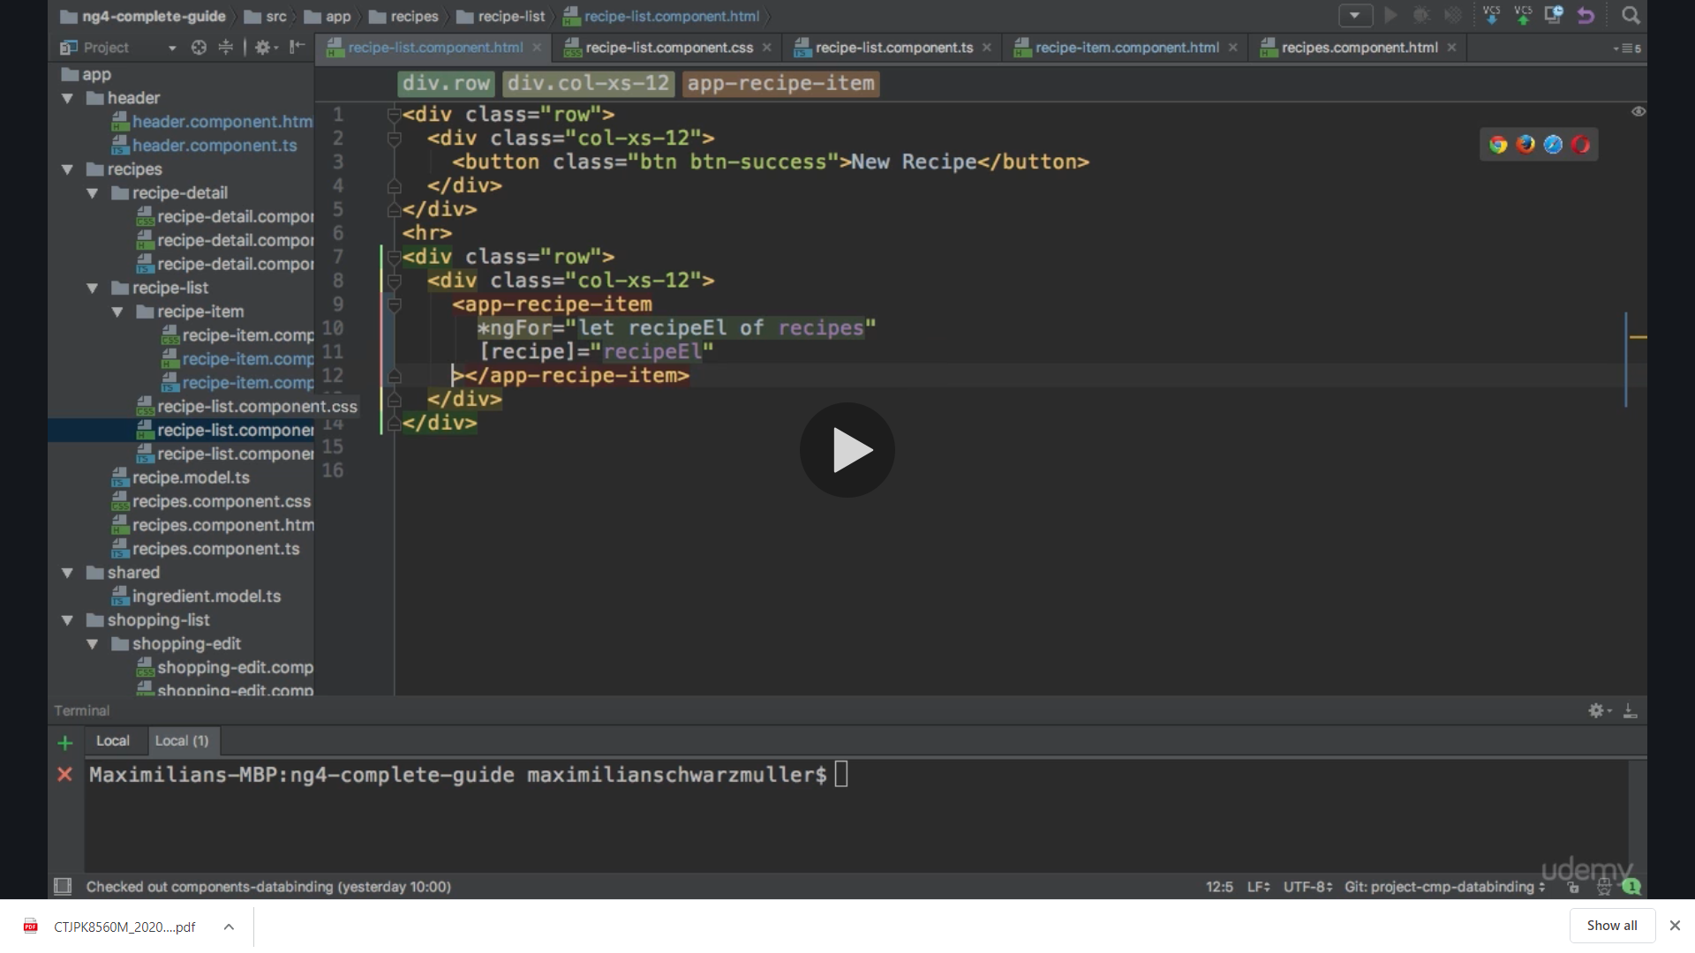

**We will implement our own event here that we created**

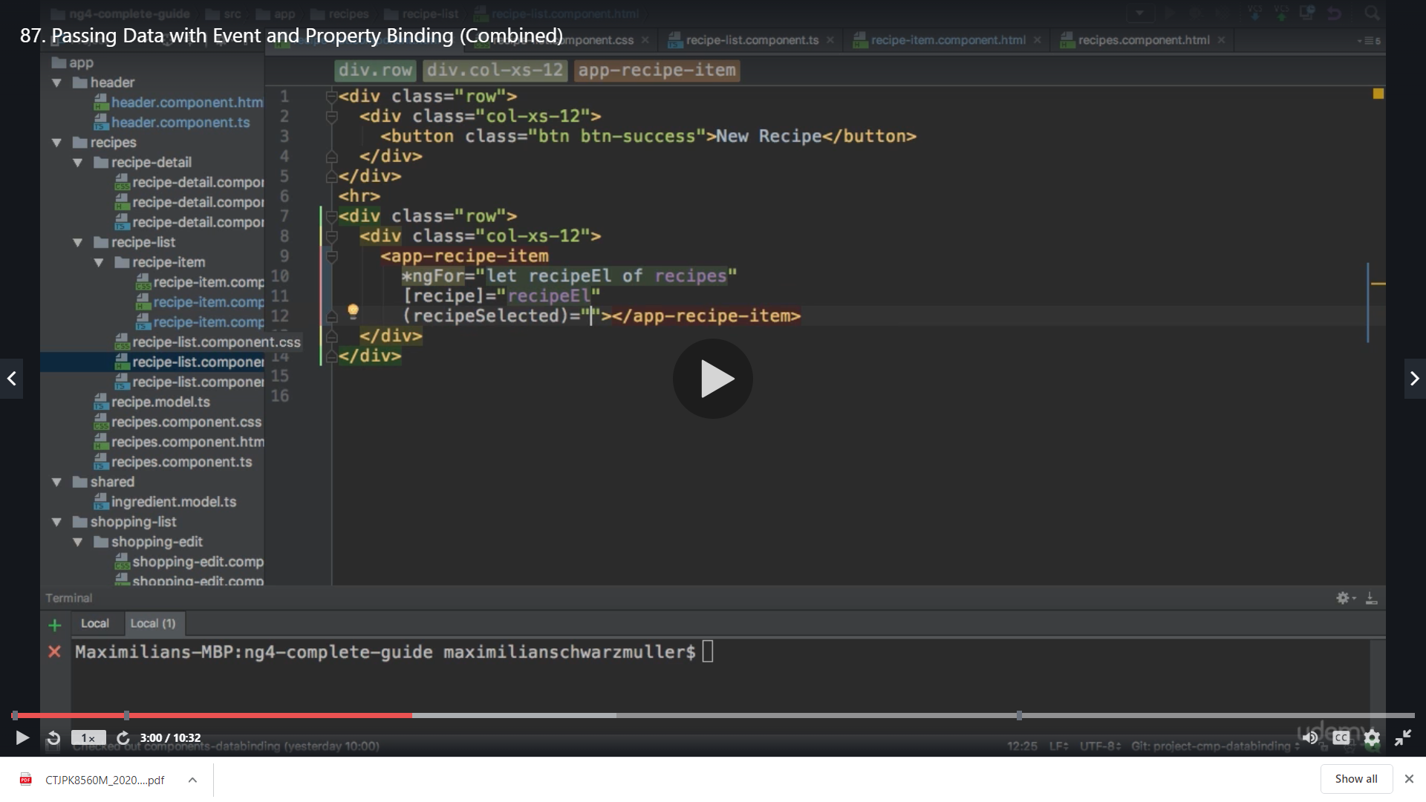

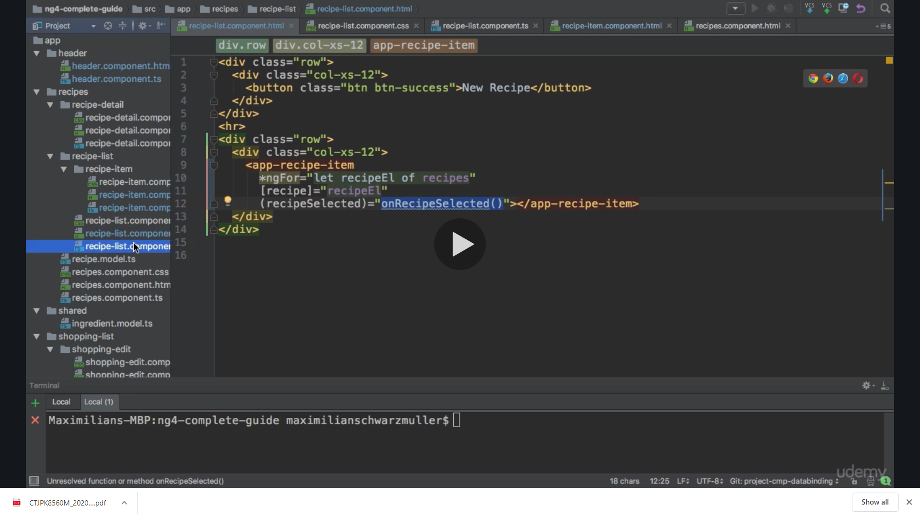

**We implement the method in ts**

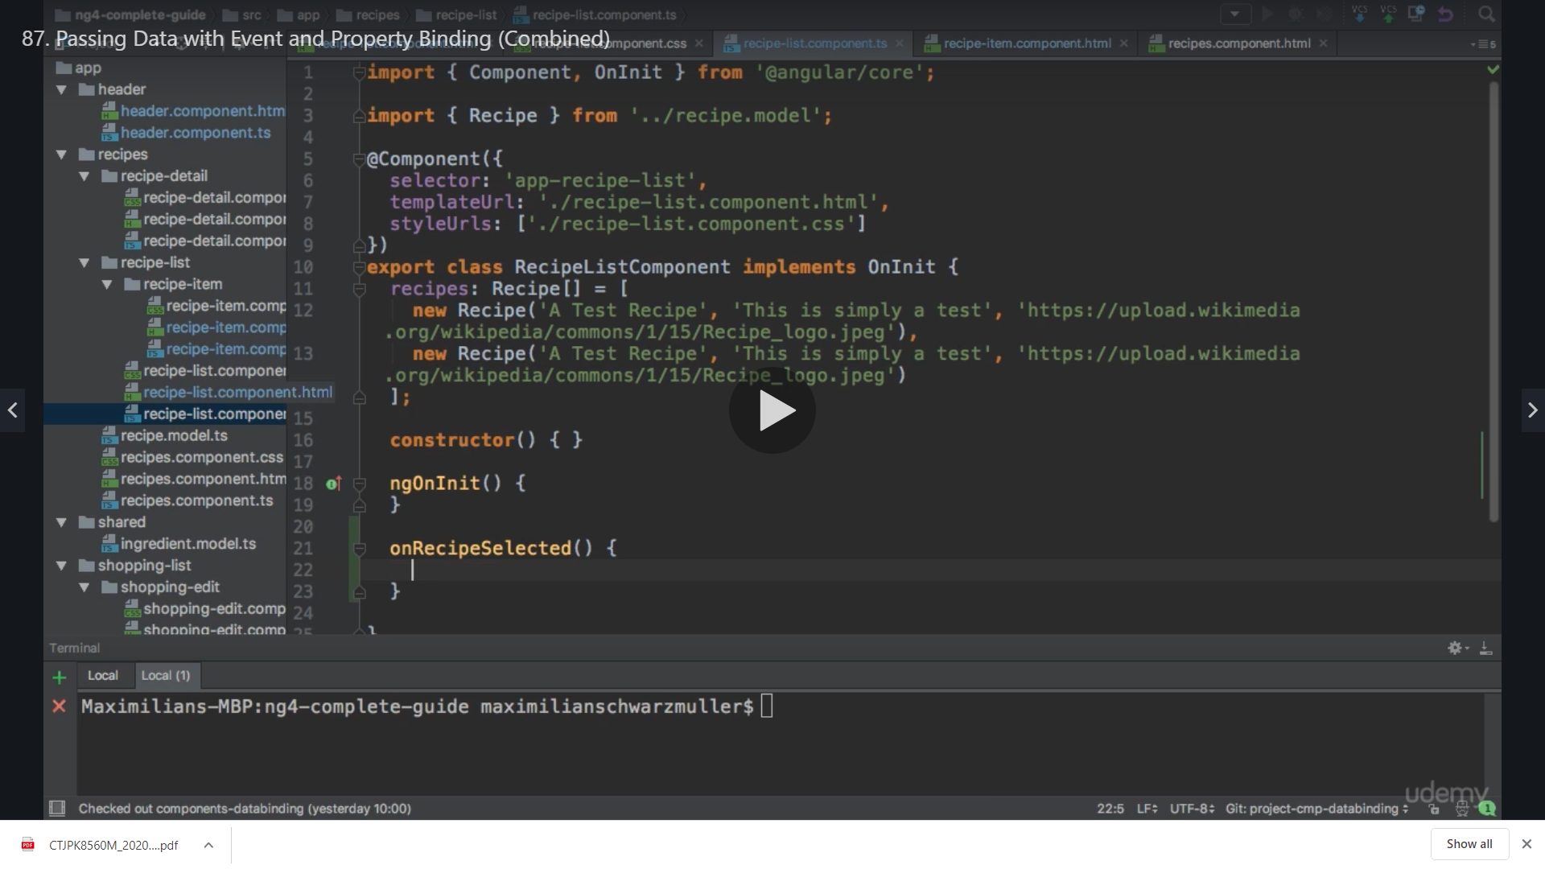

**Here we need information for this method which recipe was selected**

**So on HTML we pass the recipeEL here which is the variable of our for loop which will have the detail of our recipe we selected**

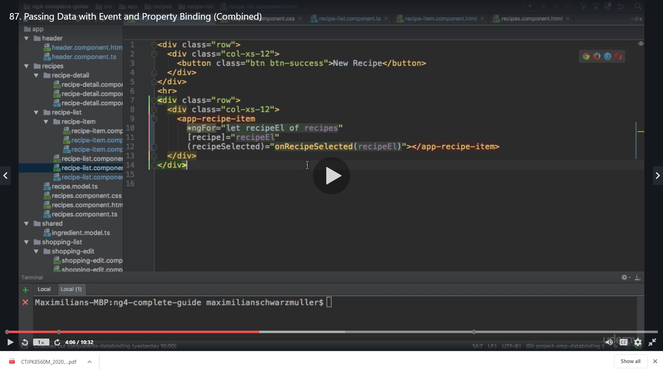

**Now in our ts we are already implementing the Recipe model so we can use it**

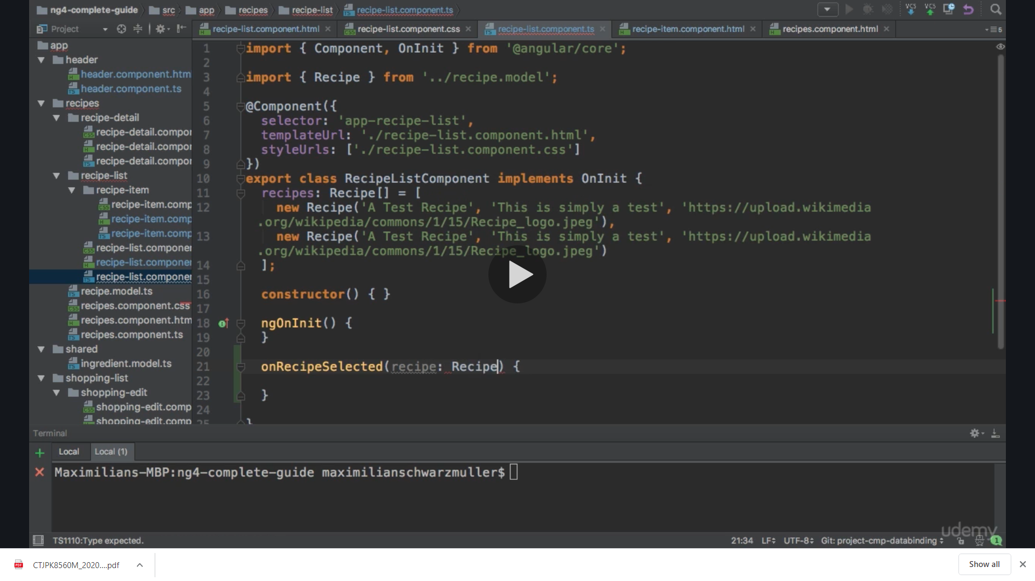

**Now we again create an event here with name recipeWasSelected and its type as Recipe because we want to send this data upwards to the main component ie recipe component**

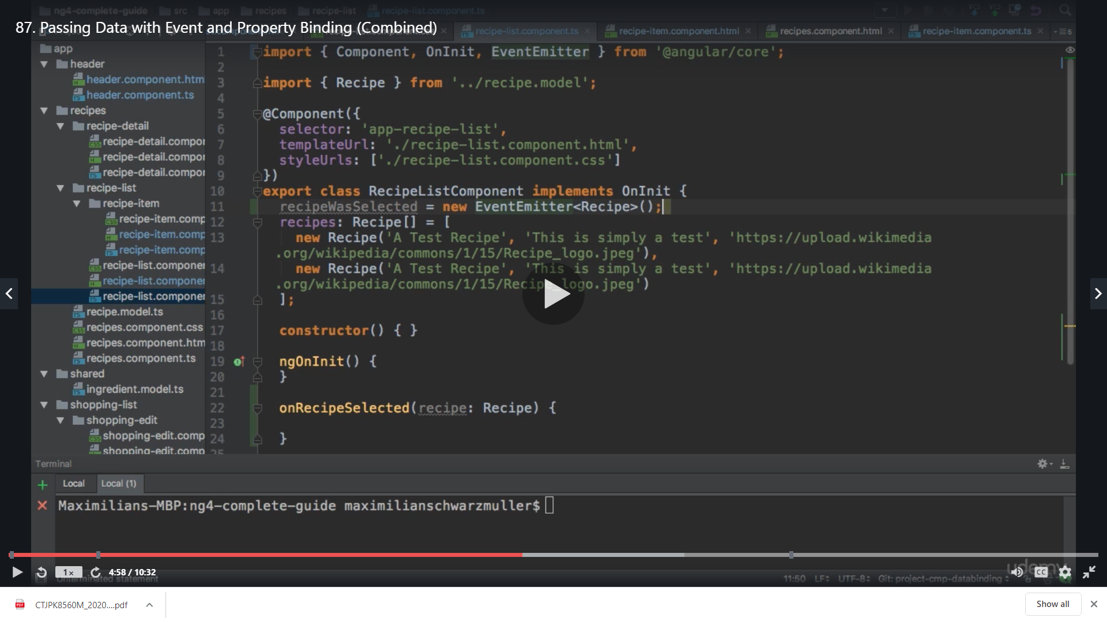

**We add @Output () so that we can listen to this event from outside**

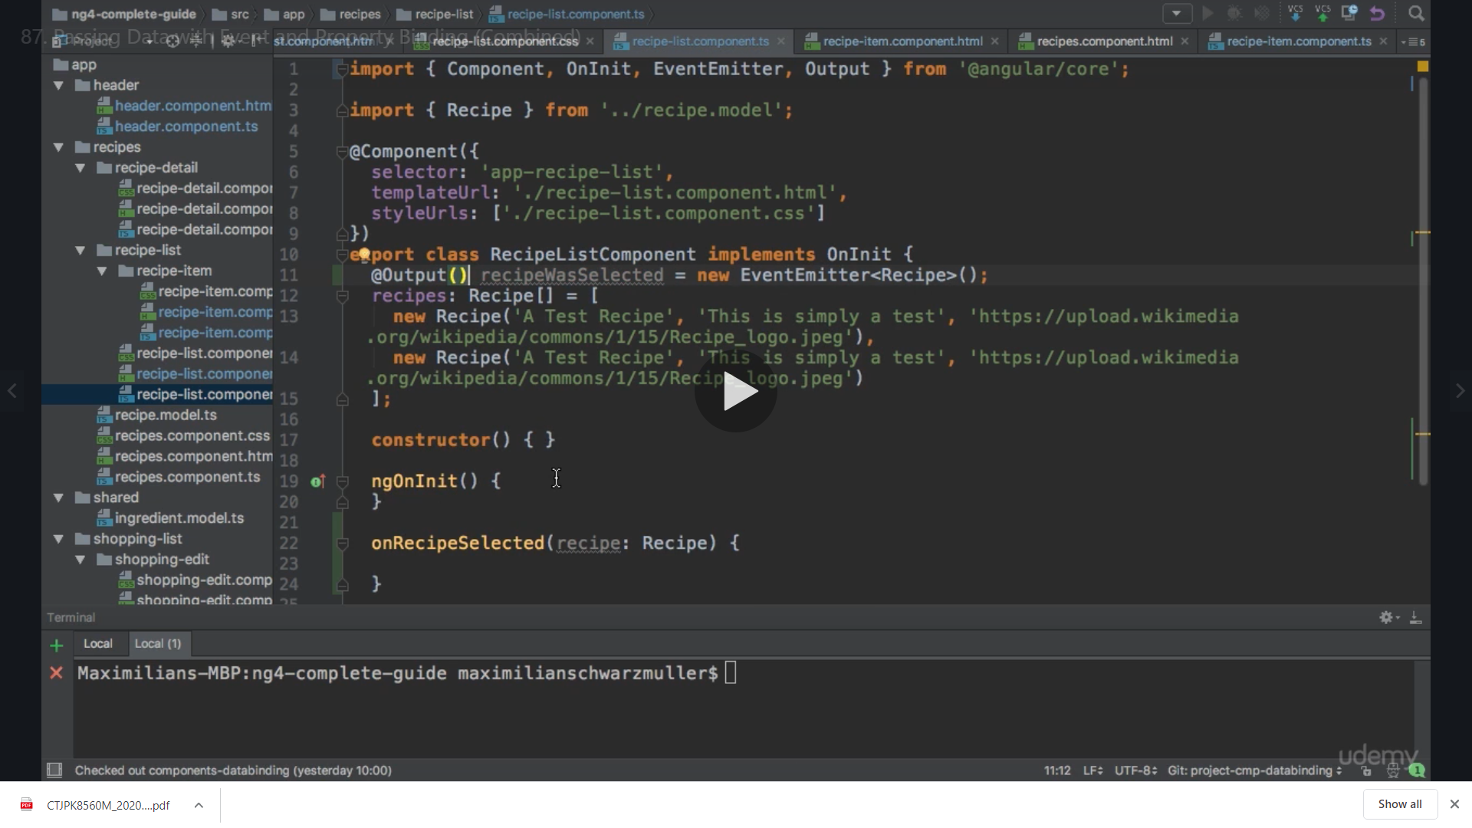

**Now we implement our method and pass recipe as data**

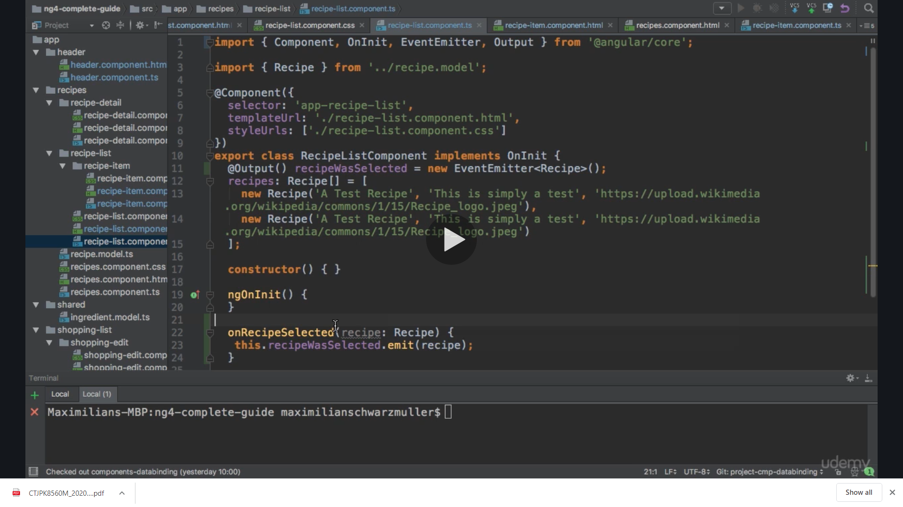

**Now we come to our main component ie recipe component**

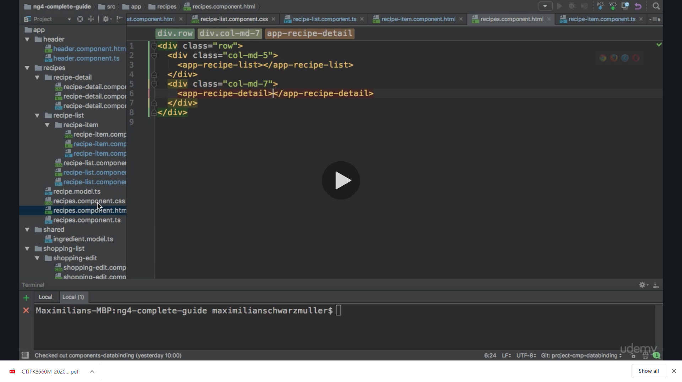 **On recipe list selector we listen to the event we created**

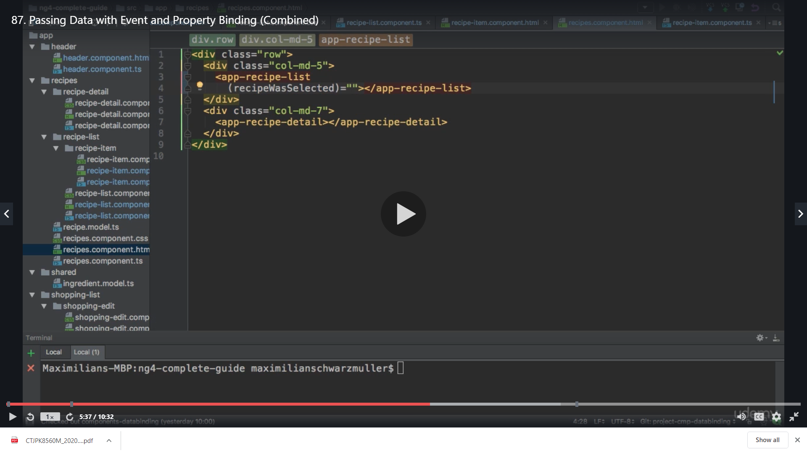

**Now here we want to store the selected recipe so in our ts**

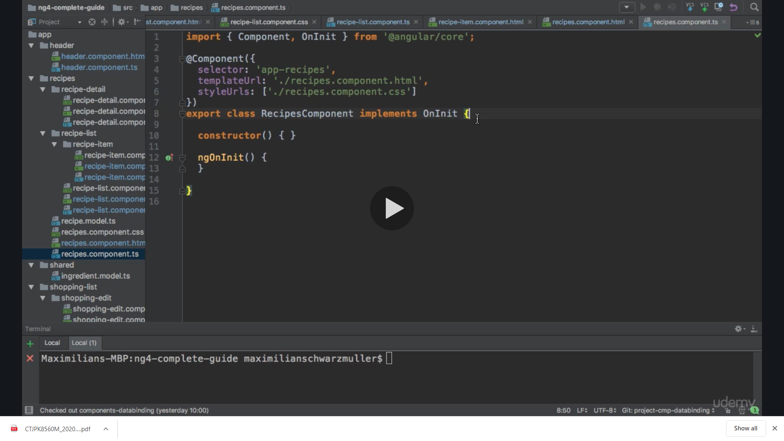

**We create a property selectedRecipe property which will be of type Recipe and initially it is undefined because we are not assigning any value**

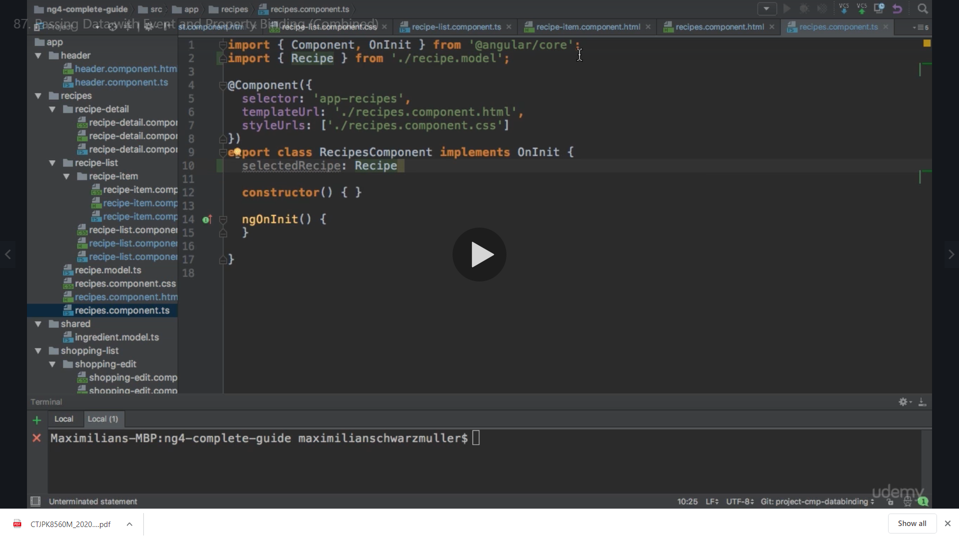

**So now to assign value to it we assign event to it**

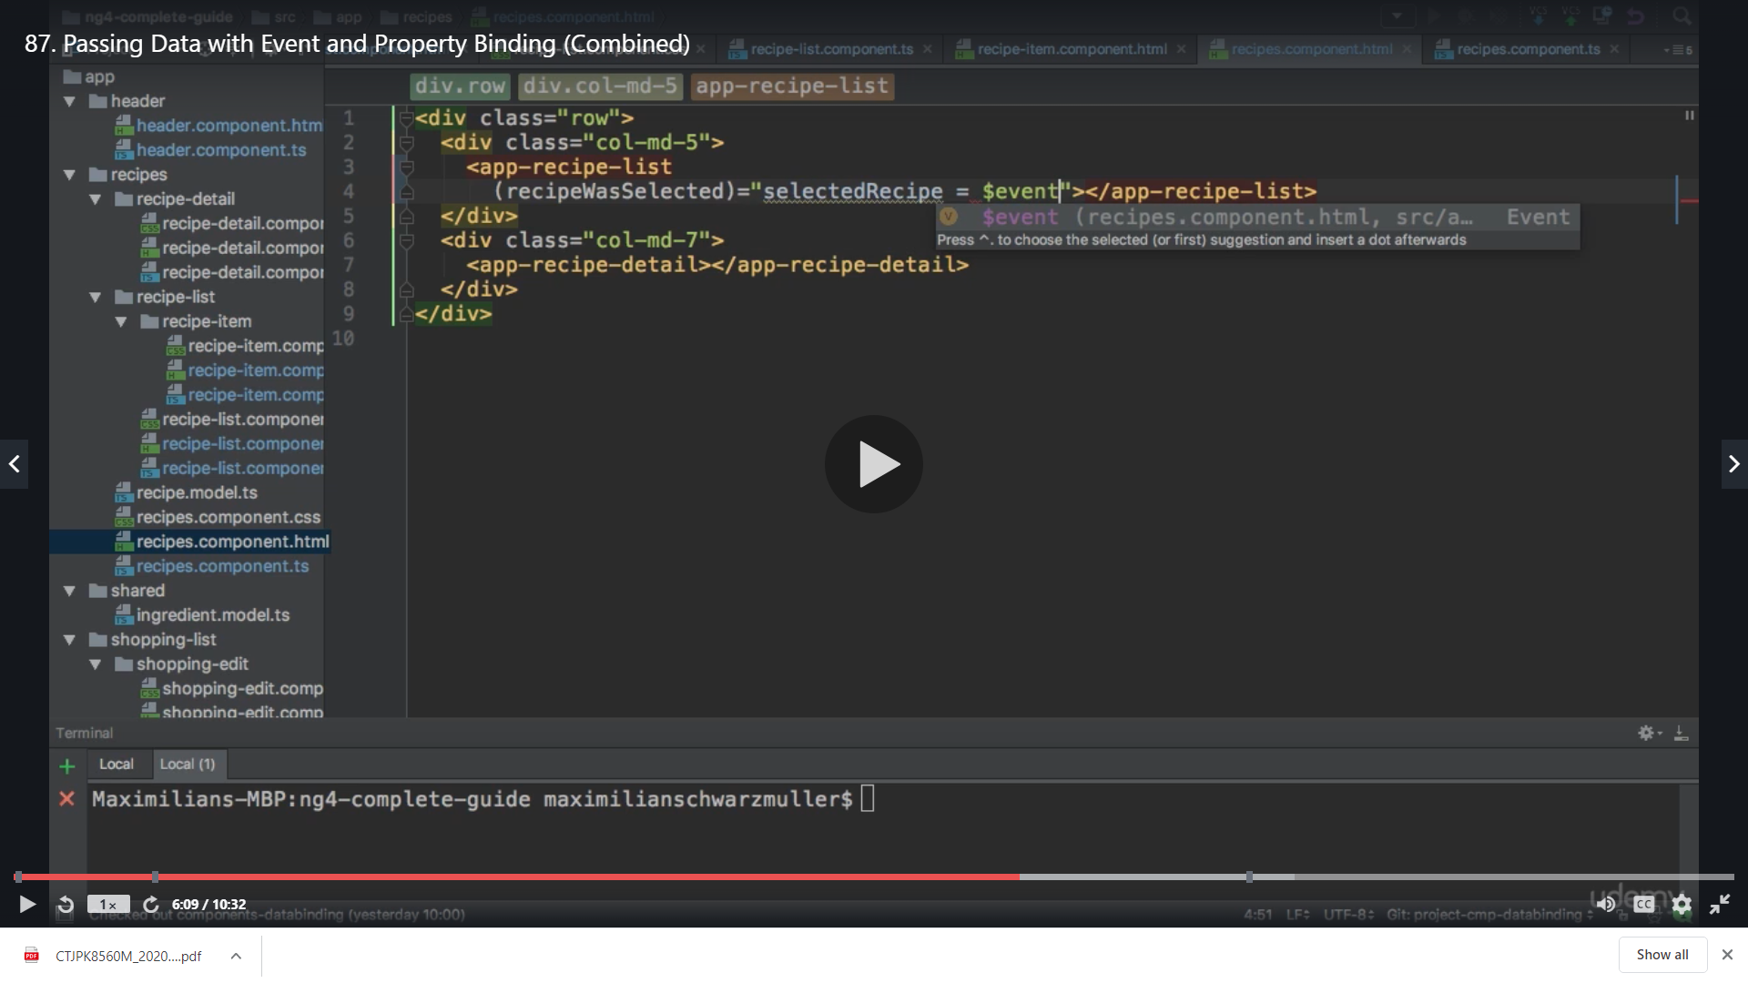

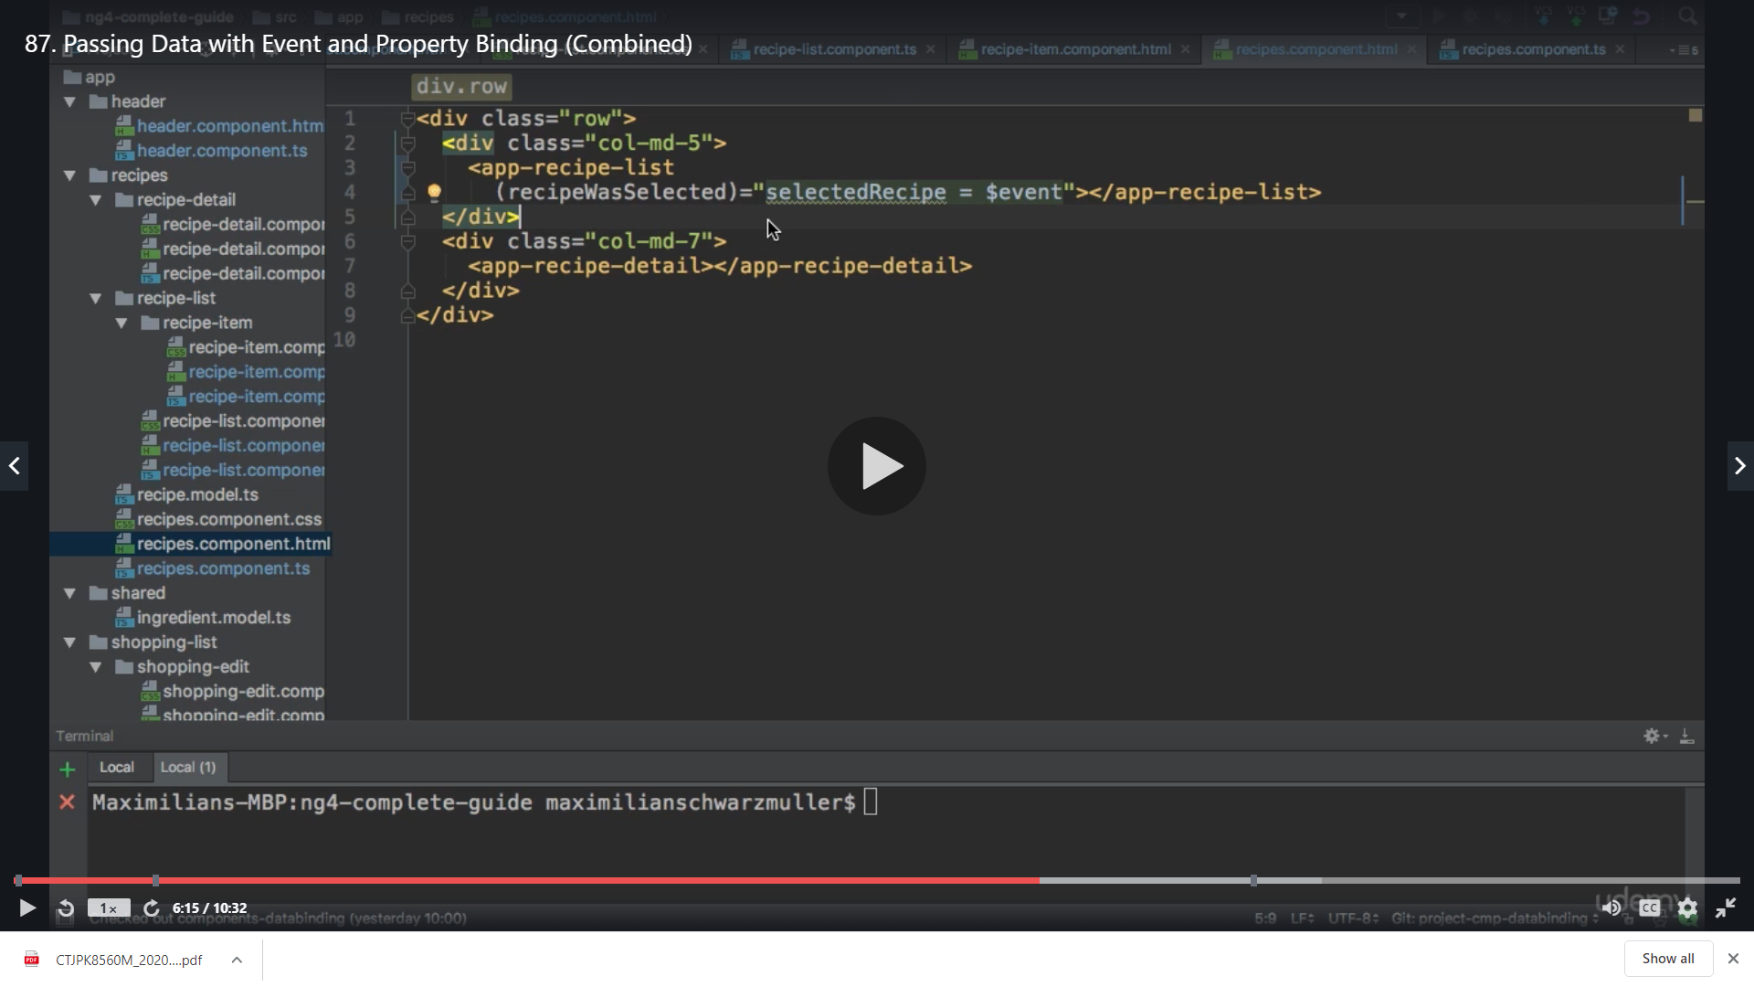

**Now we can pass this recipe list information to the recipe detail component and for that we first add *ngIf to the selectore that we have**

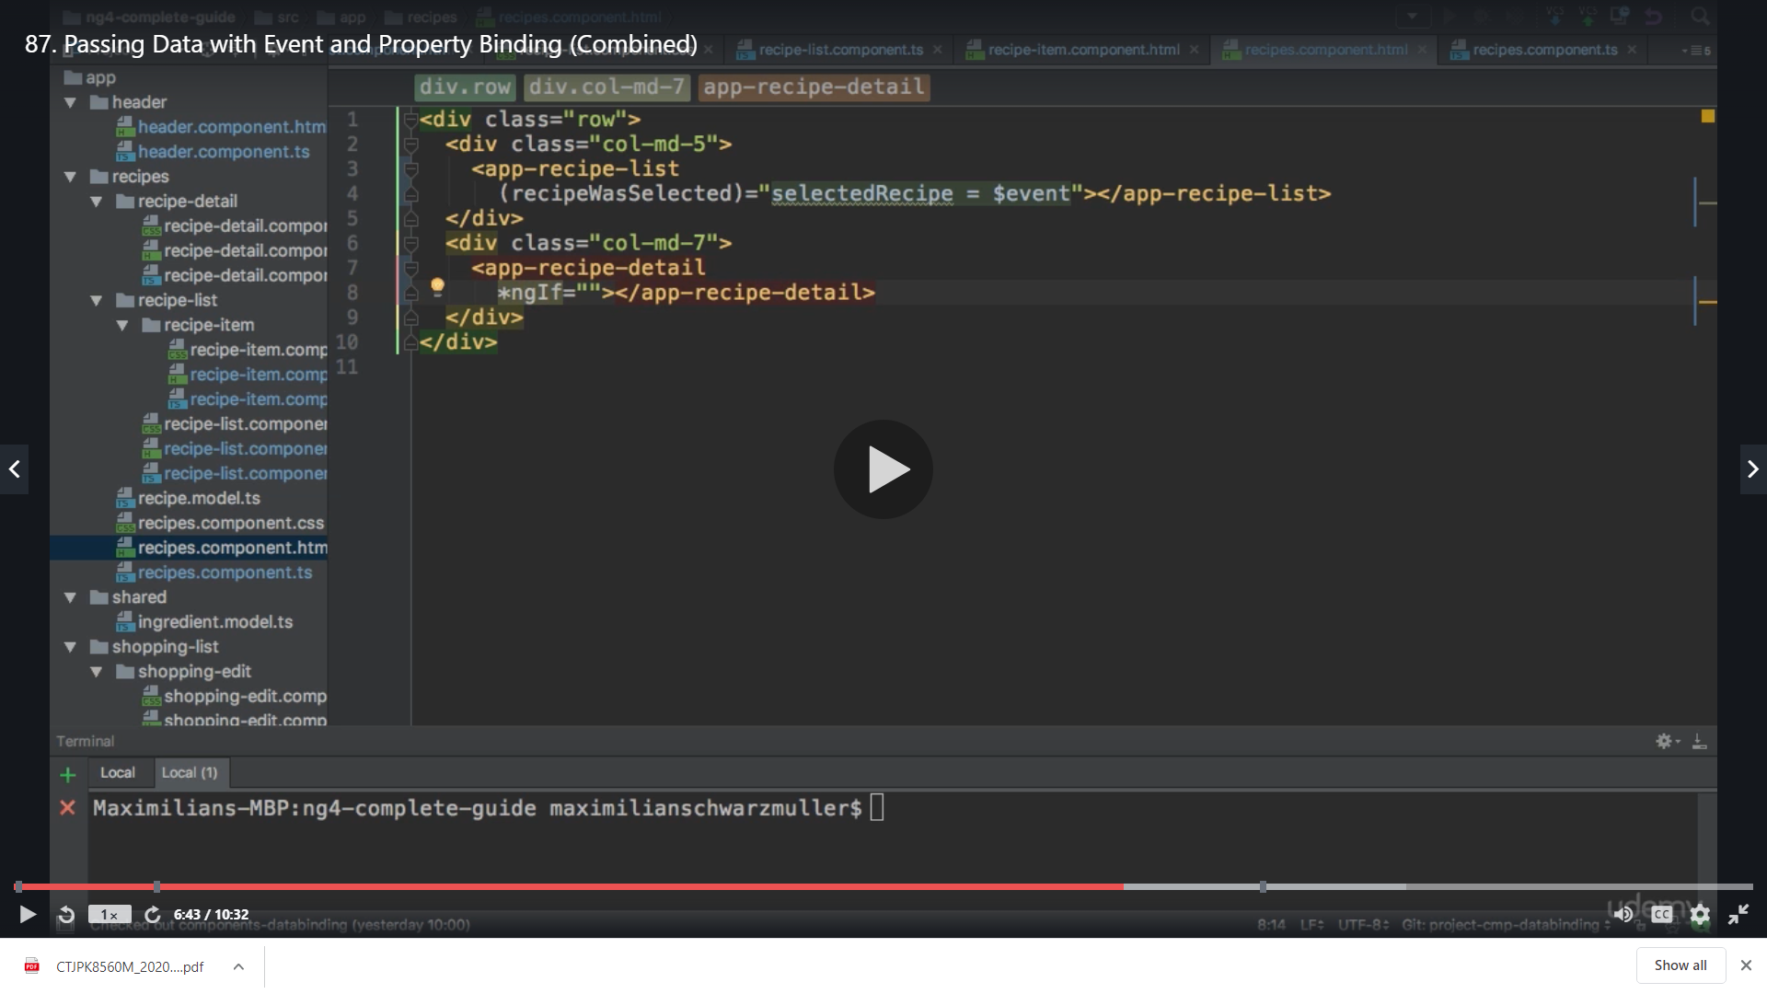

**Here we only want to display if the selected recipe is set**

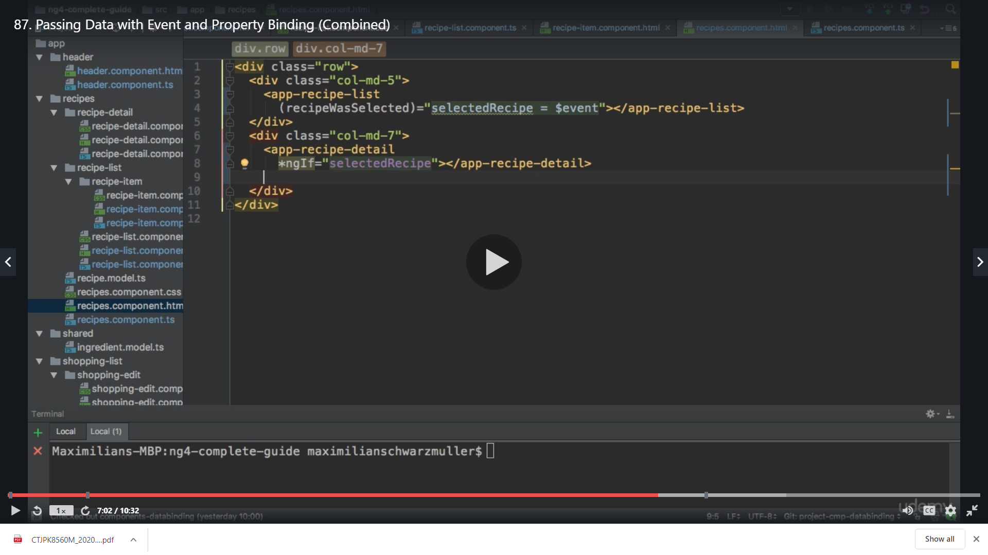

**And if it is not set then we use <ng-template>**

Like the name indicates, the ng-template directive represents an Angular template: this means that the content of this tag will contain part of a template, that can be then be composed together with other templates in order to form the final component template.

Angular is already using ng-template under the hood in many of the structural directives that we use all the time: ngIf, ngFor and ngSwitch.

**The ng-container directive**

In order to avoid having to create that extra div, we can instead use ng-container directive:

|  |  |
| --- | --- |
|  |  |
|  | <ng-container *ngIf="lessons"> |
|  | <div class="lesson" *ngFor="let lesson of lessons"> |
|  | <div class="lesson-detail"> |
|  | {{lesson | json}} |
|  | </div> |
|  | </div> |
|  | </ng-container> |

[**view raw**](https://gist.github.com/jhades/0f1abb3c55cf772043ed26d9c6a50a8a/raw/f798393fc73451110615a9ea3e9dc294c609b234/06.ts)[**06.ts**](https://gist.github.com/jhades/0f1abb3c55cf772043ed26d9c6a50a8a#file-06-ts) hosted with ❤ by [**GitHub**](https://github.com/)

As we can see, the ng-container directive provides us with an element that we can attach a structural directive to a section of the page, without having to create an extra element just for that.

There is another major use case for the ng-container directive: it can also provide a placeholder for injecting a template dynamically into the page.

**Dynamic Template Creation with the ngTemplateOutlet directive**

Being able to create template references and point them to other directives such as ngIf is just the beginning.

We can also take the template itself and instantiate it anywhere on the page, using the ngTemplateOutlet directive:

|  |  |
| --- | --- |
|  |  |
|  | <ng-container *ngTemplateOutlet="loading"></ng-container> |

**Back to our ng-template**

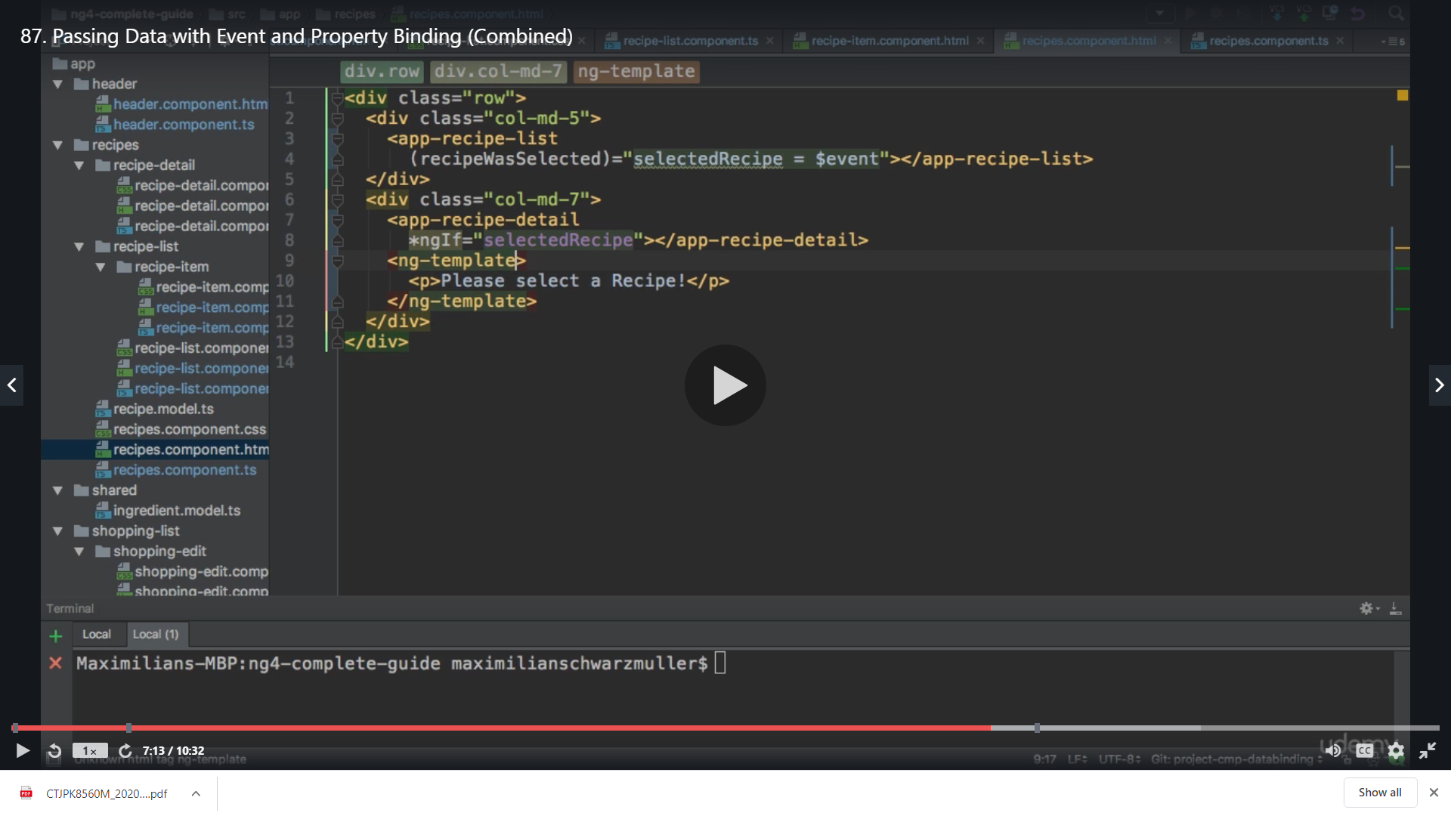

This <ng-template> will receive a local reference say #infoText

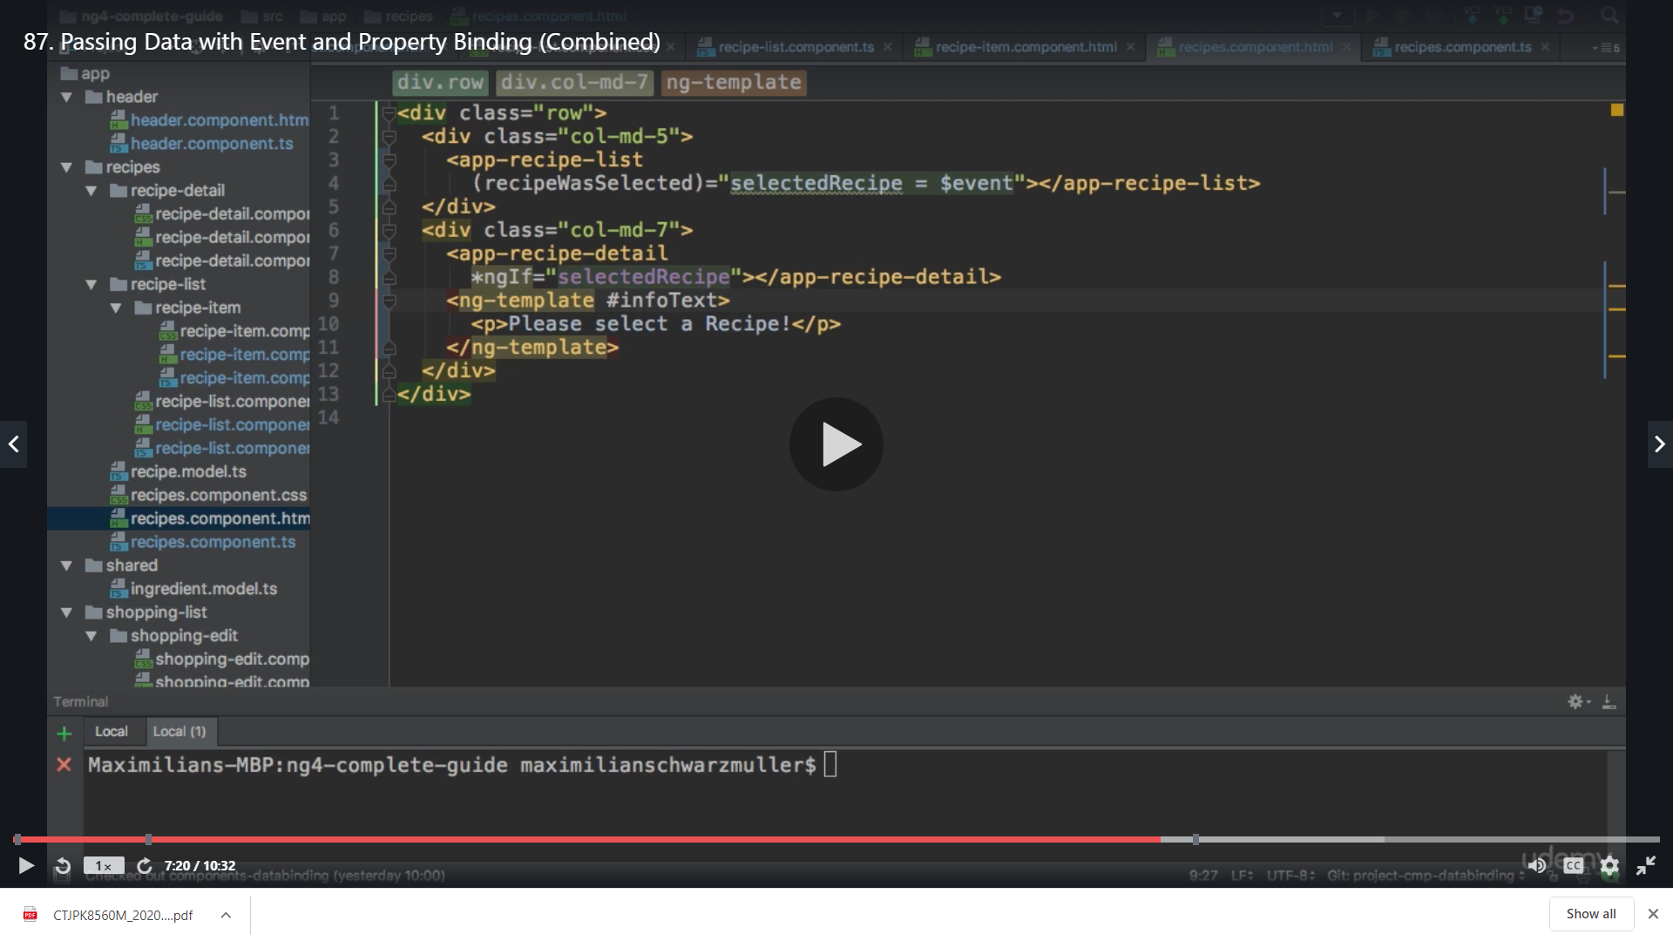

Now when we have the local reference we can use this ng-template as else

So our If condition now is

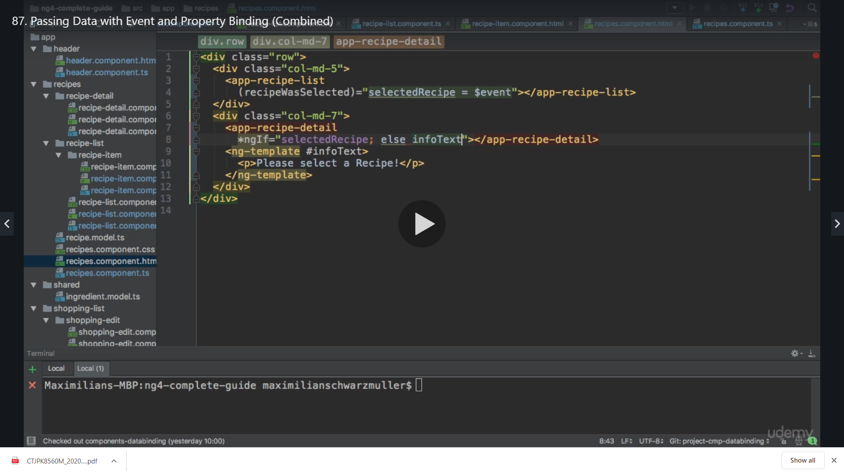

When we save this we see please select a recipe

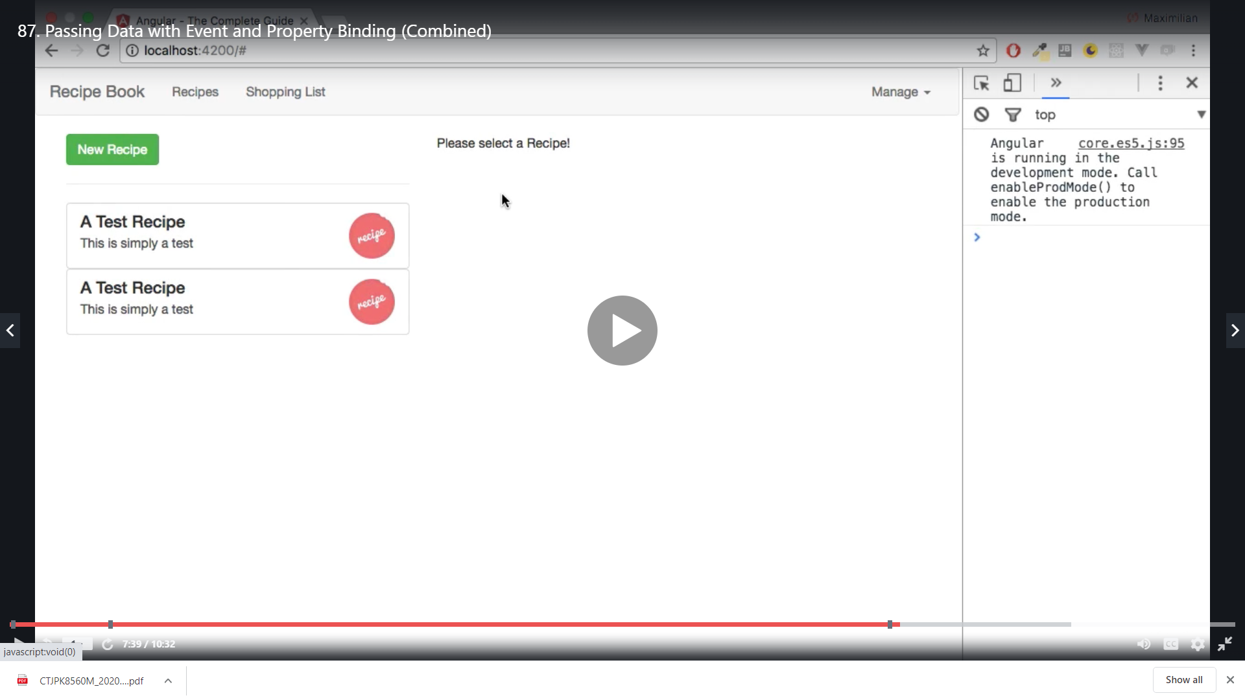

Now when we select a recipe we get

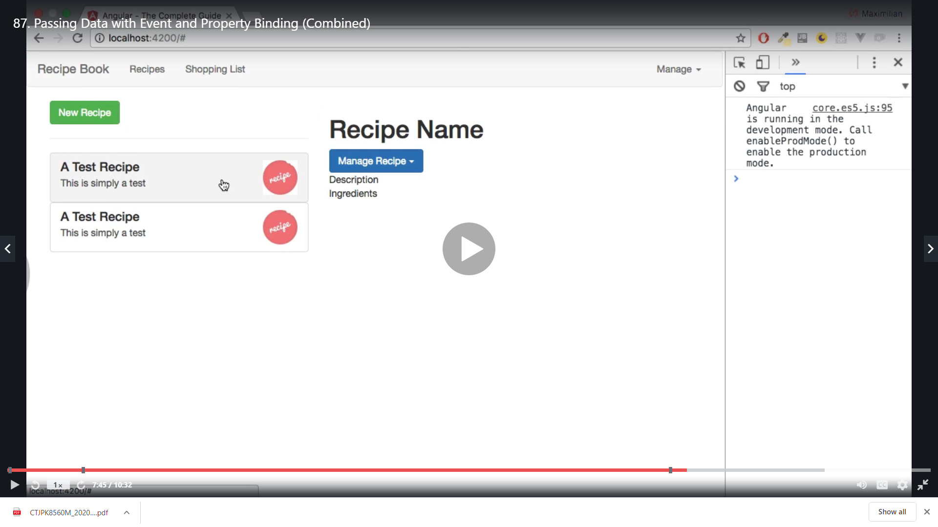

Here we re not getting the recipe data as we are not passing the data to the component but our ngIf check is working and our recipe event is working successfully

Now as final step we pass the recipe to the recipe detail component

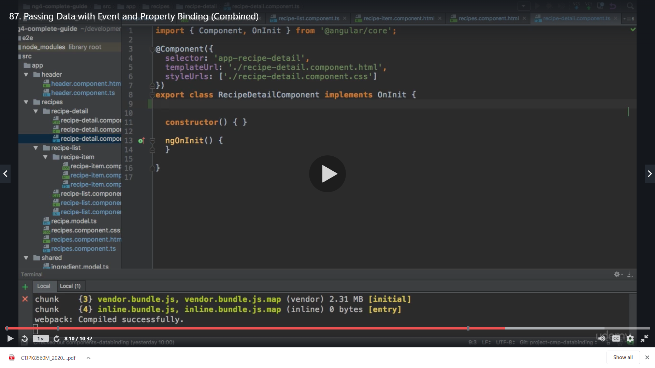

We again create a property of recipe and assign our Recipe Model to it

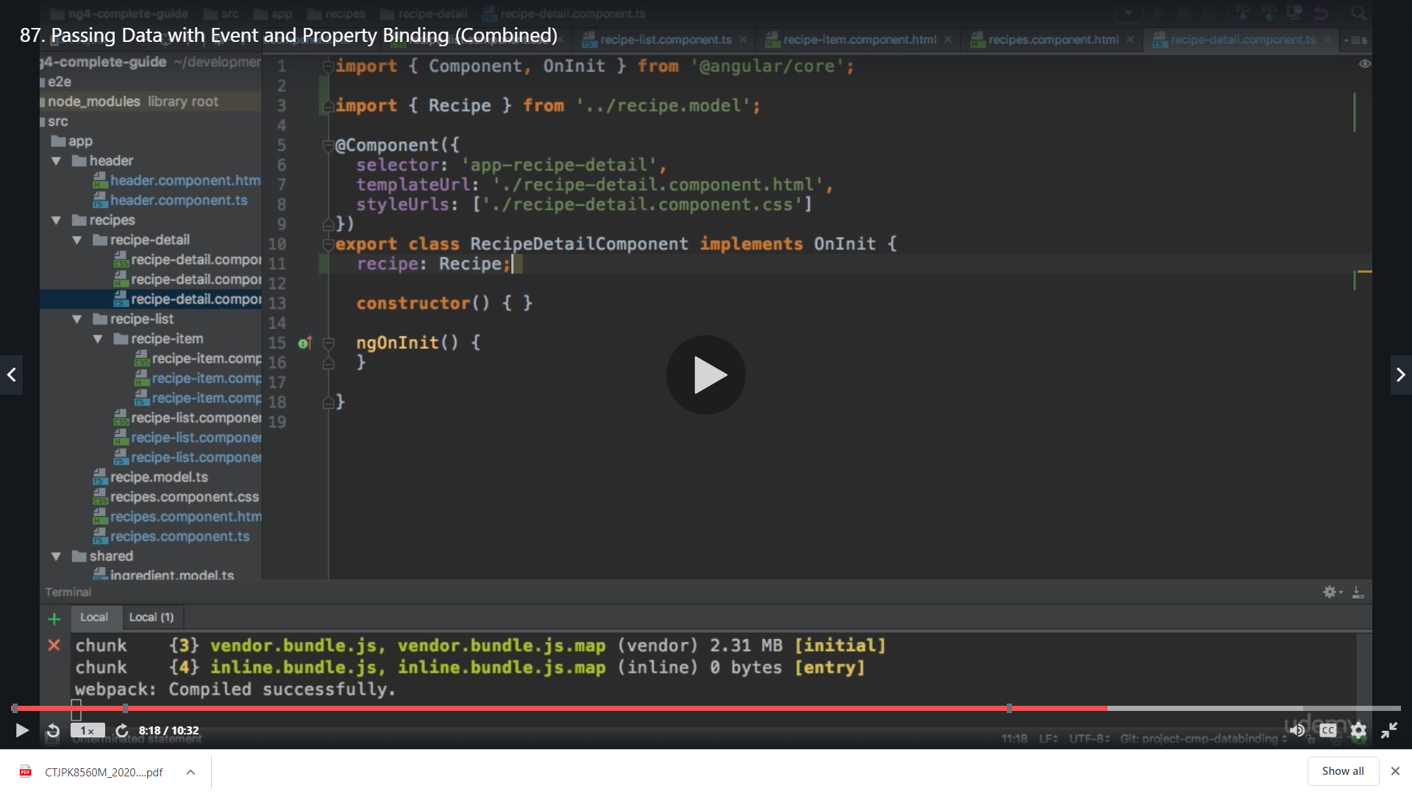

Its not set initially but we may set it from outside to we add @Input ()

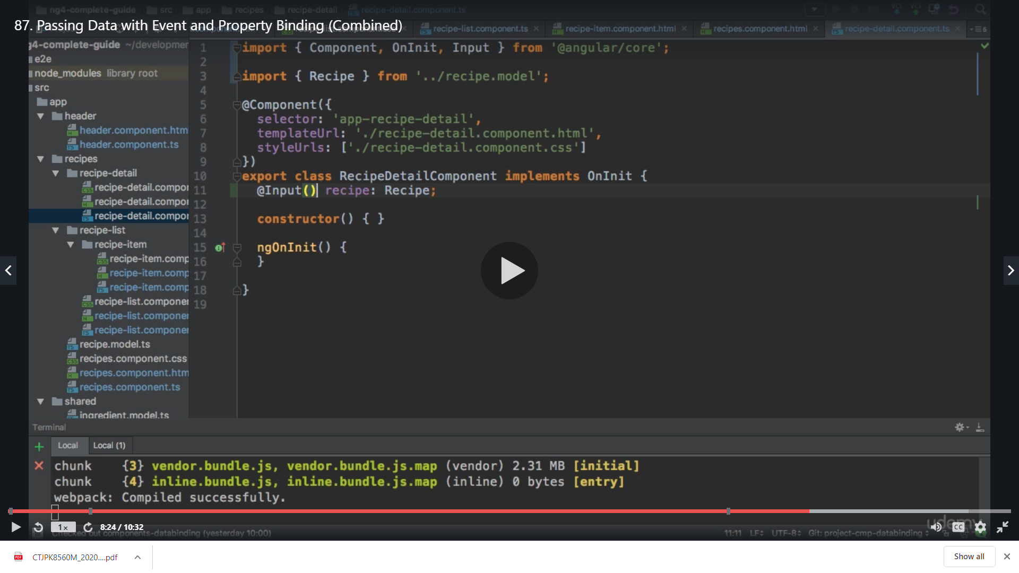

Now we go back to the recipes component

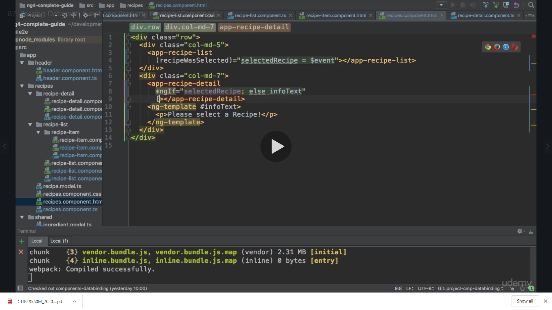

We bind to the recipe

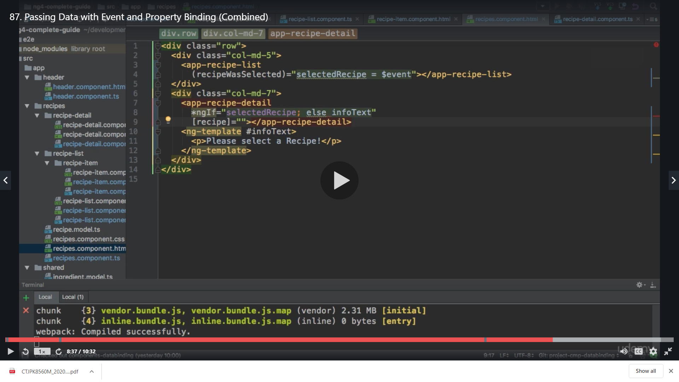

Our selectedRecipe that we have .IMP this component will be attached to the DOM only if the above condition is fulfilled

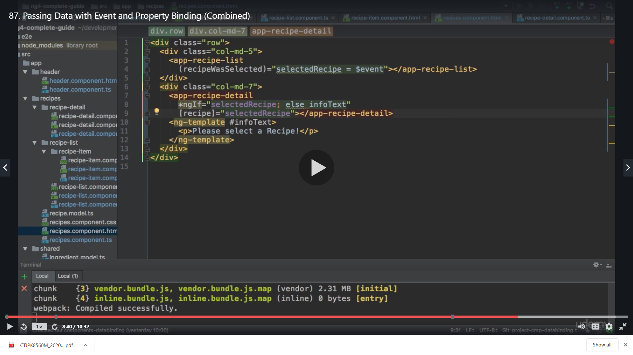

Now we can pass this in the recipe detail component

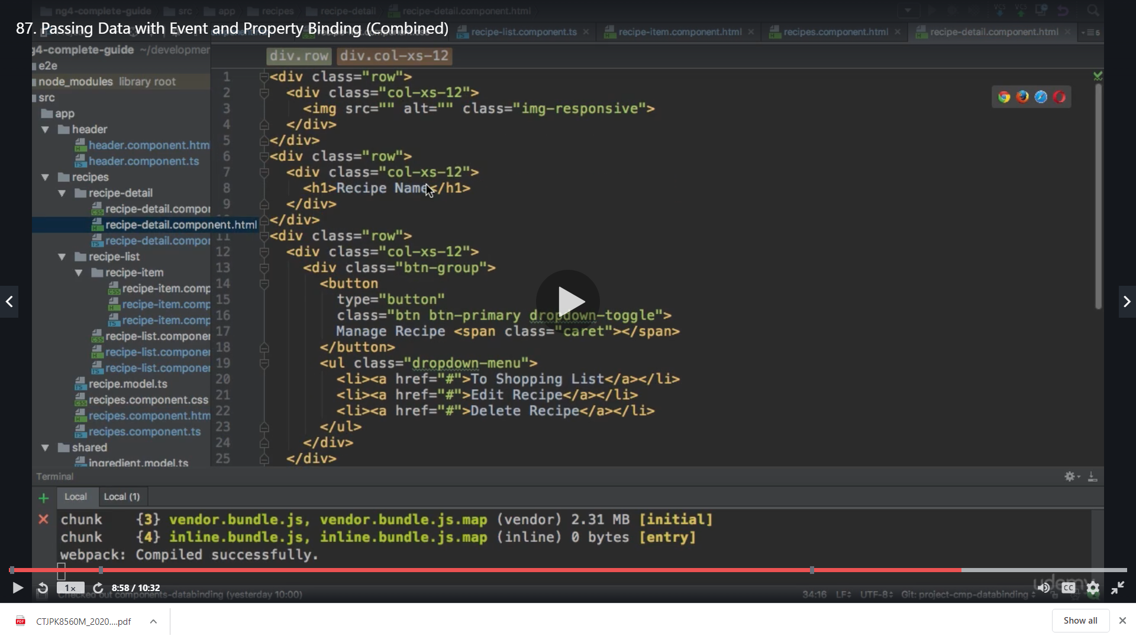

We can output the recipe name

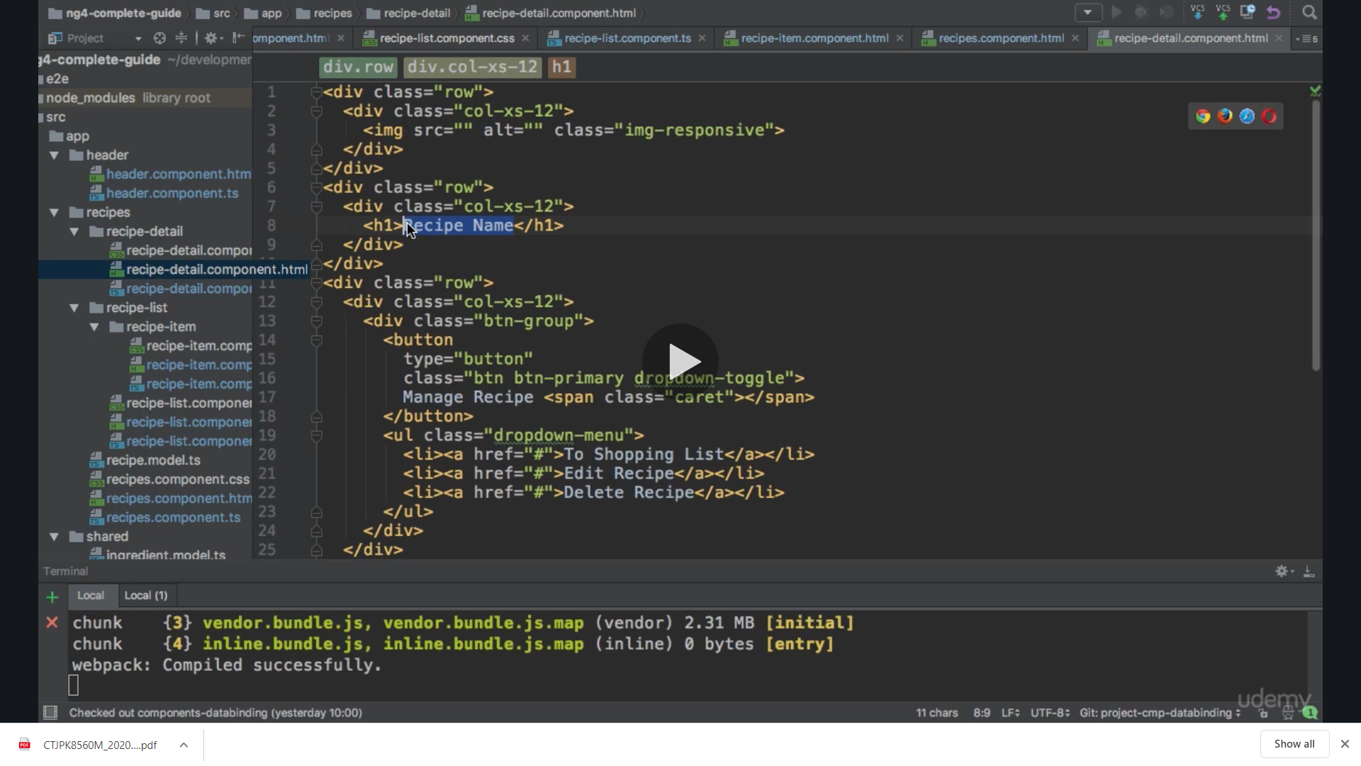

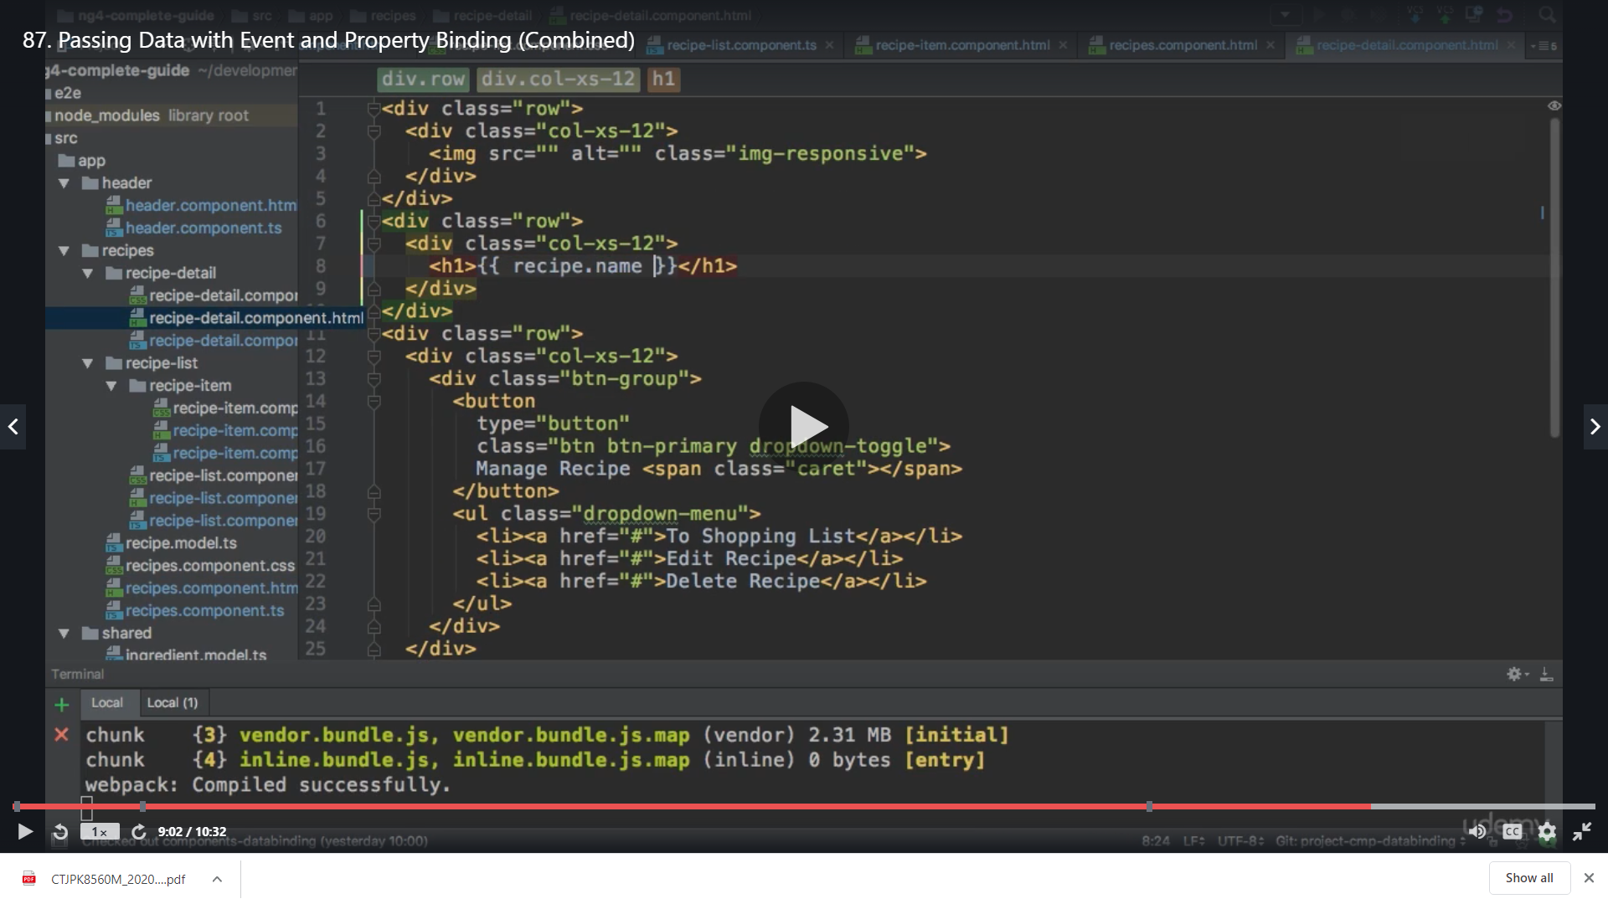

The recipe is the property name in this component which we are using

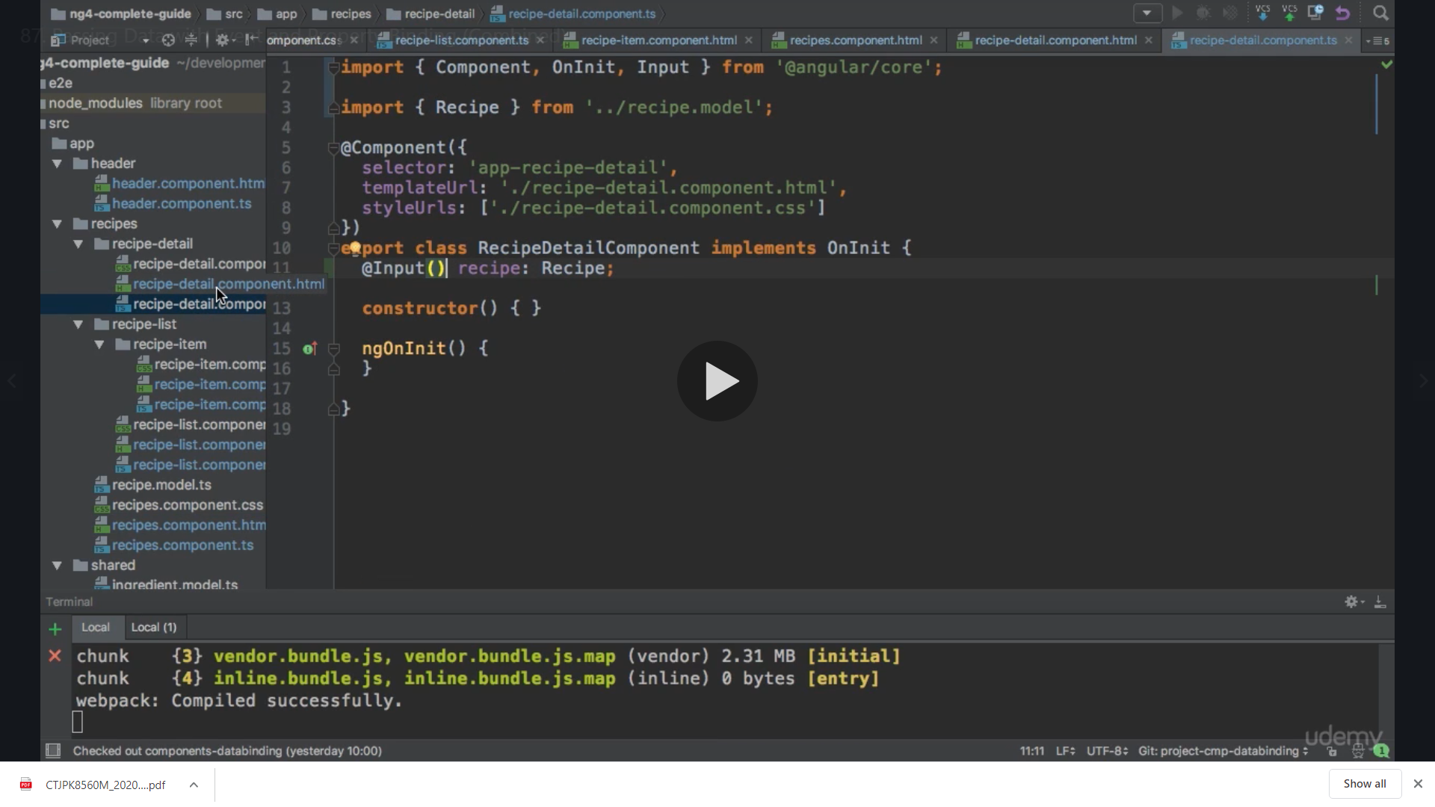

We do the same for image

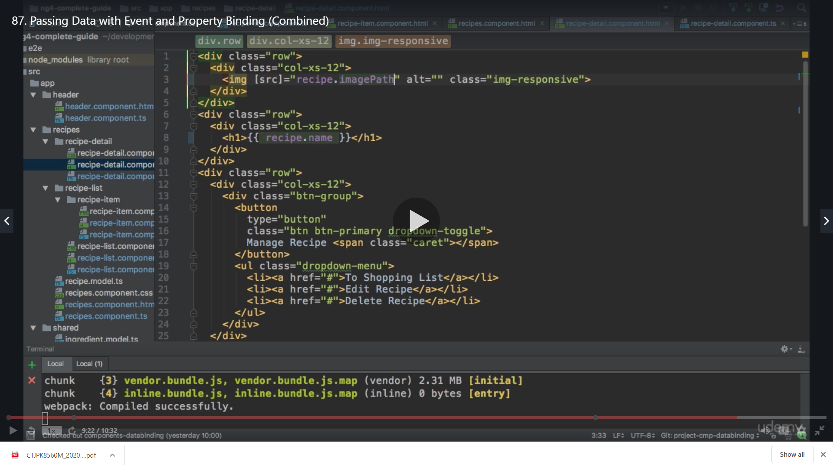

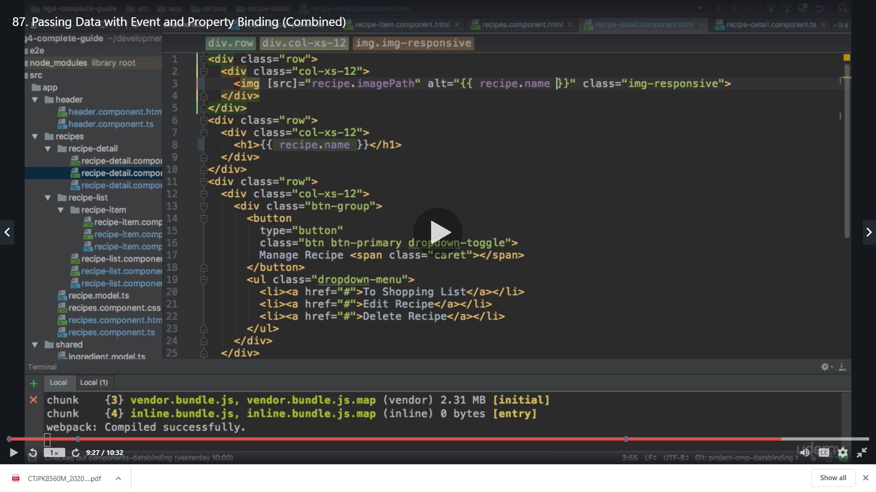

Now description

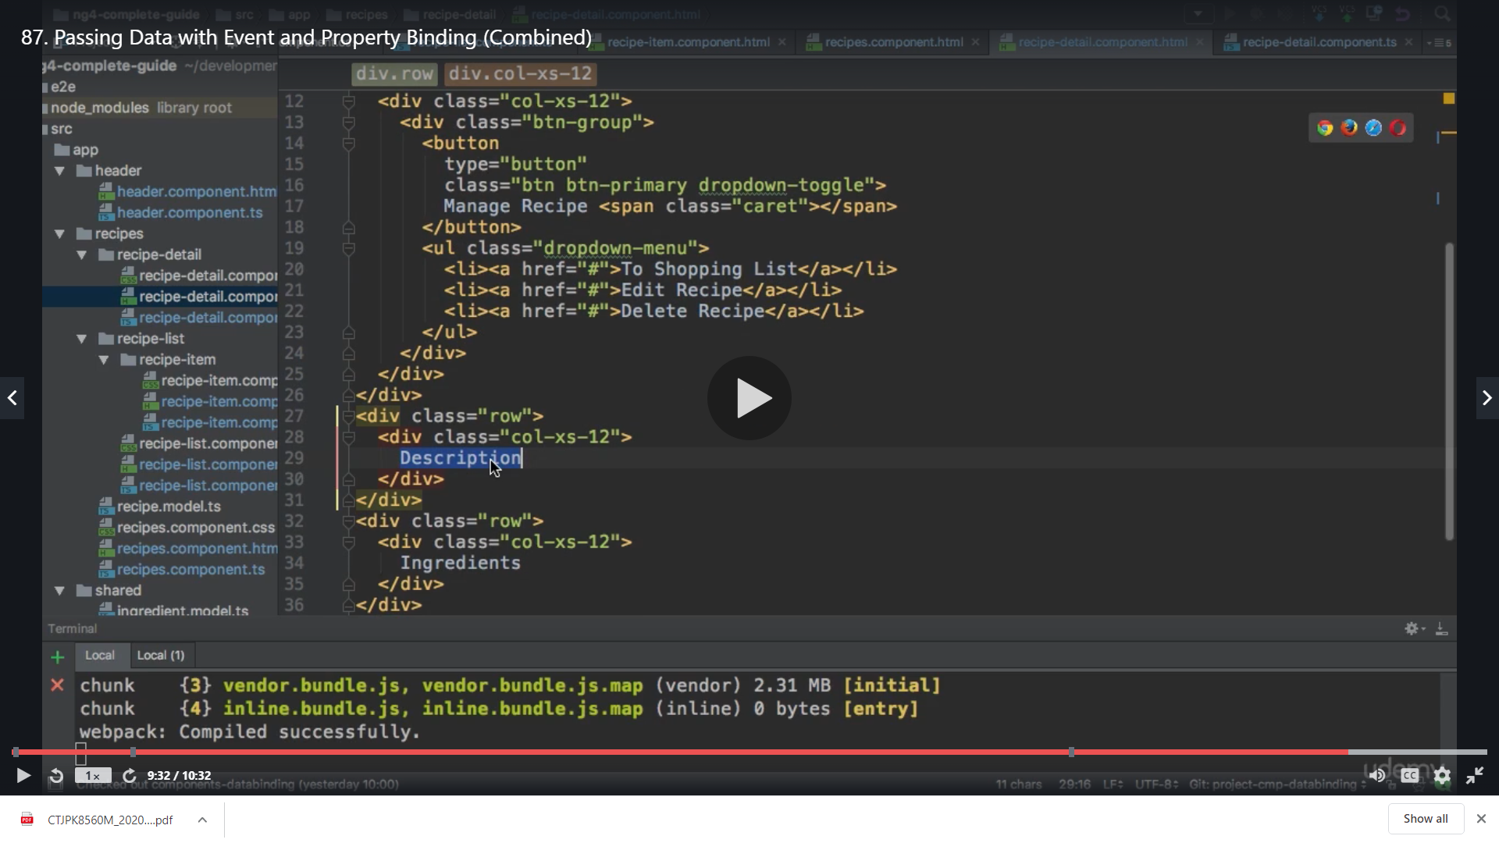

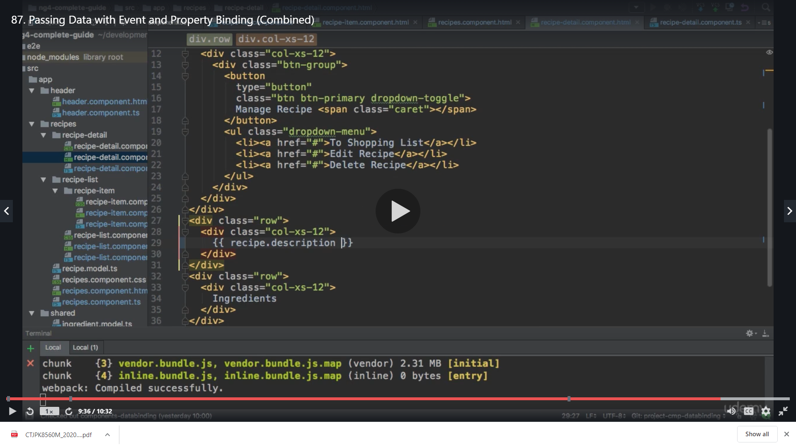

We save and get below

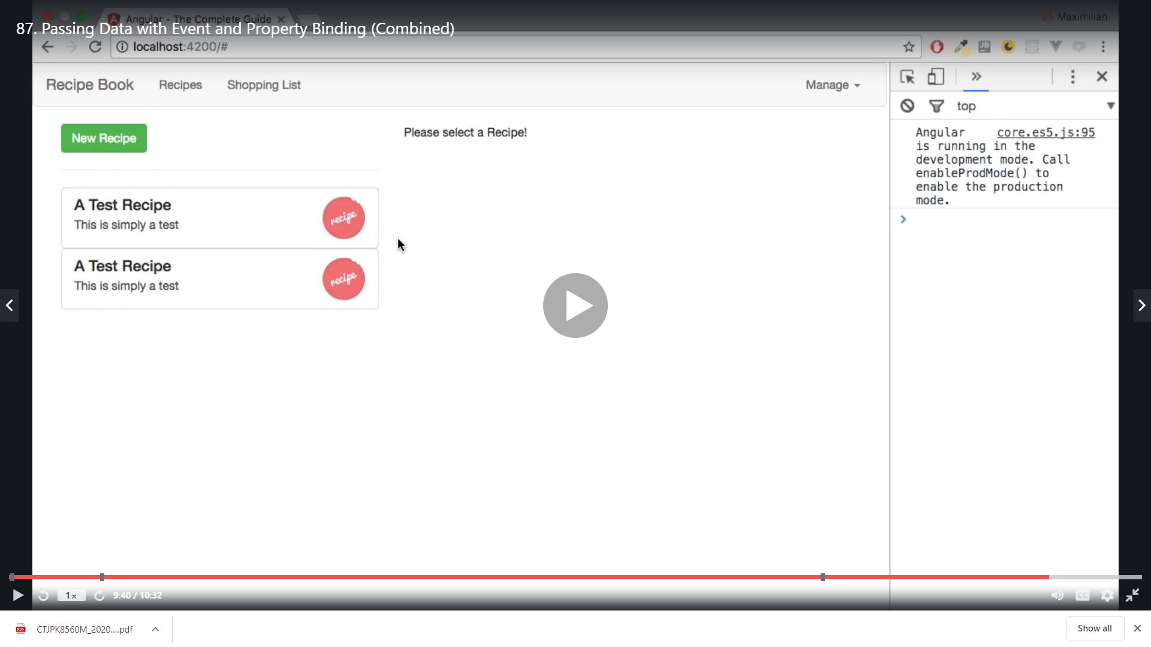

We click the recipe

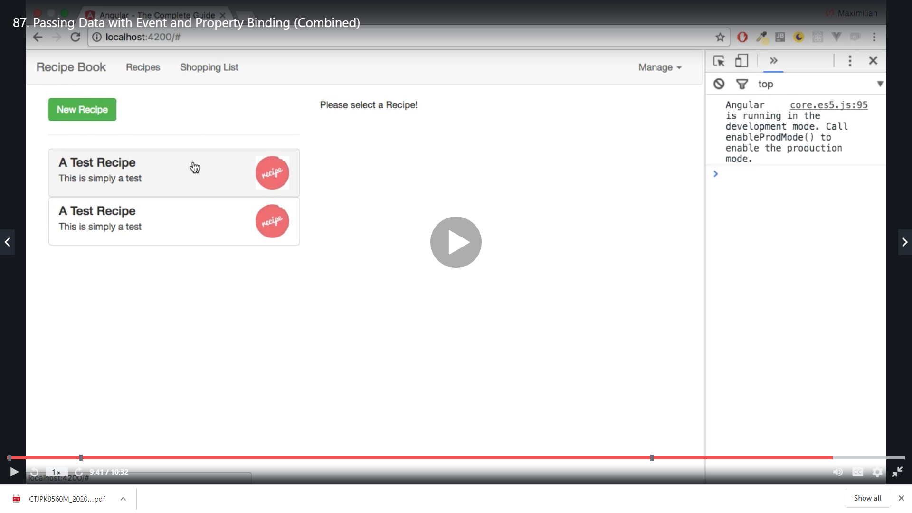

And we get the details

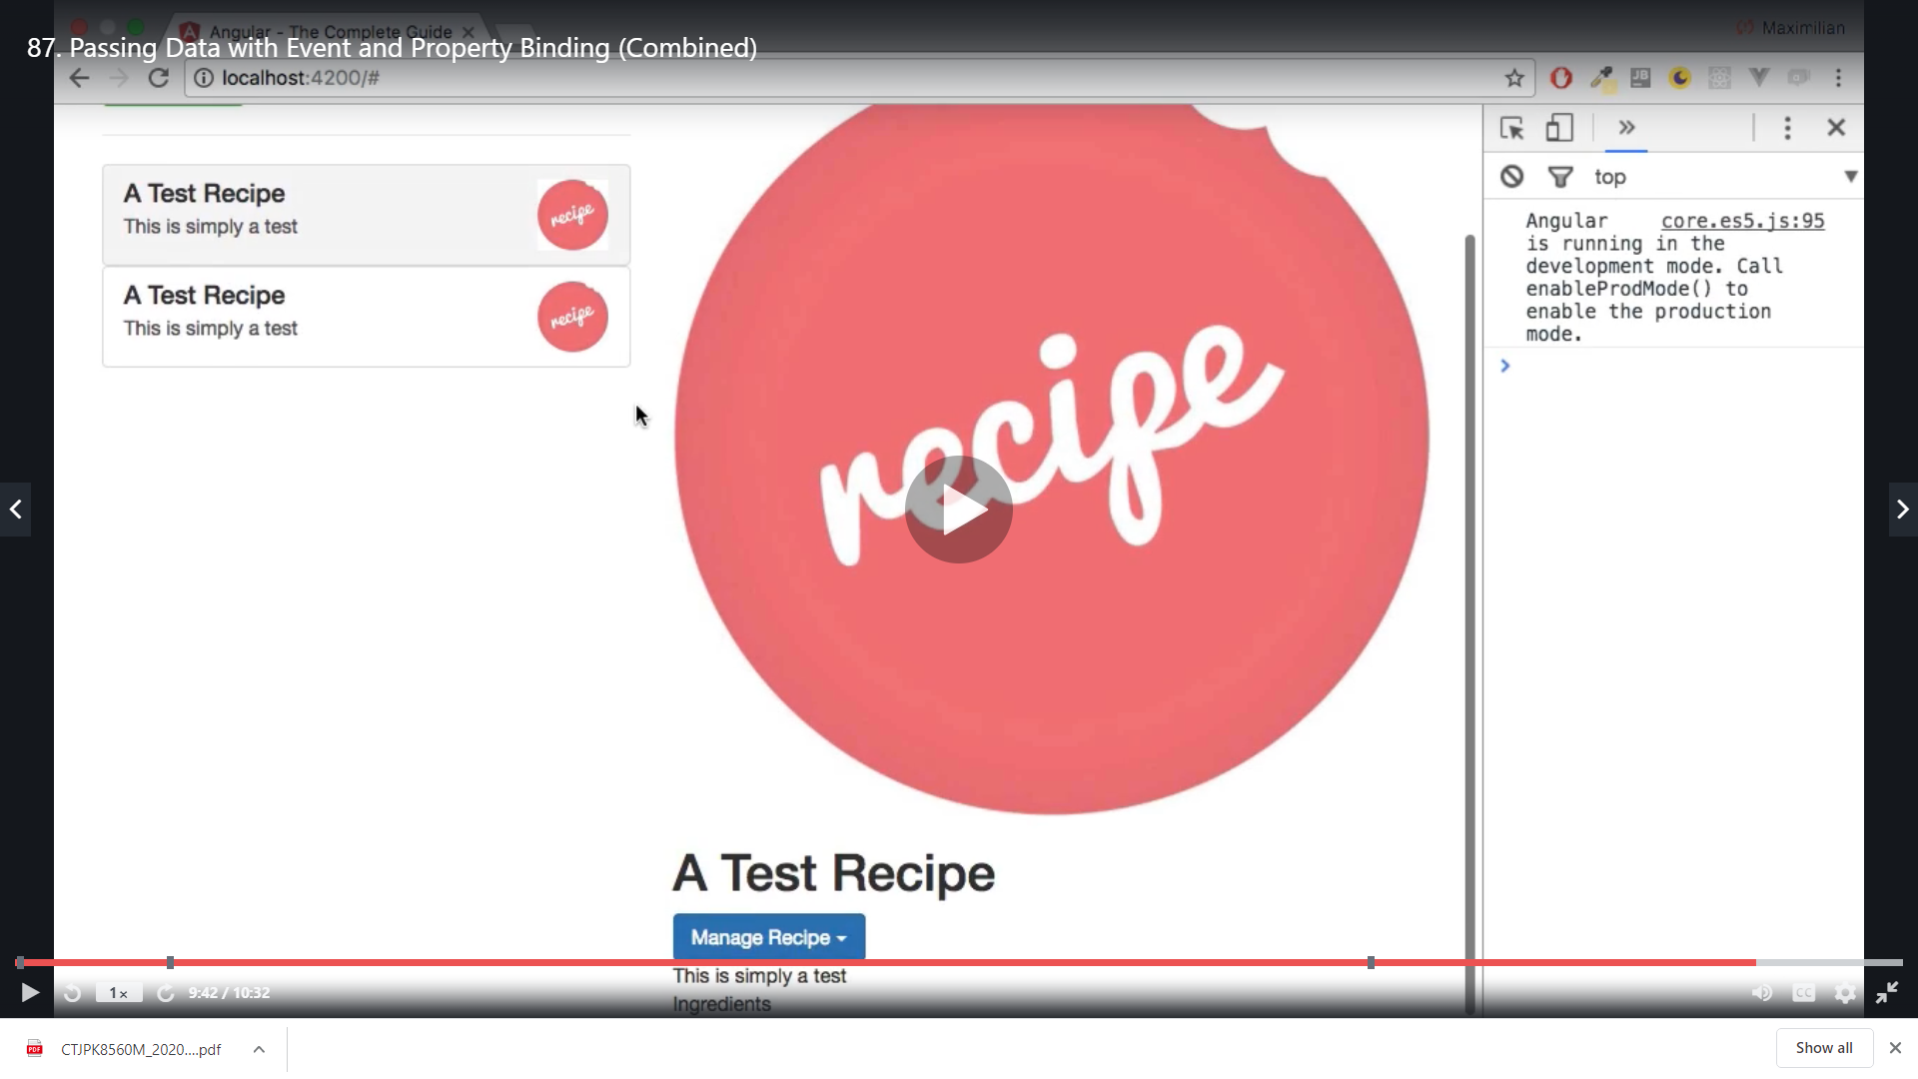

The image is big so we add below style

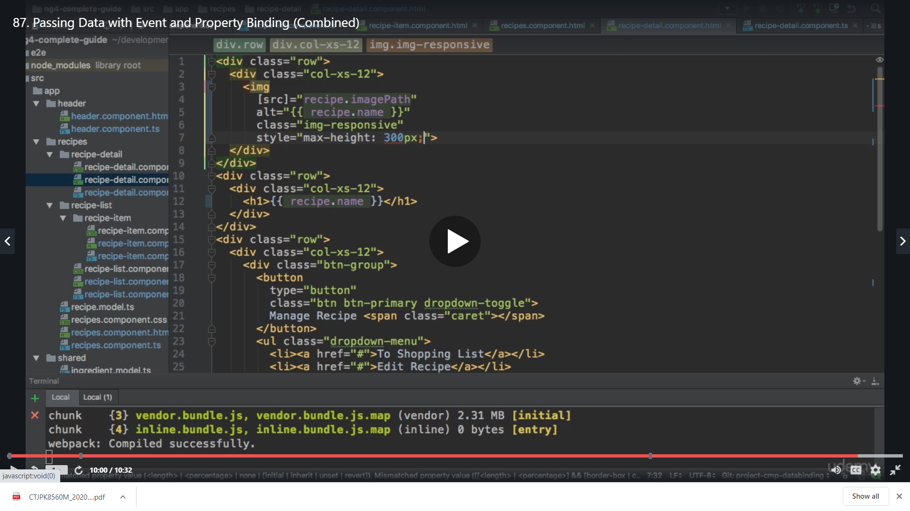

Now we get

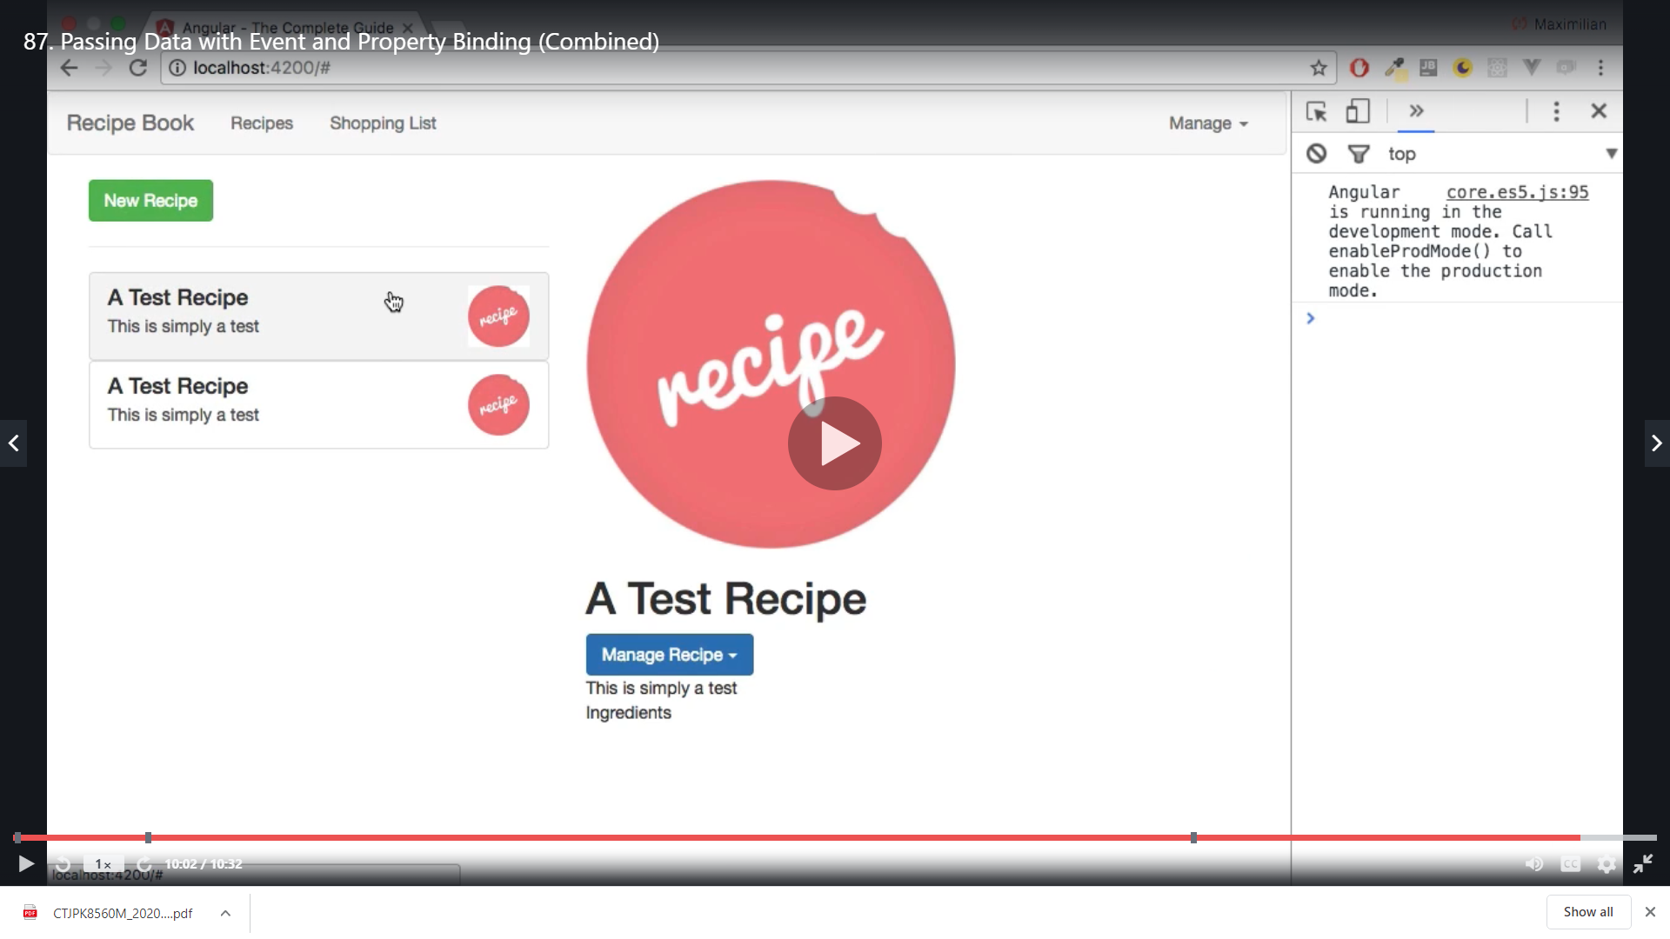

Now to see the change we go to the recipe list component

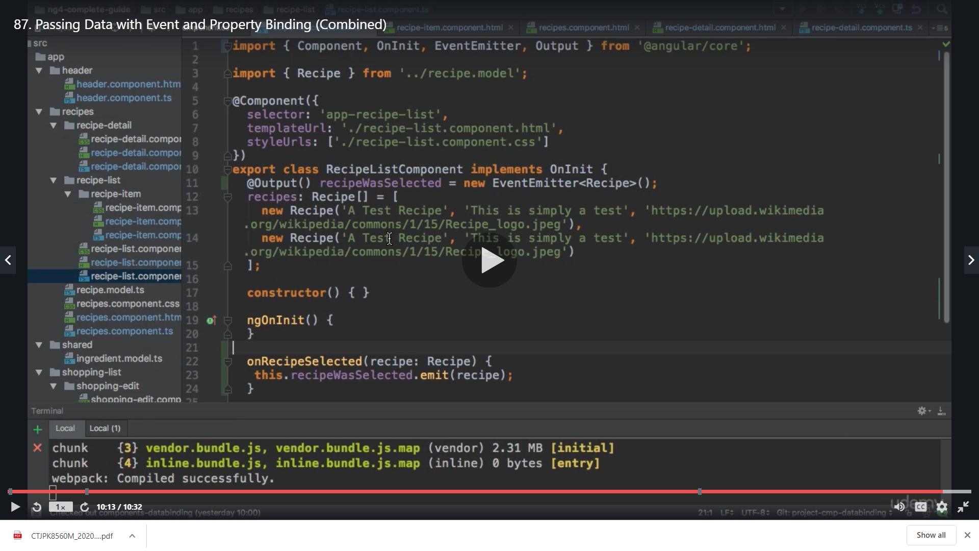

And change a little text

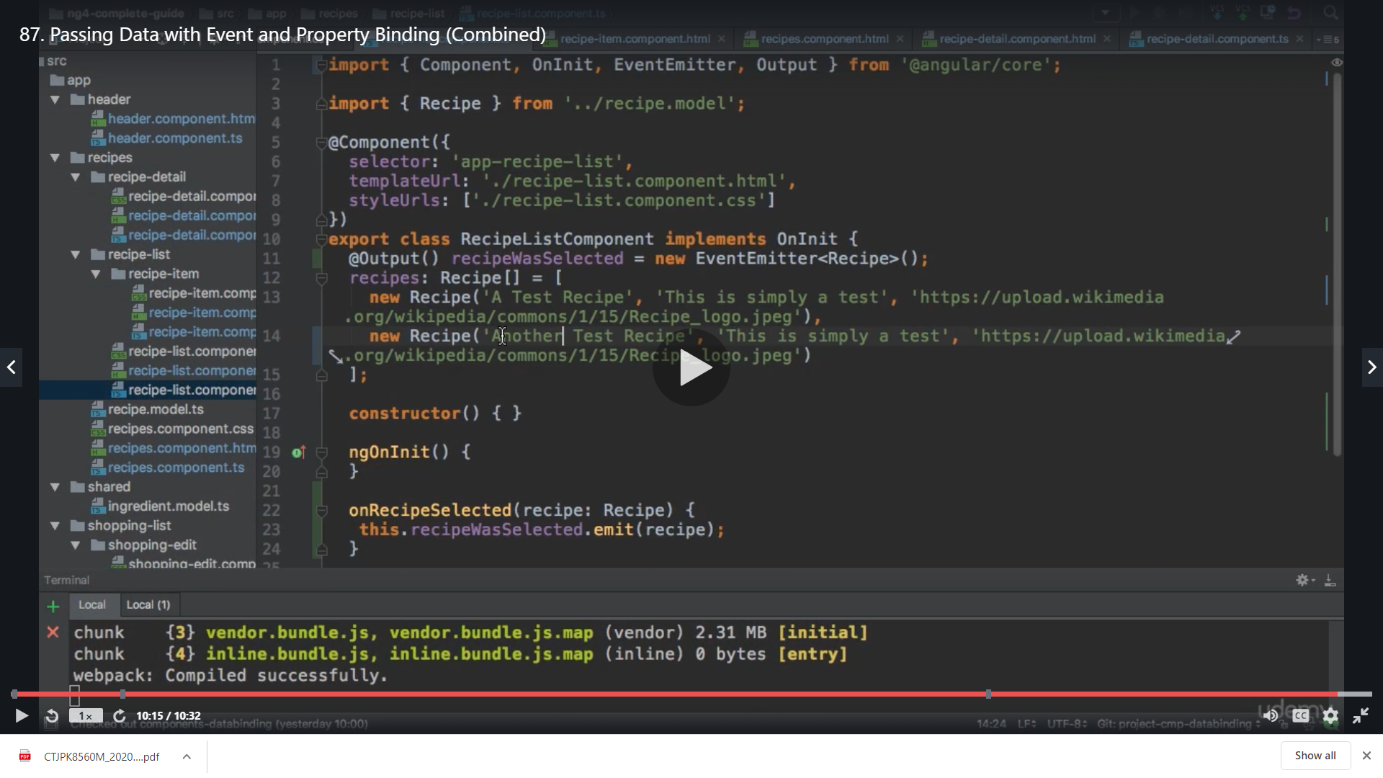

We get it in result

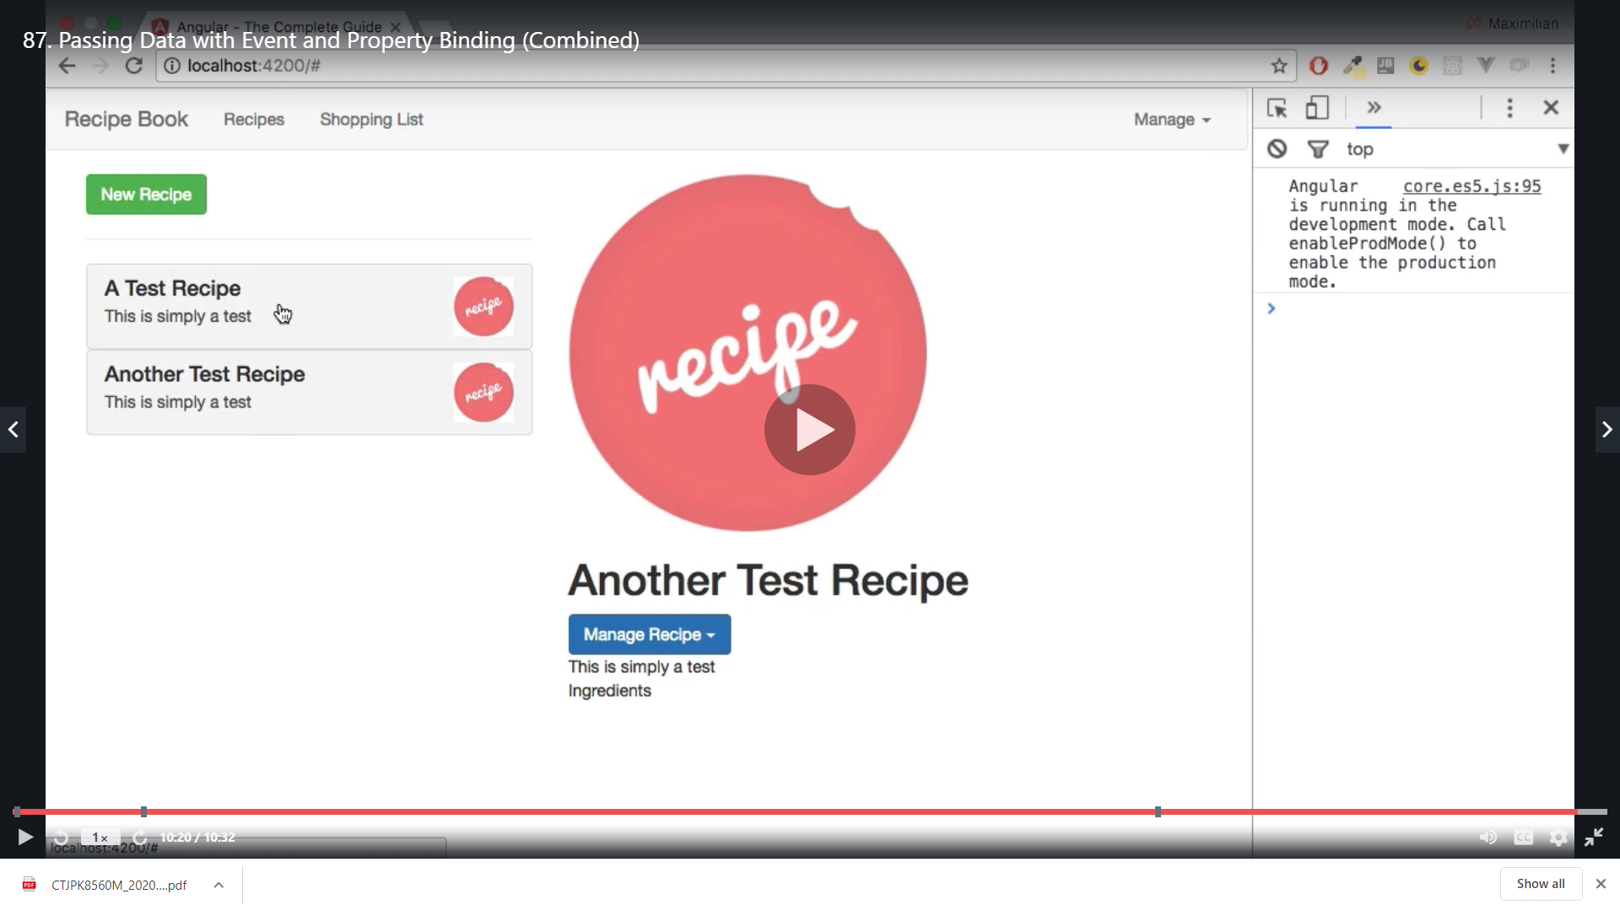

Now

Missing piece after the above successful change is the below shopping list input fields to get working

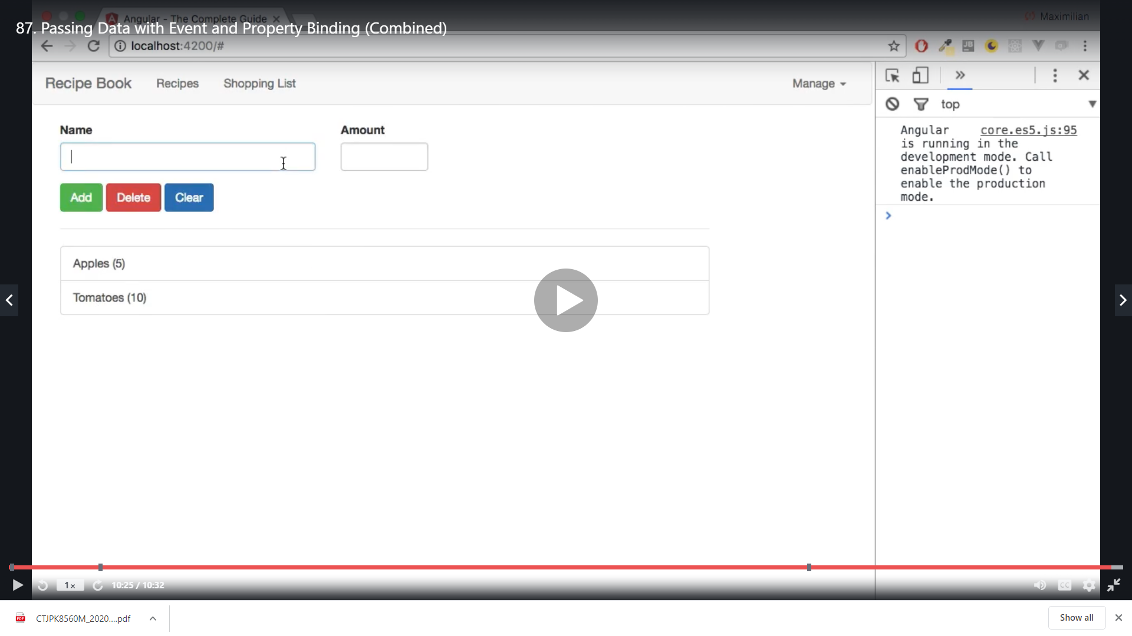

Make sure you have FormsModule added!

One quick note: In case you're hitting an error in the next lecture, make sure you have FormsModule added to your imports[] in the AppModule. Also have a look at the following Q&A thread for more info: <https://www.udemy.com/the-complete-guide-to-angular-2/learn/v4/questions/4924644>

So to Achieve it in our shopping edit component below

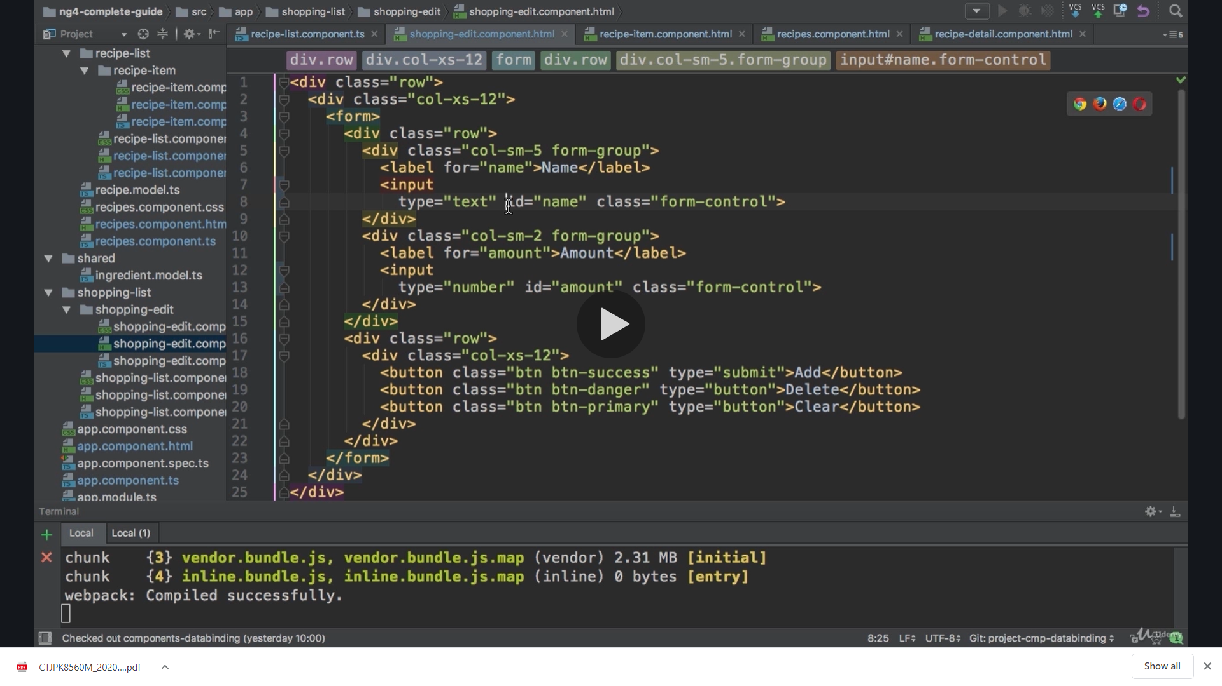

We add a local reference to the name input

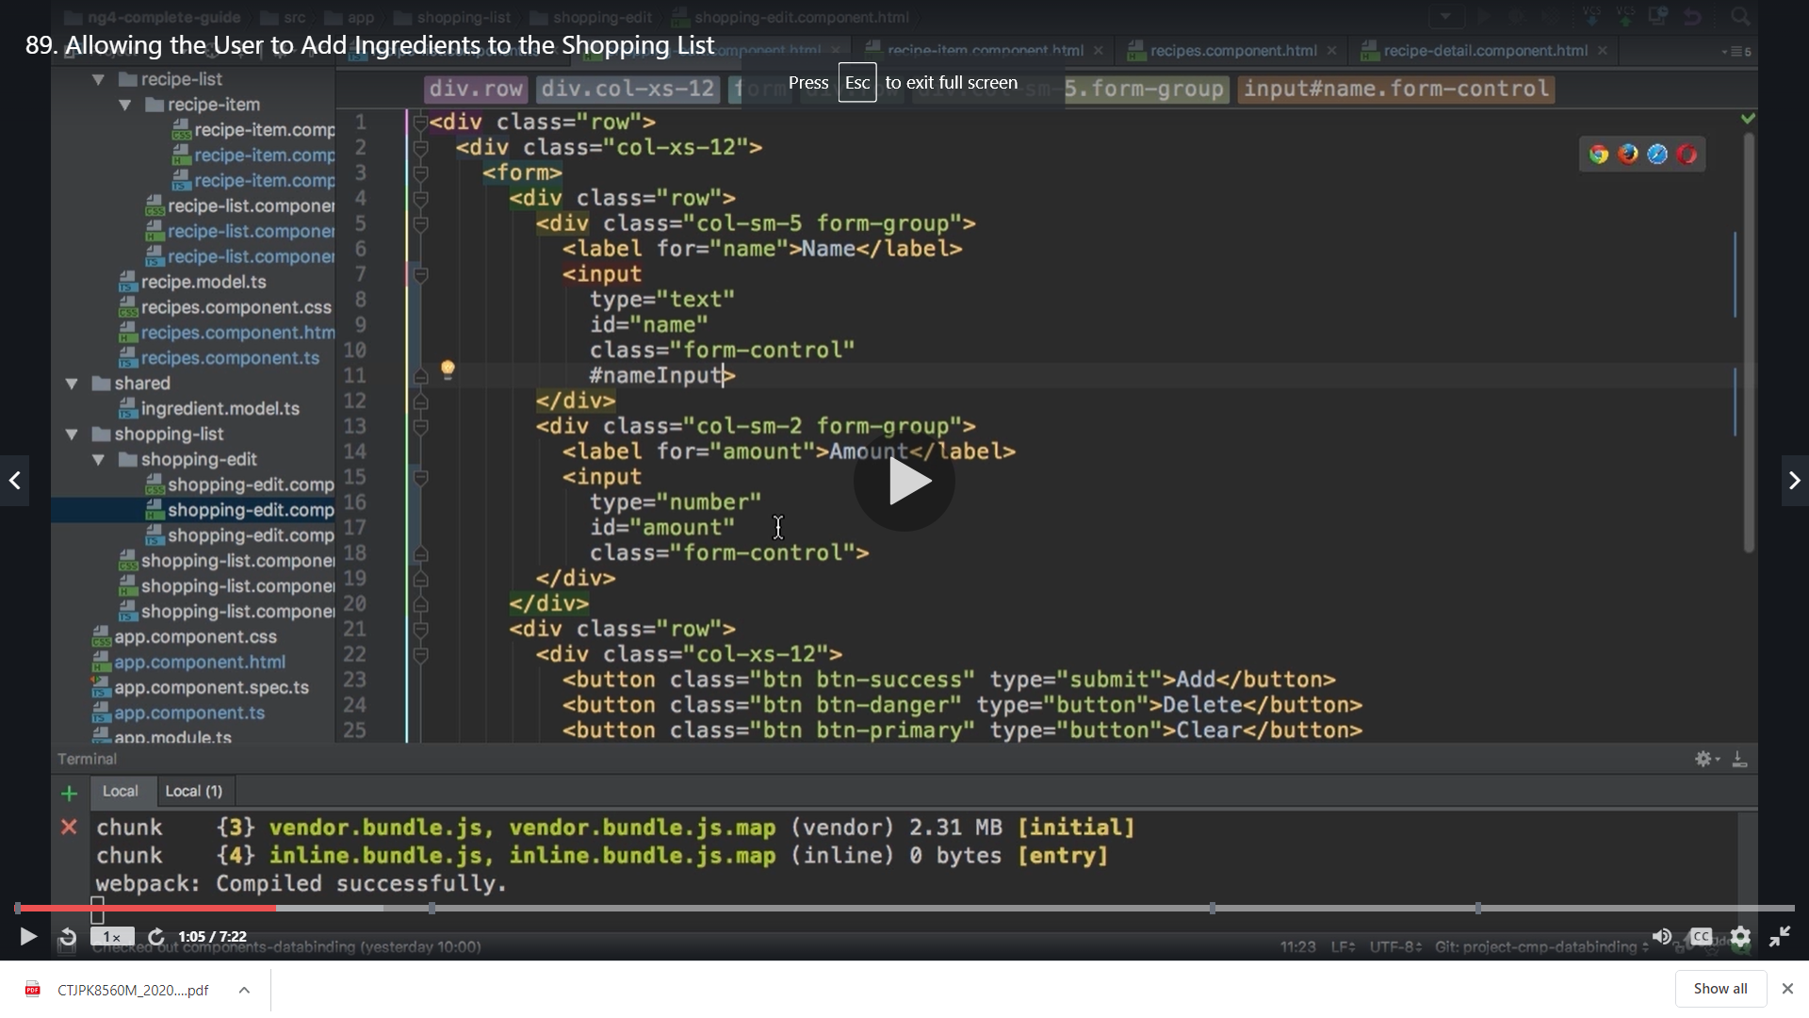

And for amount input as well

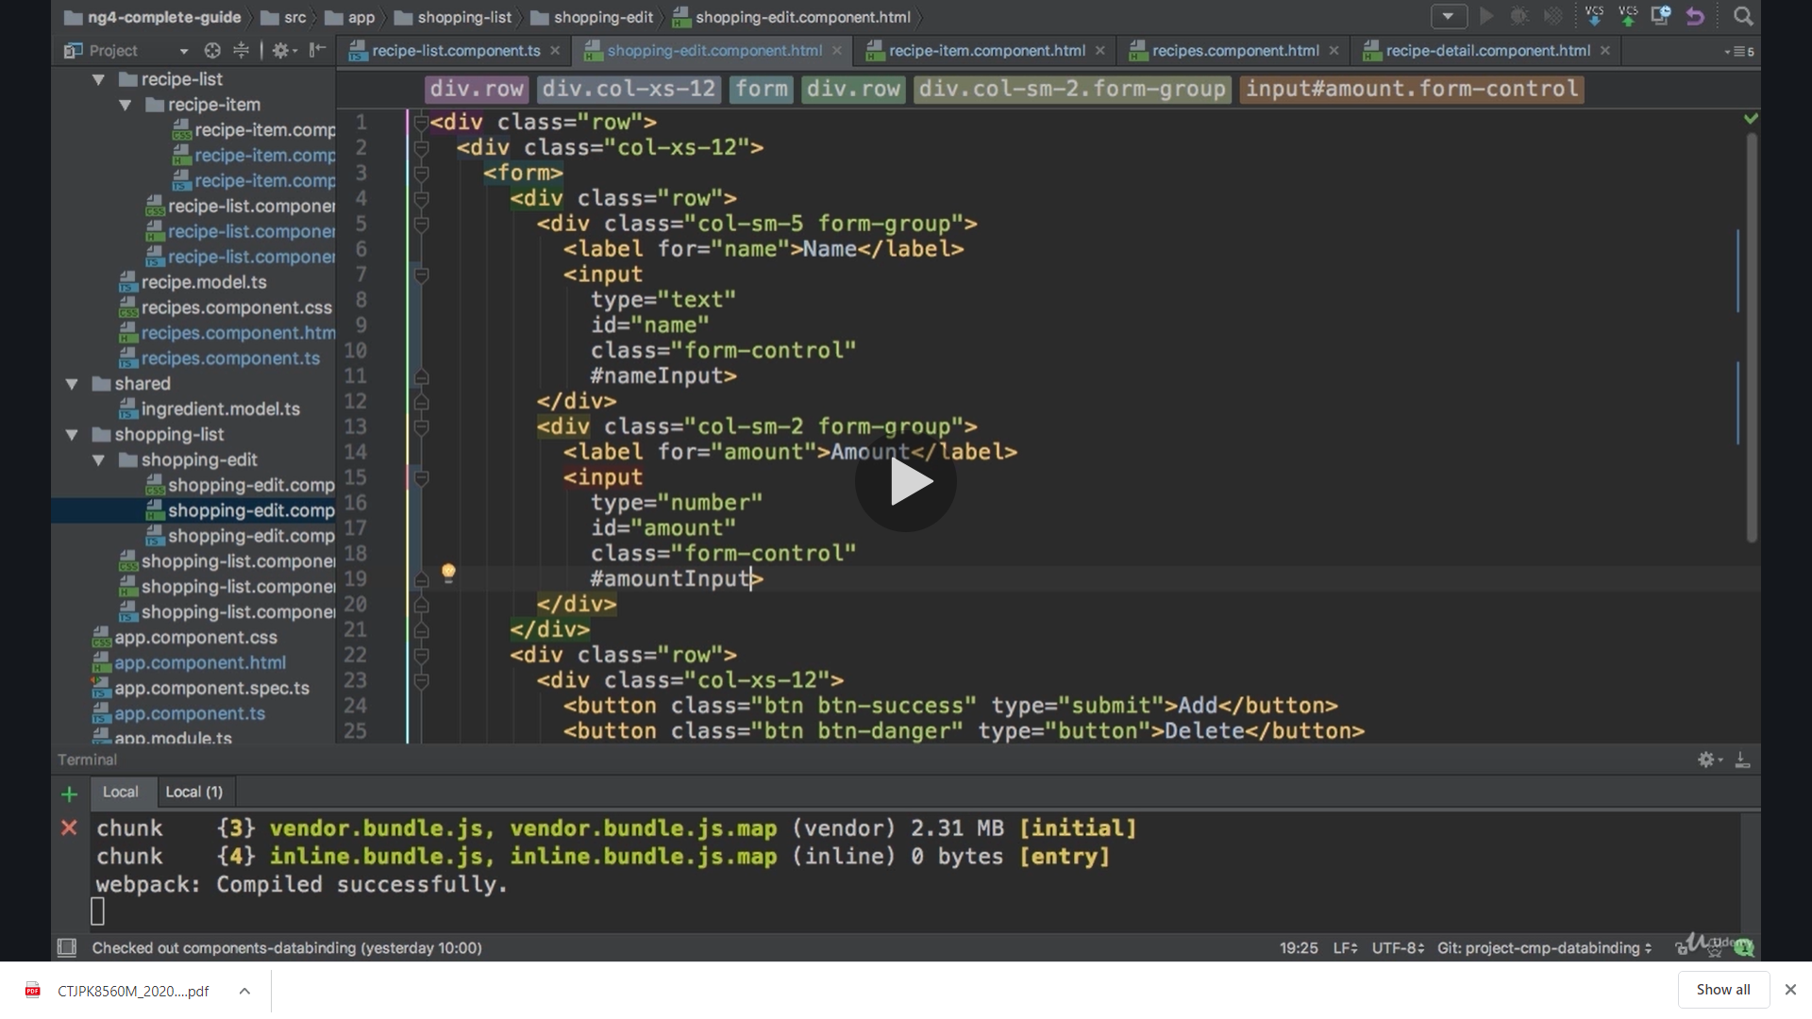

Now we need to get the buttons to use these local reference we create a click event on button

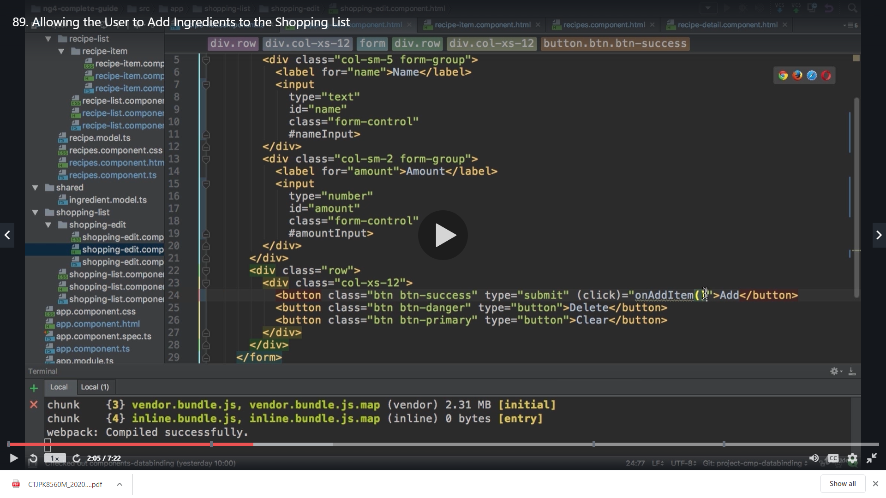

And in ts we have the method added

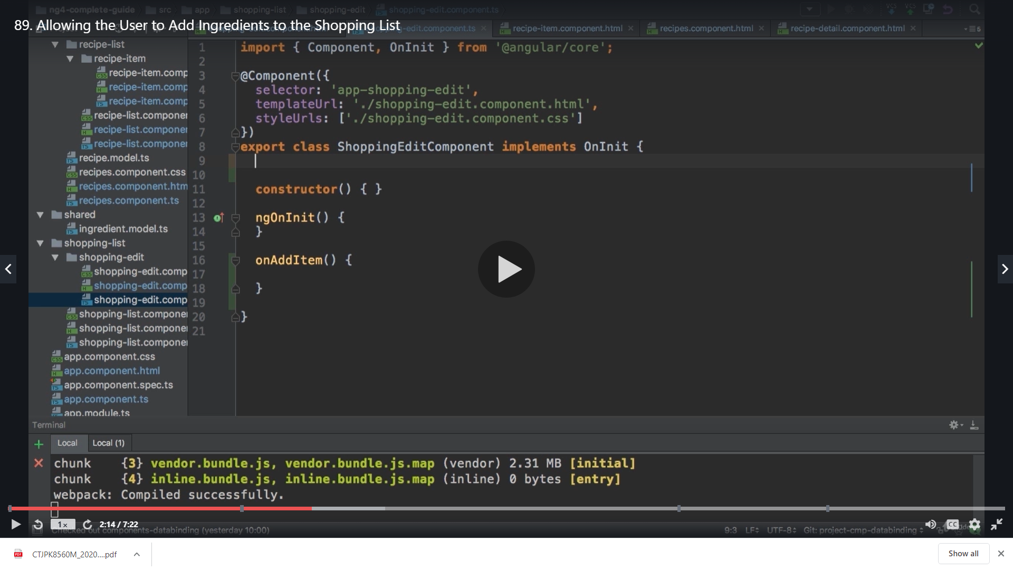

We create a property nameInputProperty of type element reference

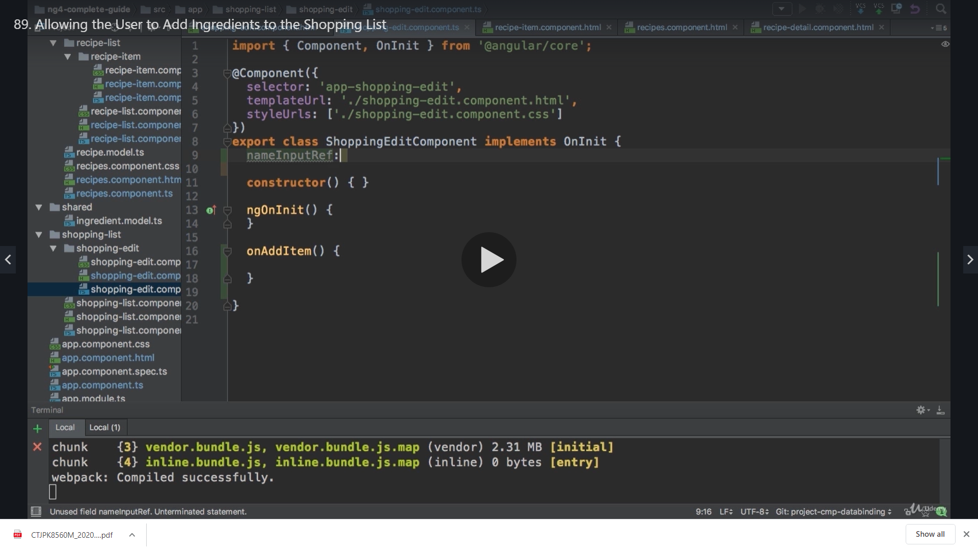

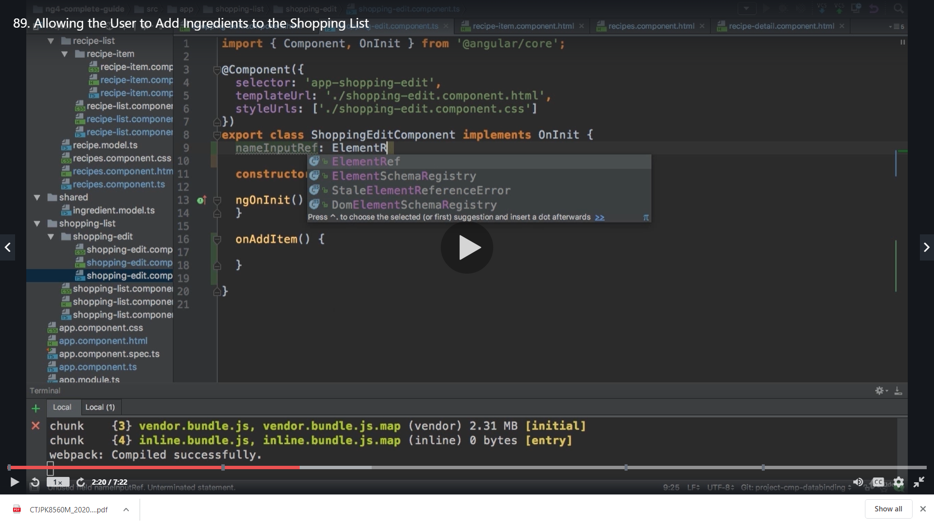

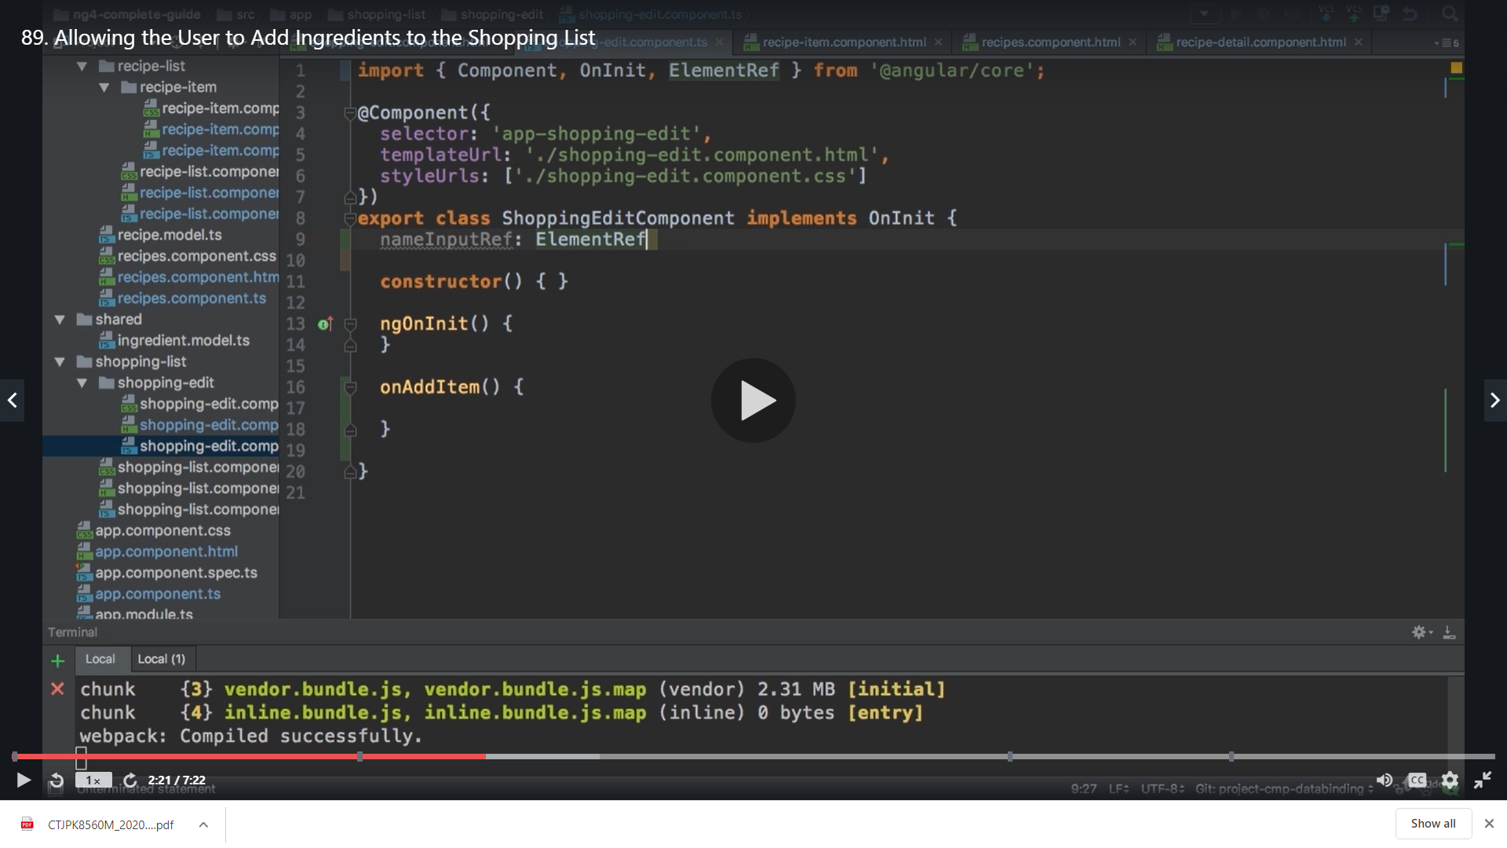

This will get its value from view child

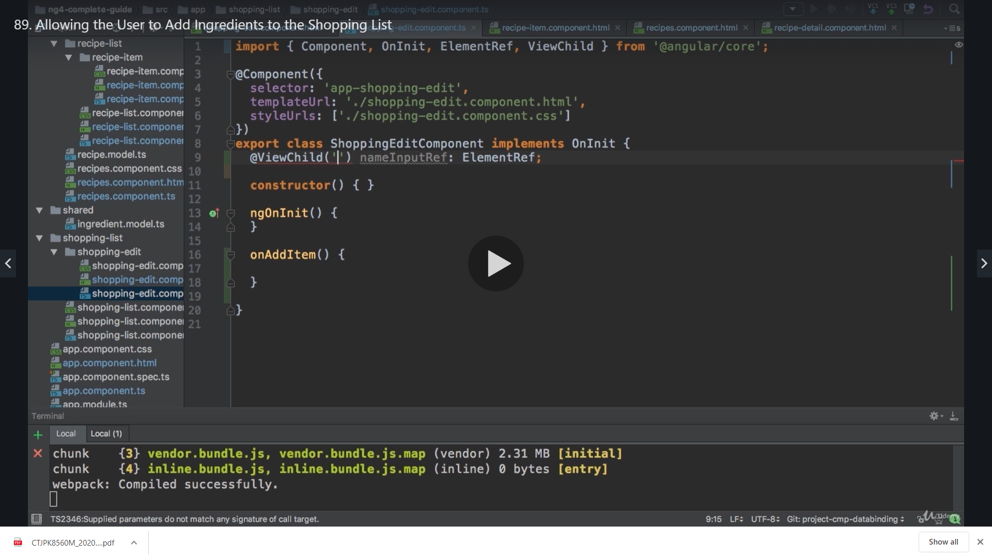

So we have our local reference as below

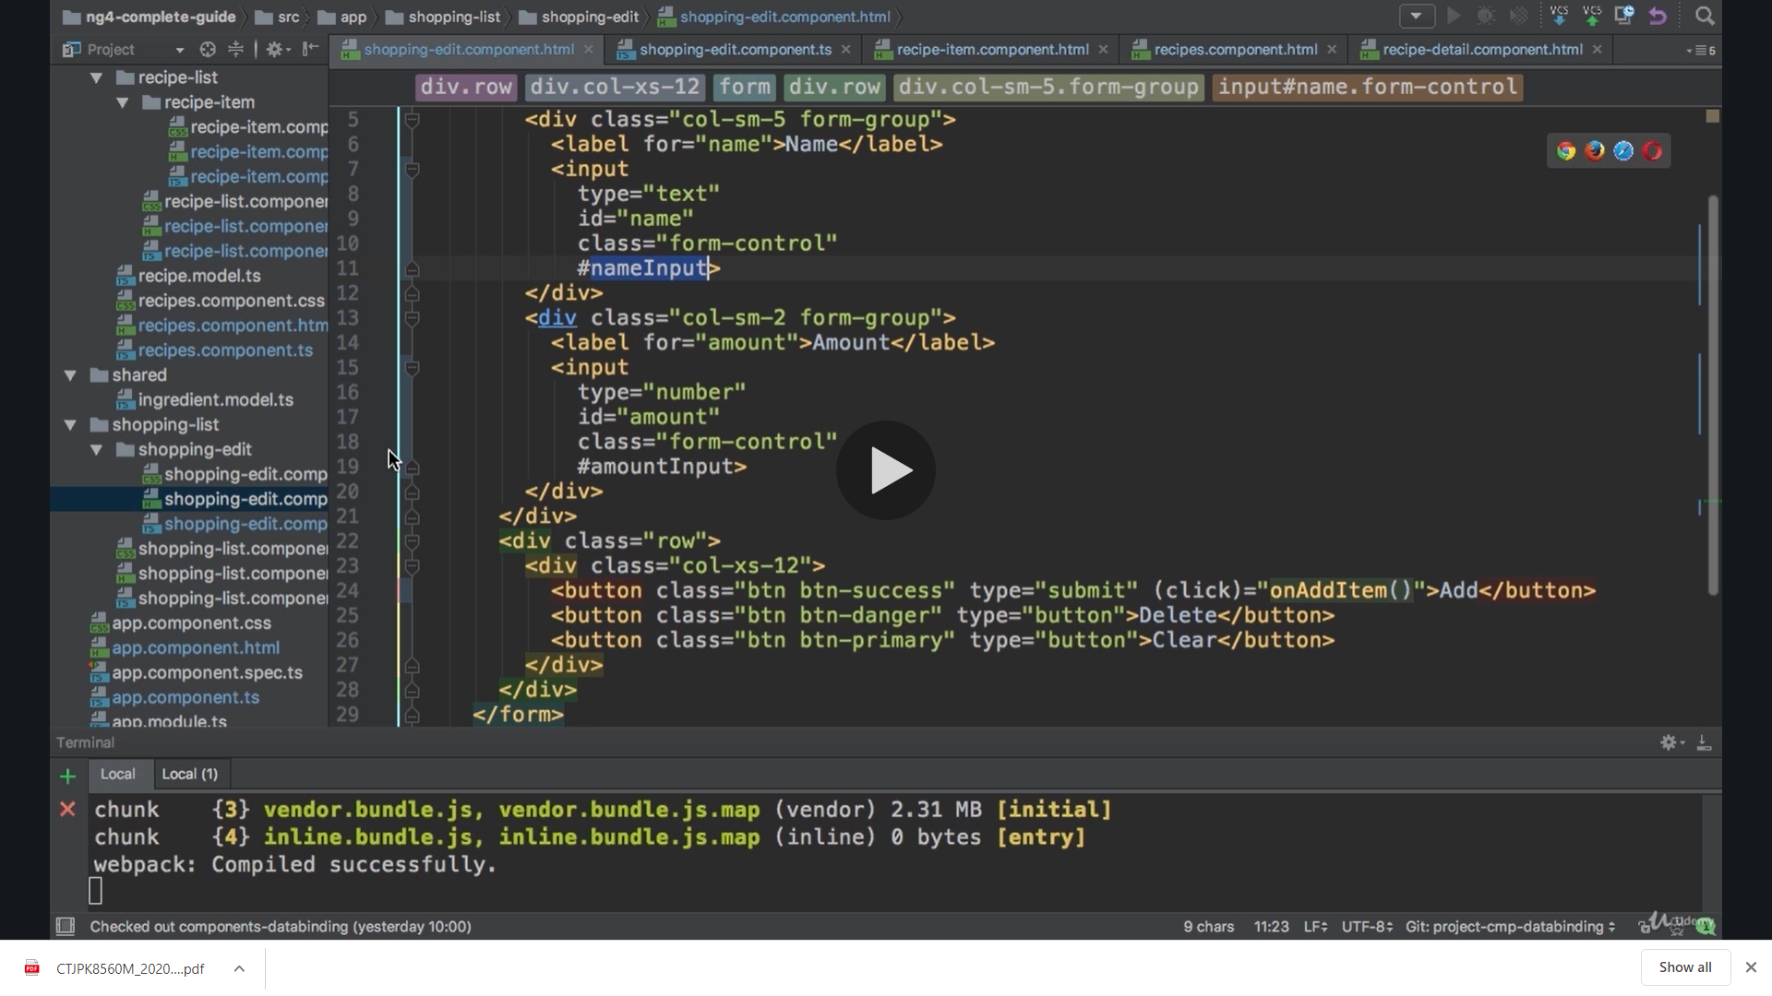

We pass it to our view child

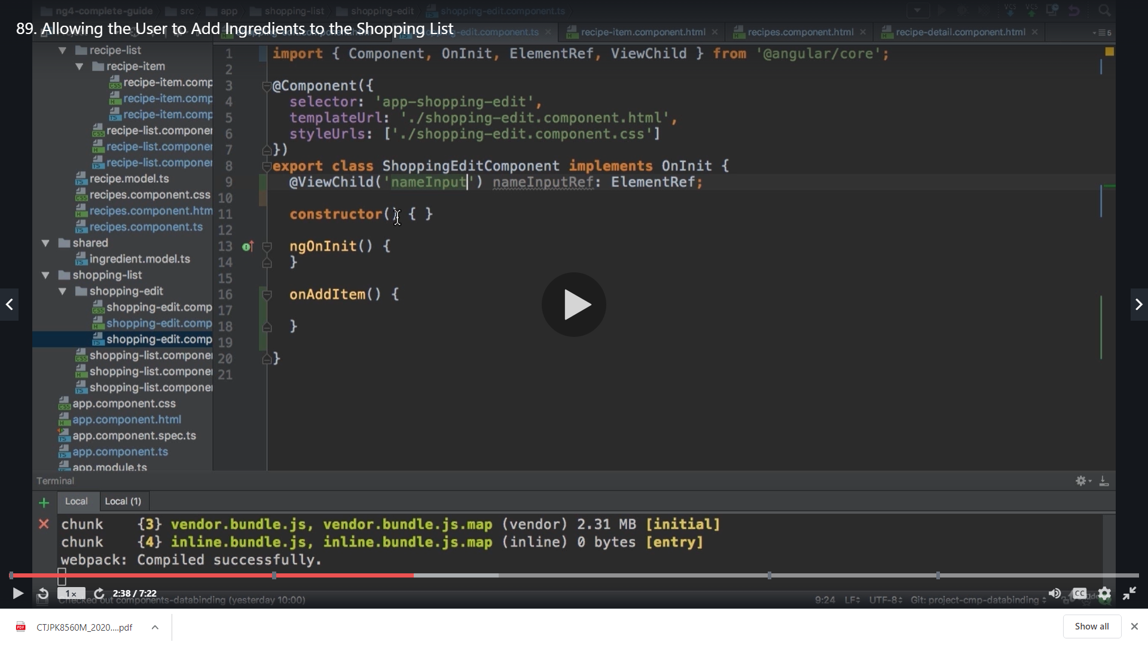

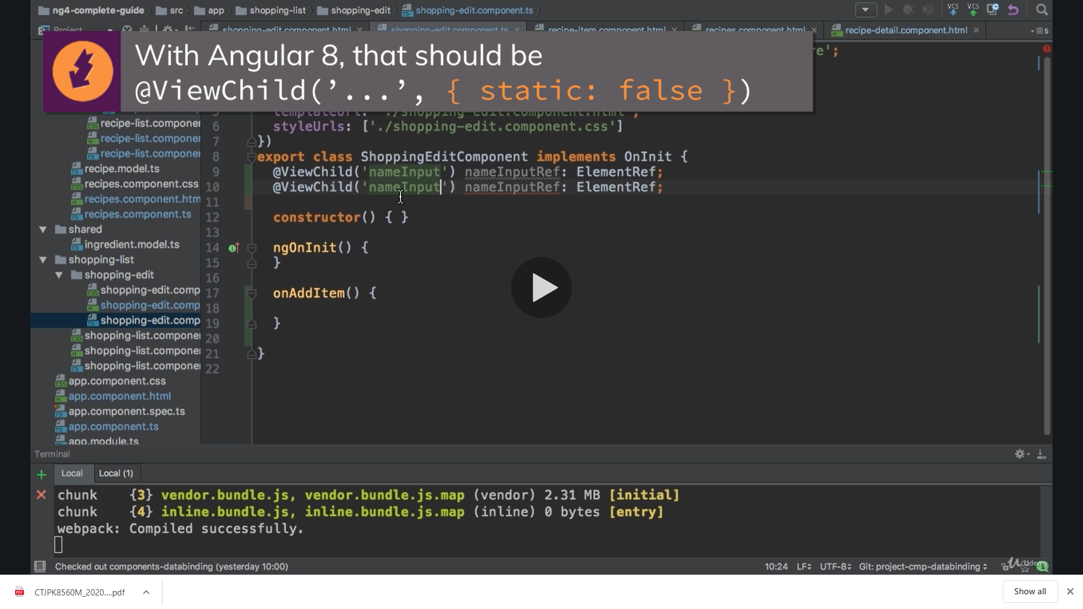

We do the same for amount as well

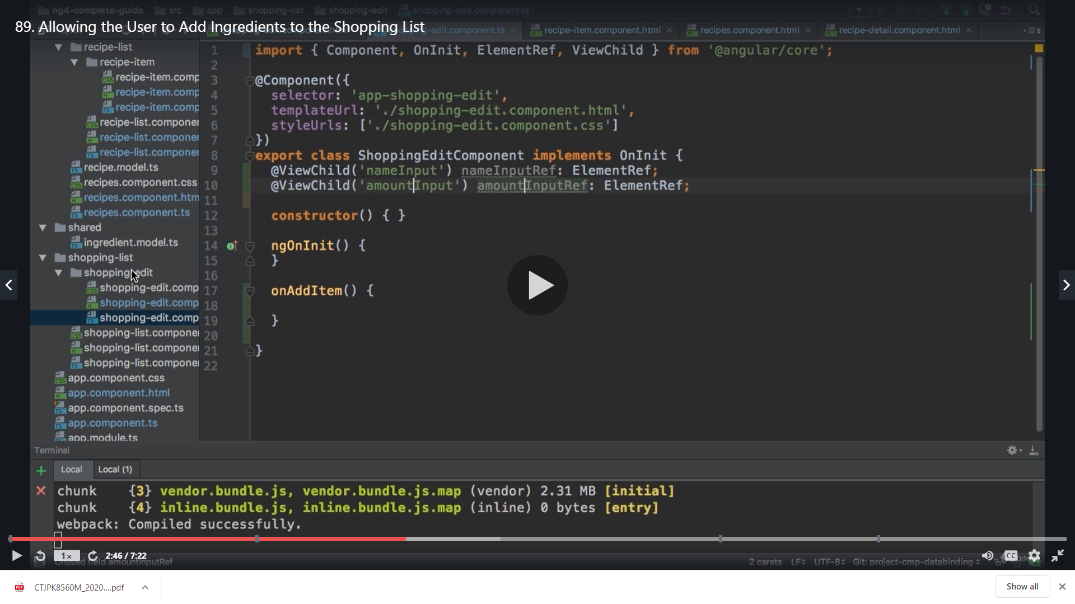

Now we need to create a new event and pass this data to the parent component which is shopping list component which manages our array of ingrediants as below

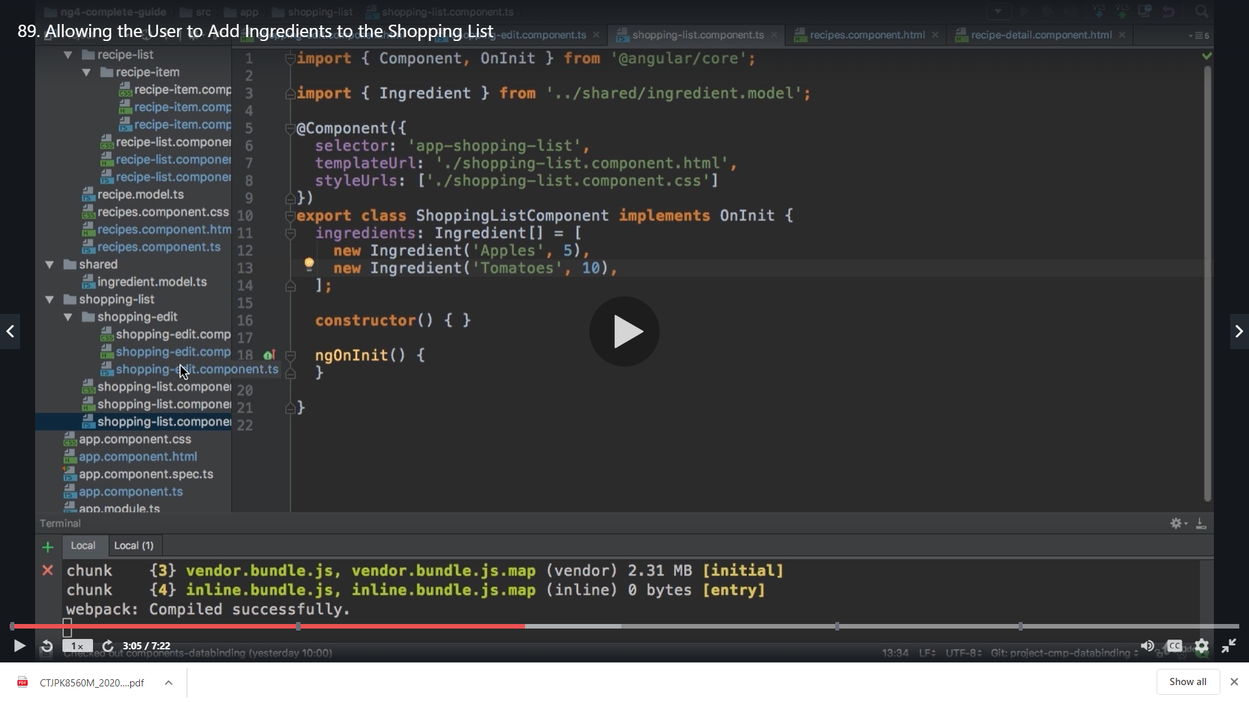So to do that we create our event on shopping edit component

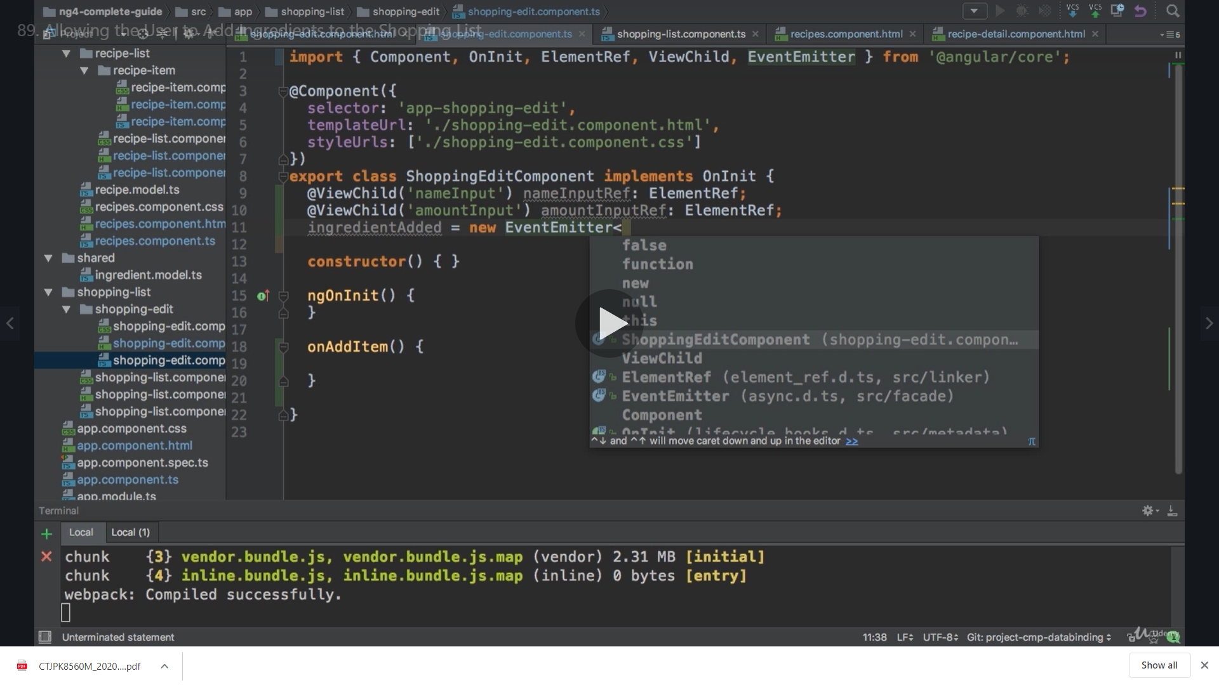

We will pass javascript object here as an argument which will hold name and amount this is not a value just a type definition

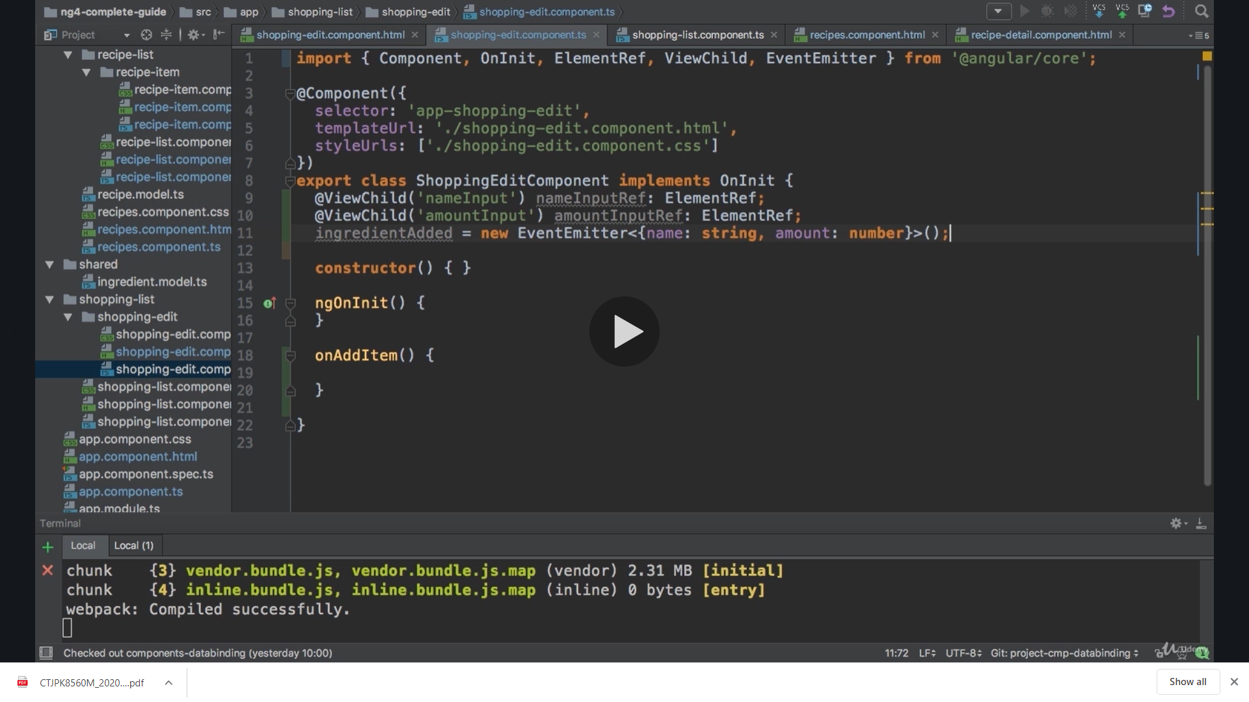

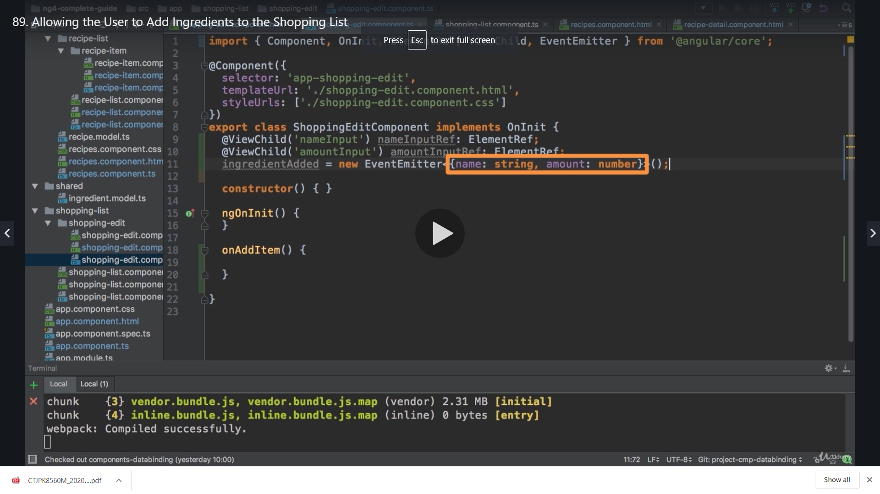

**We already have our ingrediants model in place which had this detail**

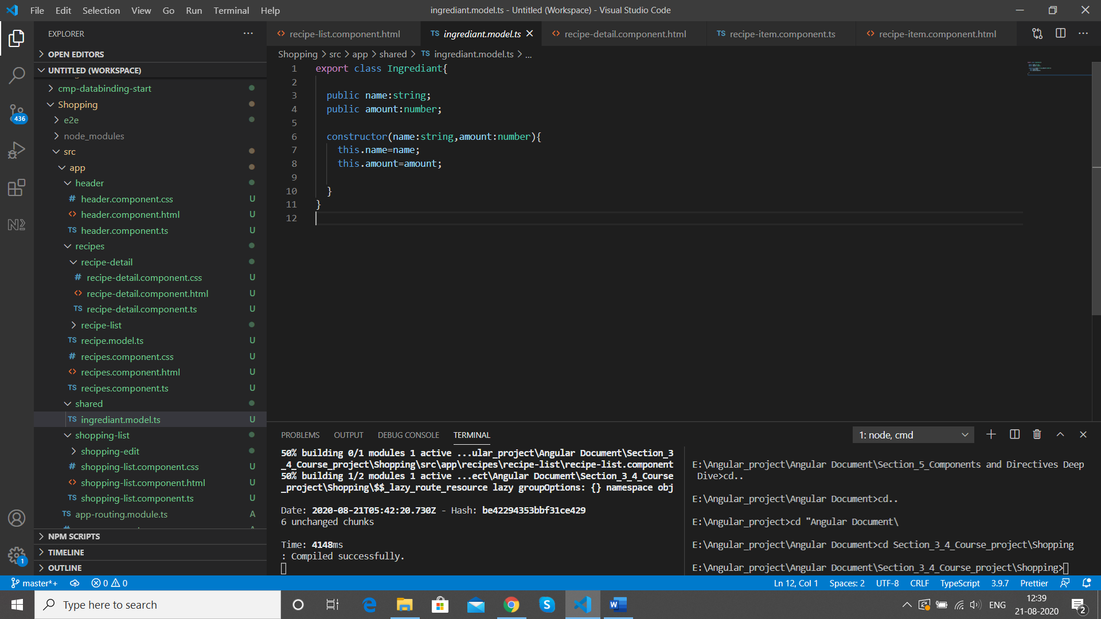

**So we change it to ingredient and import the ingrediants model**

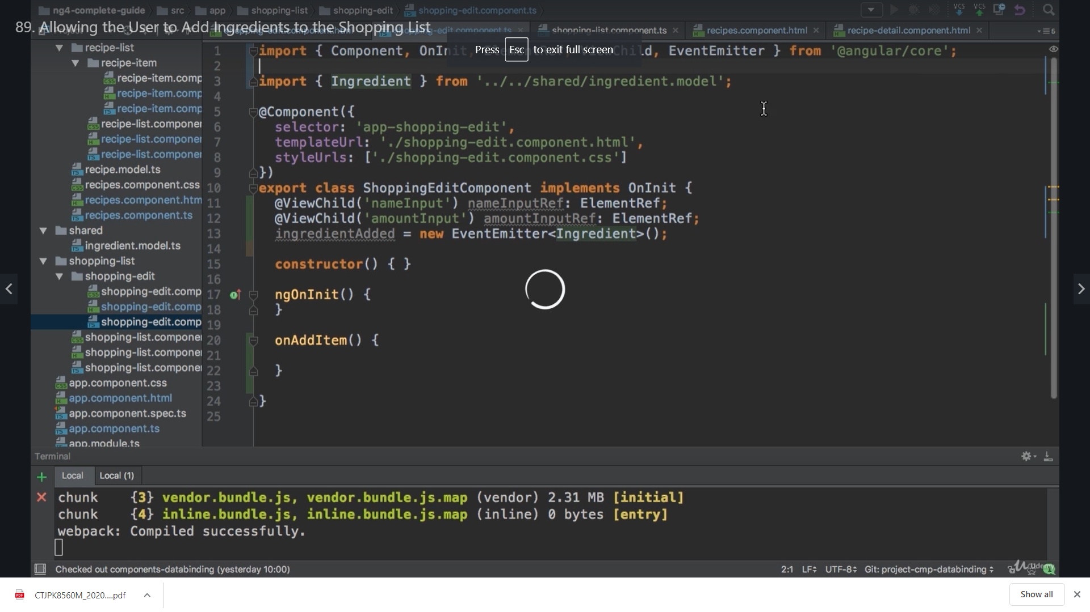

**In method we create a new local variable newIngrediant and create a new Ingrediant which will hold the new Ingrediant that we have which will be the element ref created above**

**We are using const instead of let here because we are not going to change these variables**

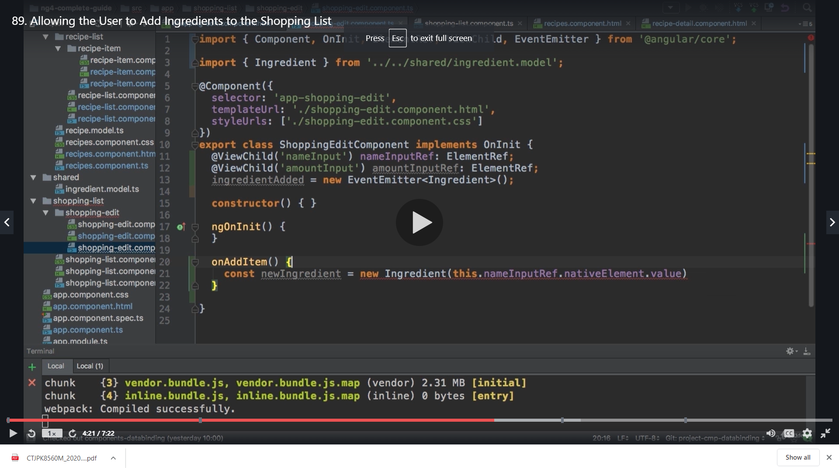

**But its getting too long so we assign the element ref to a variable**

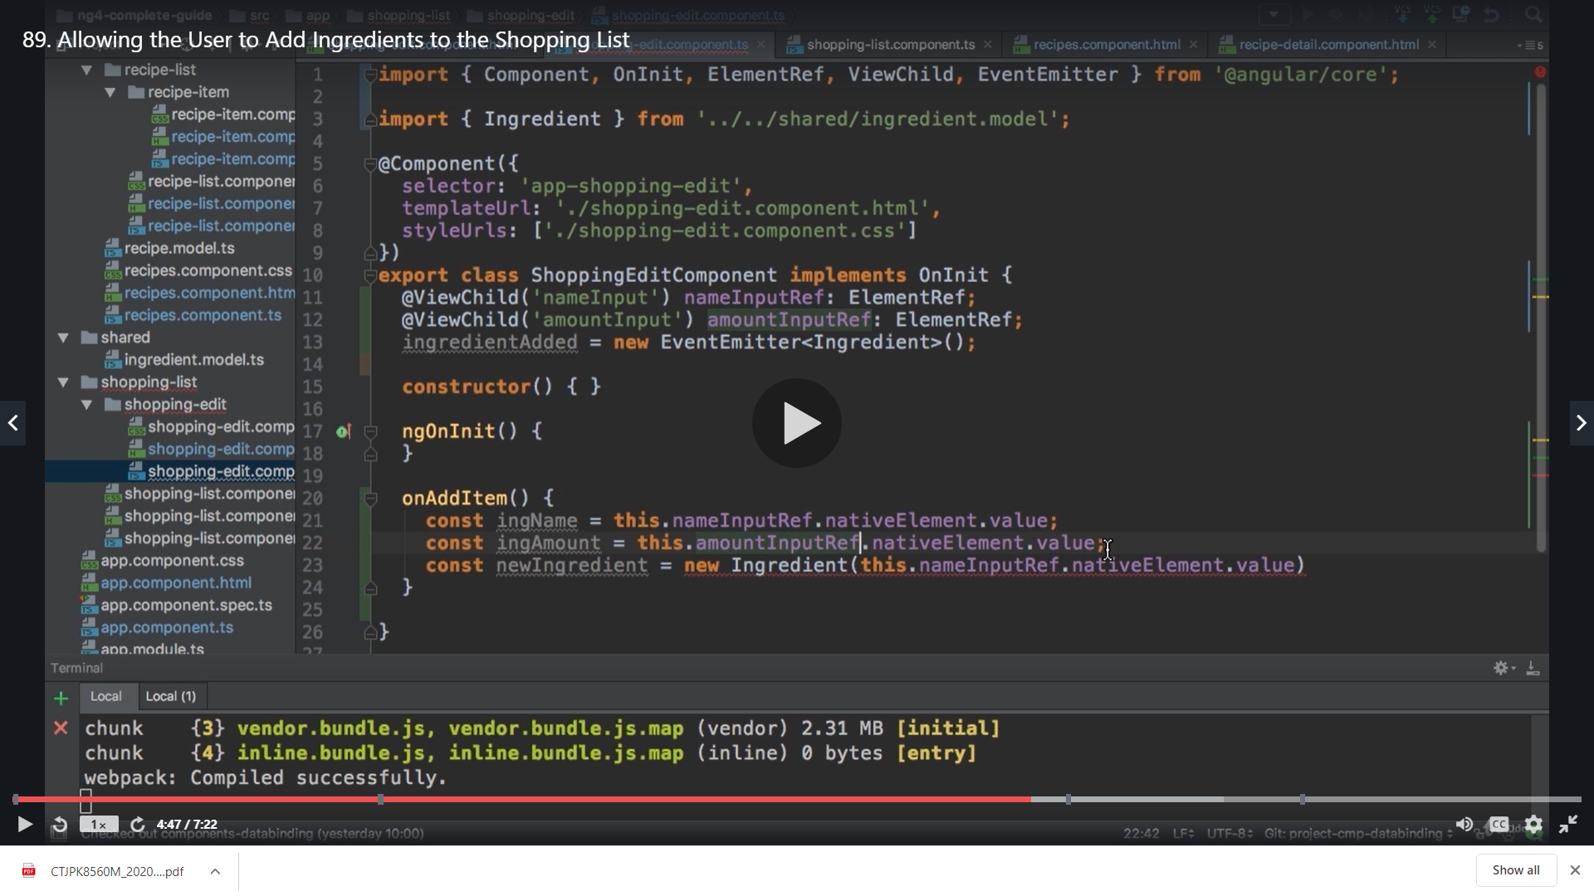

**And pass these variable to the parameter**

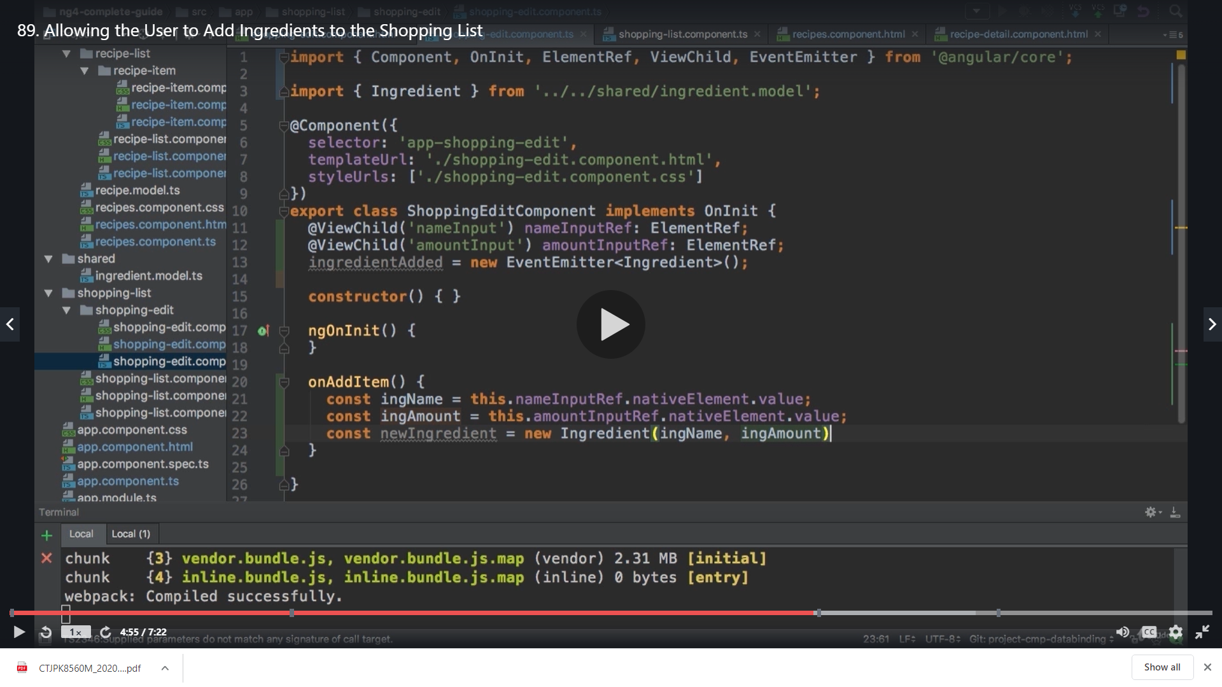

**So now we will have a new Ingrediant now which is made with the name and amount reference**

**With this we can emit our event now and pass ingrediant as data**

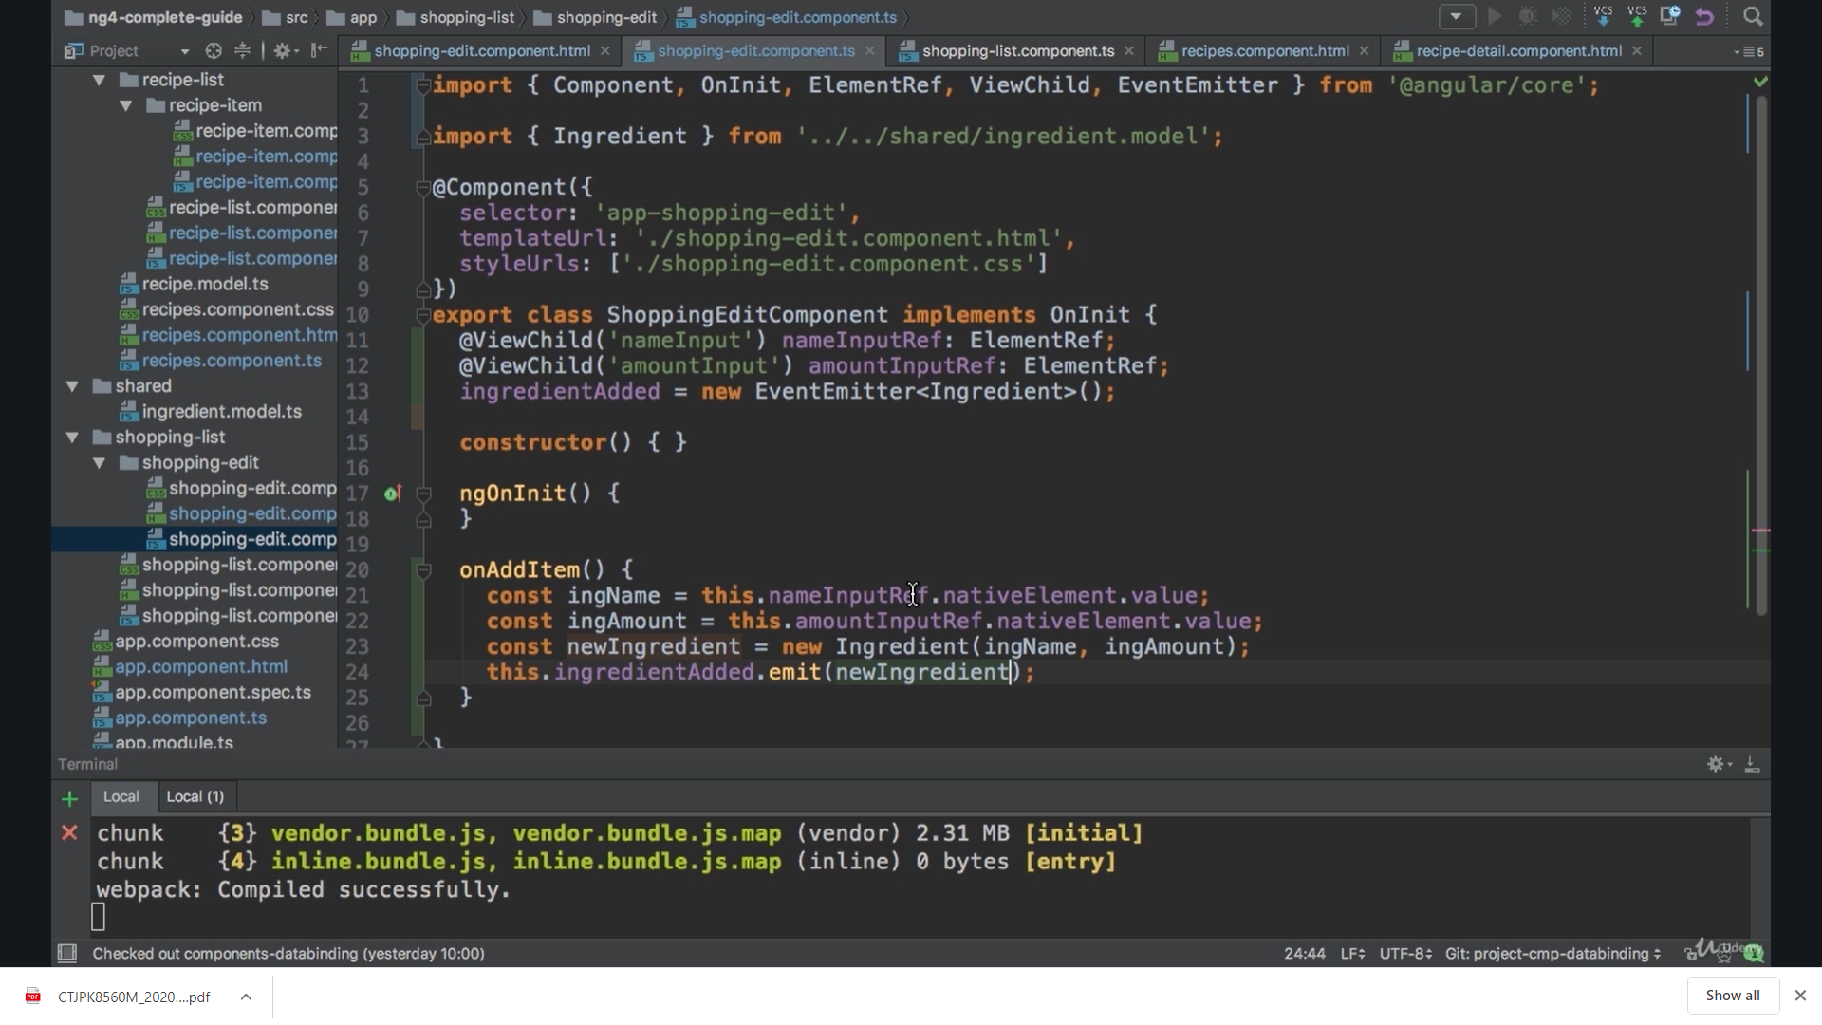

**Now we add @Output to listen to it from outside**

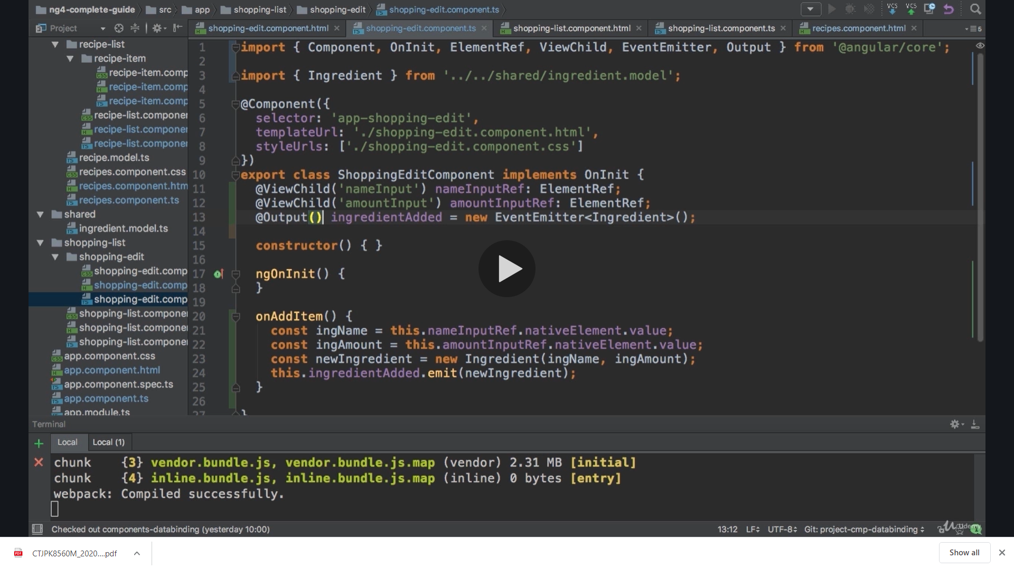

**Now in our shopping list component we listen to our event**

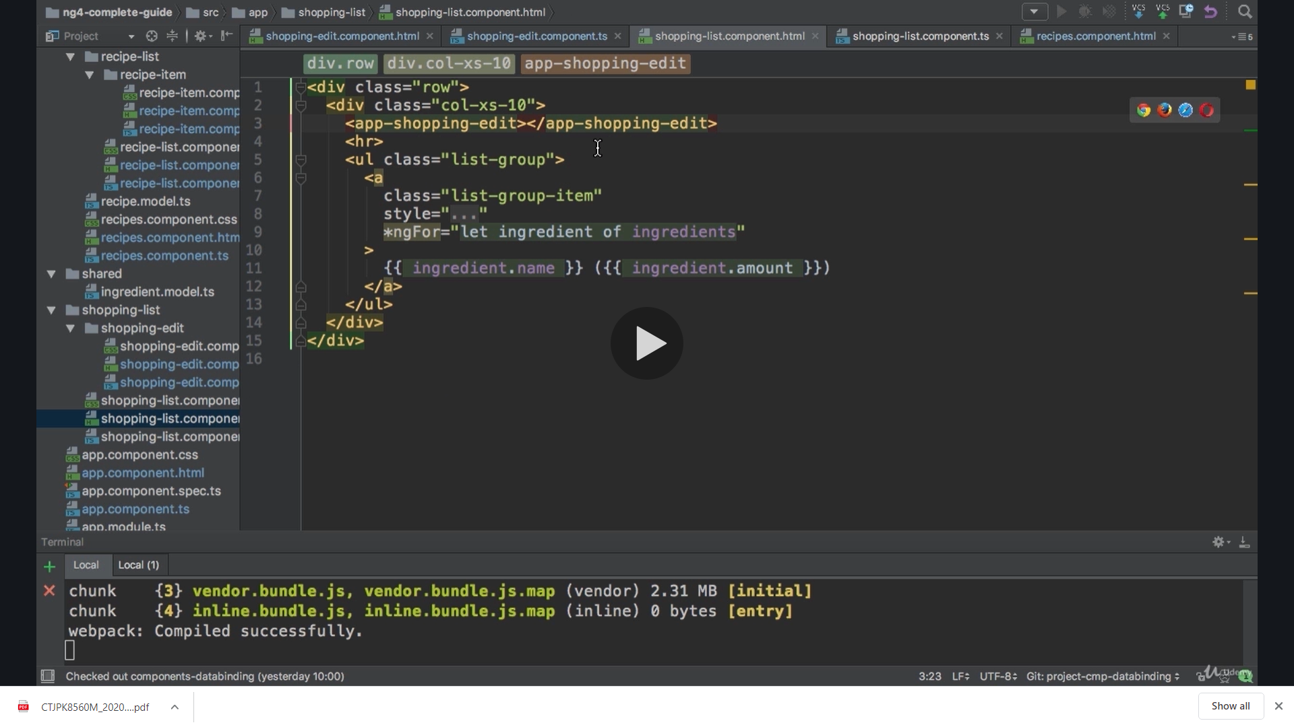

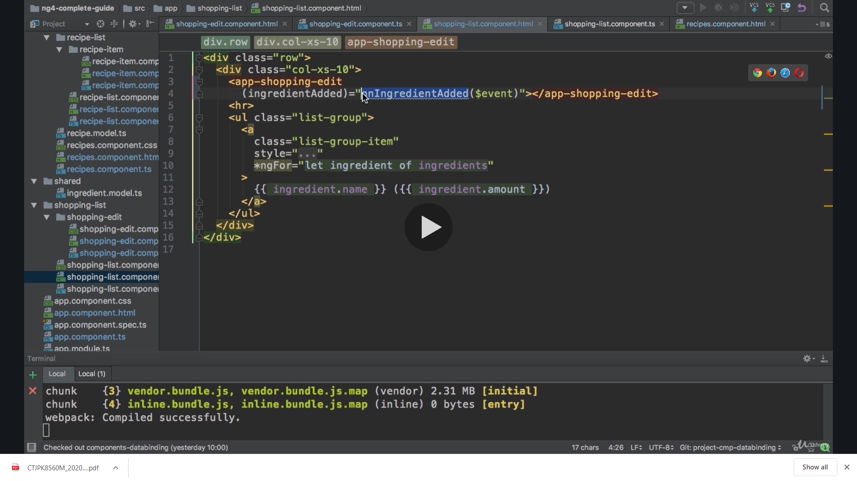

**We listen to our event we have created on its selector and pass event to it**

**Now we implement this method and it has the parameter of type ingredient that is what our event emits there**

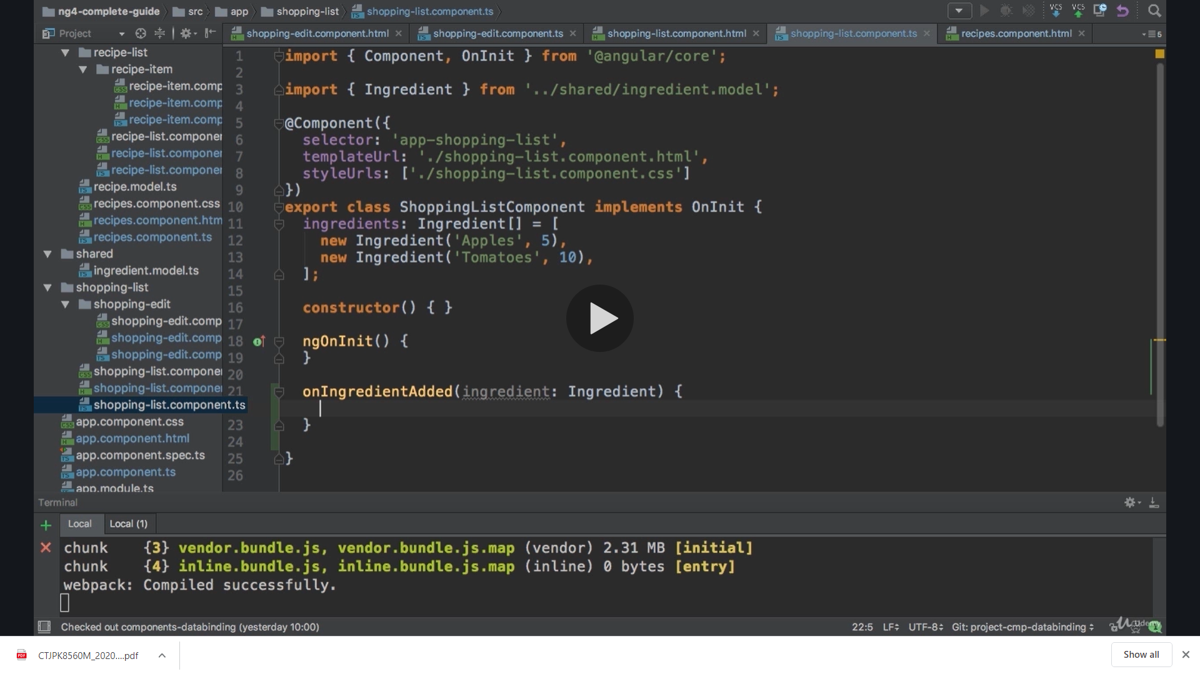

**Now we access the ingredient array and push the new ingrediant we got as data on it**

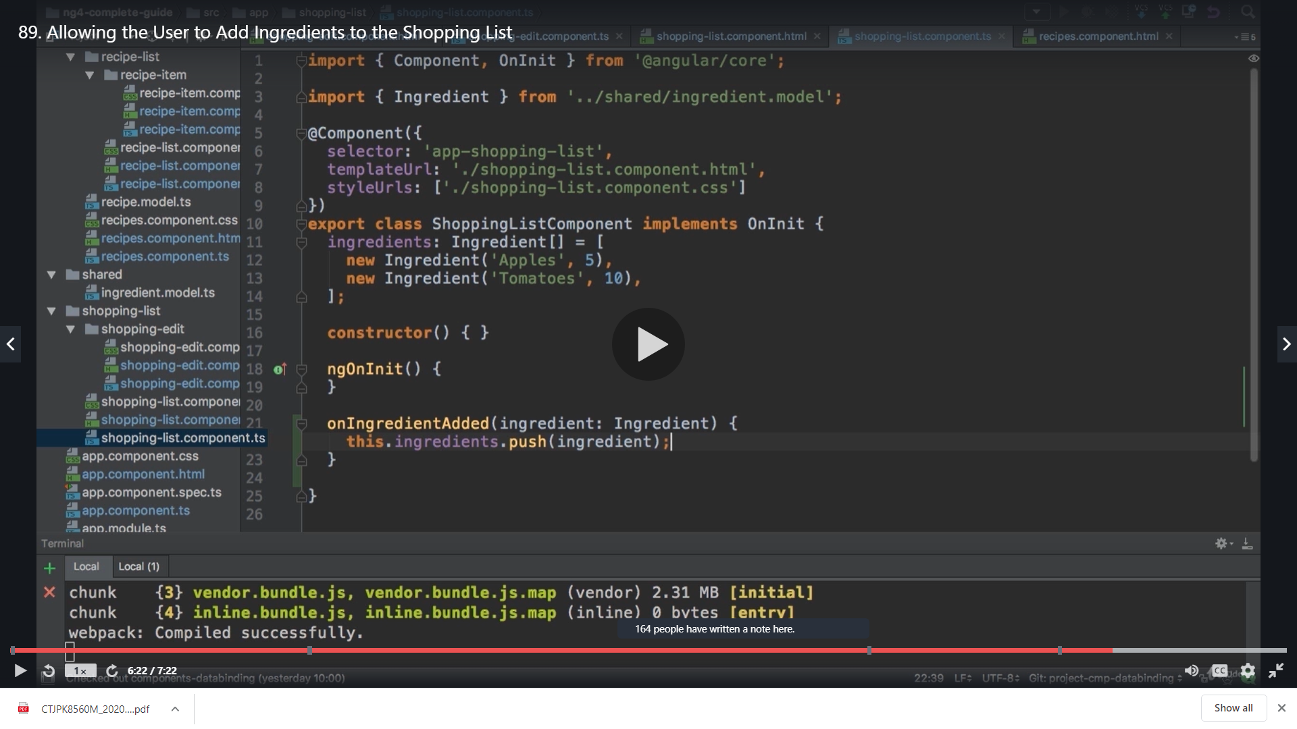

**Result**

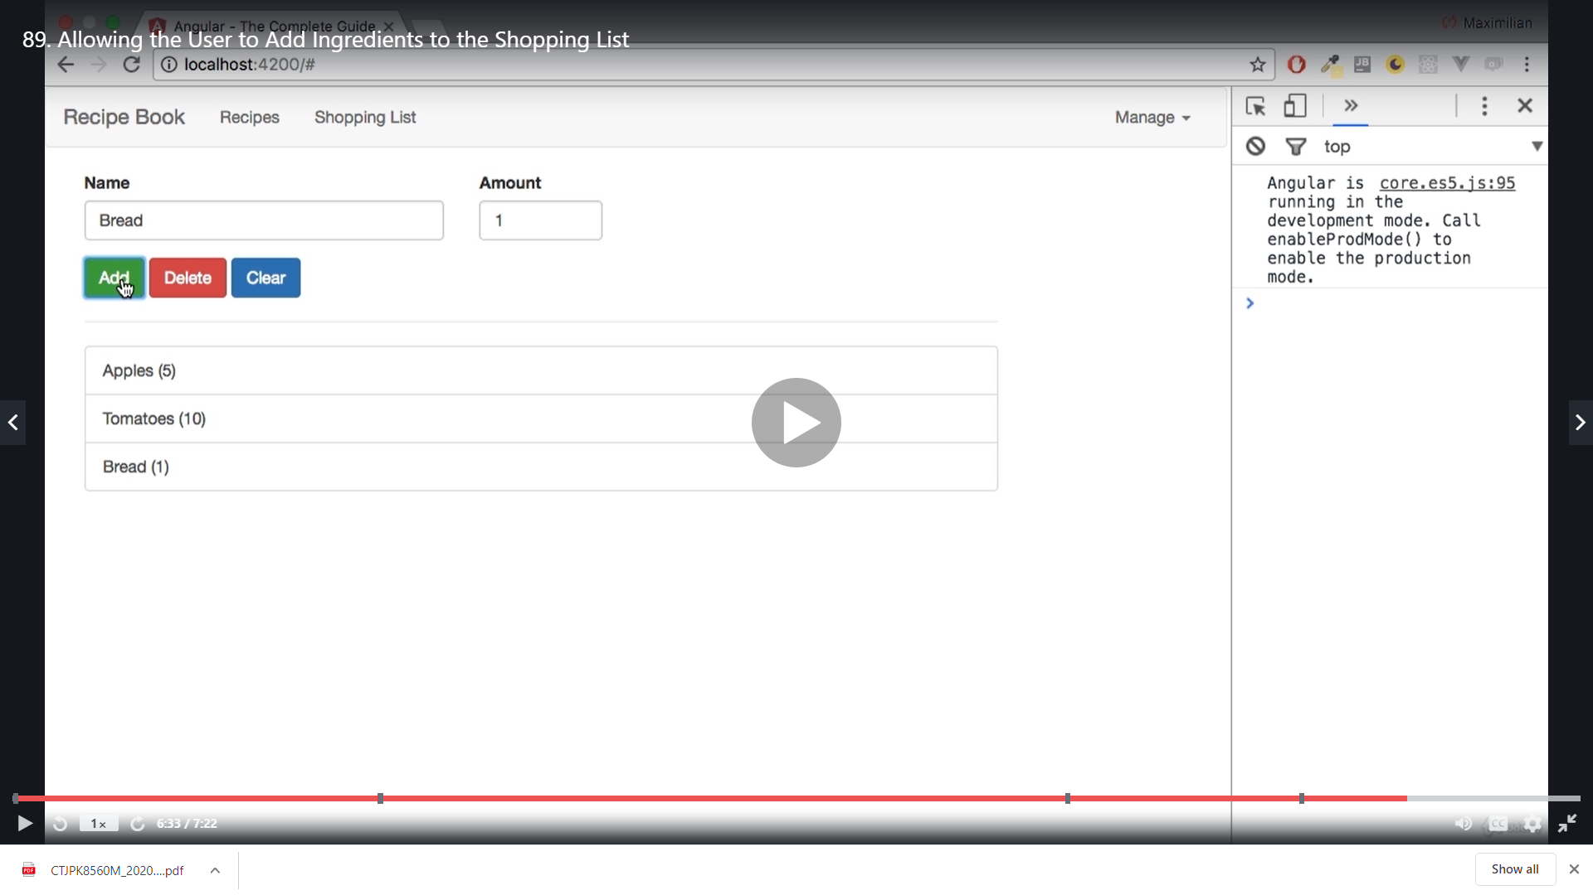

**Add again**

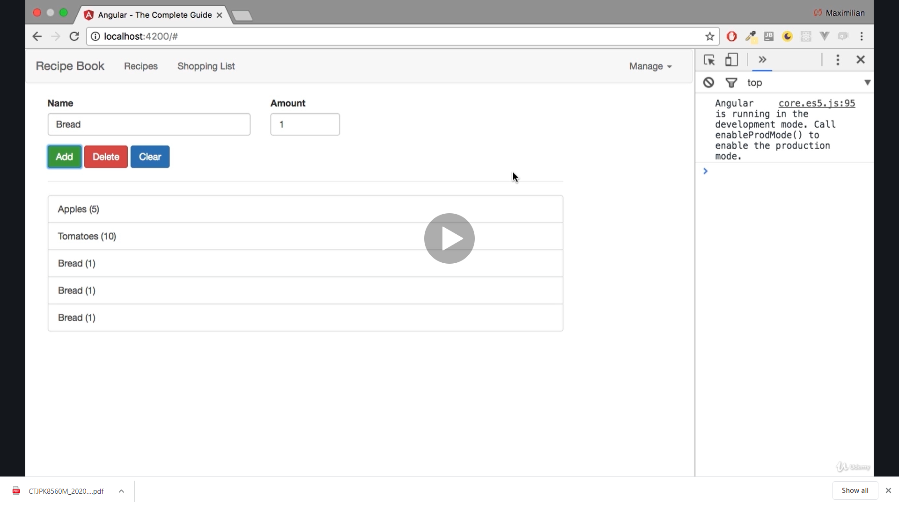

**Till here we did**

**1)Navigation**

**2)Select recipe and display in other component**

**3)We added new recipe**